Environmental and Social Impact Assessment (ESIA)
of
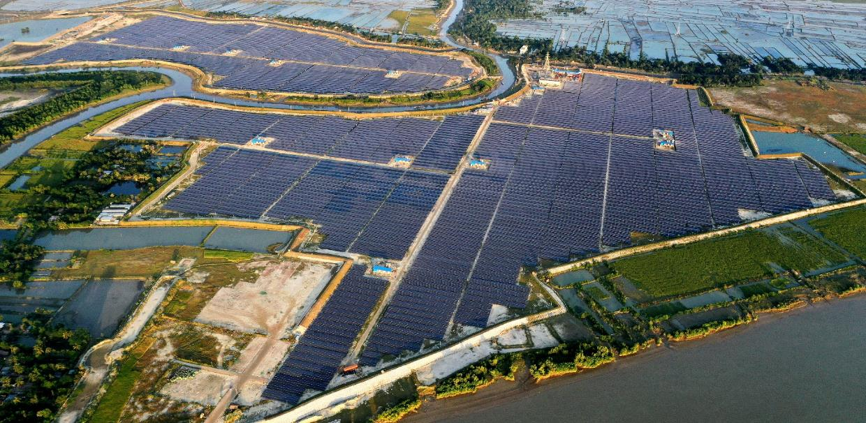
Energon Renewables (BD) Ltd

Prepared by
Bangladesh Centre for Advanced Studies (BCAS)


Table of Contents
Chapter 1 Executive Summary xi
1.1 Introduction xi
1.2 Project Description xi
1.3 Environmental Policy, Legislative and Institutional Framework xii
1.4 Approach and Methodology xiii
1.5 Environmental and Social Baseline Study xiv
1.6 Analysis of Alternatives xv
1.7 Stakeholder Engagement and Public Disclosure xvi
1.8 Grievance Redress Mechanism xvi
1.9 Risk Analysis and Identification xvi
1.10 Impact Identification and Mitigation/ Optimization Measures xvii
1.11 Environmental and Social Management Program (ESMP) xvii
1.12 Monitoring, Evaluation and Reporting xvii
1.13 Impact Summary and Conclusion xix
Chapter 2 Introduction 1
2.1 Context 1
2.2 Project Background 1
2.3 Purpose and Scope of Work 2
2.4 ESIA Team 3
2.5 Limitations 4
2.6 Layout of the ESIA Report 4
Chapter 3 Project Description 7
3.1 Project Overview 7
3.2 Project Justification and Purposes 8
3.3 Project Location 8
3.4 Accessibility 8
3.5 Project Site Setting 9
3.6 Project Description and Associated Activities 9
3.6.1 Project Components 9
3.6.2 Associated Facilities and Other Plant Infrastructure 10
3.6.3 Power Generation through Solar Module 11
3.6.4 Power Transmission Process 13
3.7 Resource Requirement 14
3.7.1 Workforce Requirement 14
3.7.2 Water Requirement and Source 15
3.7.3 Raw Material Requirement 17
3.7.4 Power Requirement 17
3.8 Project Cost 18
3.9 Project Schedule 20
Chapter 4 Environmental Policy, Legislative and Institutional Framework 21
4.1 National Environmental Policies and Laws Related to the Sector 21
4.2 Renewable Energy Law/ Policy 21
4.3 World Bank Operational Policy OP 4.03 25
4.4 Project Categorization 25
4.4.1 World Bank Categorization of Projects 25
4.4.2 E&S Risk Rating as Per Bangladesh Bank IPFF-II Guidelines 26
4.4.3 DoE Categorization 27
4.5 Triggering of the IFC Performance Standards (PSs) in the Present Project 27
4.6 Salient E&S Features of Agreement Between BPDB and ERBL 29
Chapter 5 Approach and Methodology 30
5.1 General Approach and Scoping 30
5.2 Methodology 30
5.3 Assumptions, uncertainties, and Constraints 33
Chapter 6 Environmental and Social Baseline Study 34
6.1 Environmental Baseline Conditions 34
6.1.1 Land Use 34
6.1.2 Topography 34
6.1.3 Geology 35
6.1.4 Hydrology and Drainage 38
6.1.5 Water Resources 38
6.1.6 Ambient Air Quality 40
6.1.7 Ambient Noise Quality 41
6.1.8 Soil Type 43
6.1.9 Traffic Movement 43
6.1.10 Forests and Protected Areas 43
6.1.11 Climate and Meteorology 44
6.1.12 Natural Hazards 49
6.2 Socio-economic Baseline 54
6.2.1 Approach and Methodology 54
6.2.2 Demarcation of the Project Area for Socio-Economic Study 54
6.2.3 Reconnaissance Survey 55
6.2.4 Consultations with Stakeholders 55
6.2.5 Collection and Review of Documents 55
6.2.6 Socio-Economic Baseline Profile of the Project Impact Area 55
6.3 Ecology and Biodiversity Baseline 67
6.3.1 Flora 67
6.3.2 Fauna 68
6.3.3 Aquatic Fauna/ Fish 69
6.3.4 Endangered/Vulnerable Species 69
Chapter 7 Analysis of Alternatives 71
7.1 “No Project” Scenario 71
7.2 Analysis of Site Alternatives 71
7.3 Analysis of Technological Alternatives 72
Chapter 8 Stakeholder Engagement and Public Disclosure 73
8.1 Introduction 73
8.2 National and International Requirements on Stakeholder Engagement 73
8.3 International Requirements (World Bank) 73
8.4 Summary of the project Stakeholders Engagement and Information Disclosure Process 74
8.4.1 Stakeholder Categorization 75
8.4.2 Approach and Methodology for Stakeholder Analysis 75
8.4.3 Summary of Stakeholder Consultation 76
8.4.4 Participants of the Stakeholder Consultation 79
8.5 Stakeholder Identification and Mapping 81
8.5.1 Stakeholders and Information Needs 81
8.5.2 Local Authorities and Regulators 82
8.5.3 Project Workers 82
8.5.4 Suppliers of Goods and Services 82
8.5.5 Local Population 83
8.5.6 Local Media 83
8.5.7 Non-Governmental Organizations 83
8.6 Stakeholder Engagement Plan (SEP) 85
8.7 Public Disclosure 85
Chapter 9 Grievance Redress Mechanism 86
9.1 Introduction 86
9.2 Purpose & Objectives 86
9.3 Membership 86
9.4 Meetings and Disclosure 87
9.5 Duties & Responsibilities of GRC 87
9.6 Current Practices of ERBL Regarding Grievance Redress 88
Chapter 10 Risk Analysis and Identification 90
Chapter 11 Impact Identification and Mitigation/ Optimization Measures 92
11.1 Introduction 92
11.1.1 Scope of the Assessment 92
11.2 Identification of Impacts of Landfilling and Land Use Change 92
11.3 Identification of Environmental Impacts in Operation Phase 93
11.3.1 Impact on Soil Environment 93
11.3.2 Impact on Water Environment 94
11.3.3 Impact on Noise and Air Quality 95
11.4 Identification of Impacts of O&M Activities in Operation Phase 96
11.5 Impacts of Hazardous E-Waste in operation Phase 96
11.6 Identification of Ecological Impacts in Operation Phase 98
11.6.1 Collision and Electrical Hazards from Transmission Infrastructure 98
11.6.2 Impact on Endangered or Vulnerable Species 98
11.6.3 Impact on Migratory Birds 99
11.7 Identification of Social Impacts in Operation Phase 100
11.7.1 Impact on Economy and Employment 100
11.8 Identification of the Potential Visual Impacts 101
11.9 Identification of Climate Change Impacts 101
11.10 Identification of Impacts on Gender 102
11.11 Identification of Environmental Impacts in Decommissioning Phase 103
11.11.1 Impact on Soil Environment 103
11.11.2 Impact on Water Environment 103
11.11.3 Impact on Air Quality 104
11.11.4 Impact on Ambient Noise 105
11.11.5 Impact from Solid Waste Generation and Decommissioning Requirements 105
11.12 Identification of Social Impacts in Decommissioning Phase 106
11.12.1 Impact on Economy and Employment 106
Chapter 12 Environmental and Social Management Program (ESMP) 107
12.1 General 107
12.2 ERBL’s Organizational Structure 108
12.3 Roles and Responsibilities 109
12.4 Inspection, Monitoring & Audit 109
12.4.1 Report and Documentation 109
12.4.2 ESMP Review and Amendments 110
12.5 Training Program and Capacity Building 110
12.6 Environmental and Social Management Plan 110
Chapter 13 Monitoring, Evaluation, and Reporting 124
13.1 Institutional Requirements 124
13.2 Environmental Training Program 124
13.3 Environmental and Hazardous Waste Monitoring 125
13.4 Environmental Monitoring and Management Budget 126
13.5 Labor Assessment 128
13.6 Environmental & Social (E&S) Audit 129
13.7 Environmental and Social Action Plan (ESAP) 129
13.8 Disaster Management and Emergency Response Plan 129
Chapter 14 Impact Summary and Conclusion 131

List of Tables

Table 2-1: List of Chapters 5
Table 2-2: List of Annexures 5
Table 3-1: Project Related Details 7
Table 3-2: Equipment Details of ERBL solar project 10
Table 3-3: Current manpower of ERBL in Operation Phase 14
Table 3-4: Breakdown of project Cost and Debt Financing 19
Table 4-1: National Legal Instruments relevant to the Project 22
Table 4-2: World Bank's Categorization for Projects 25
Table 4-3: E&S Ratings of Sub-projects 27
Table 4-4: Triggering of the IFC Performance Standards (PS) 28
Table 5-1: List of studies and work streams 32
Table 6-1: Land Use of Both Project and Study Area 34
Table 6-2: Water Quality Monitoring Points 39
Table 6-3: Surface Water Quality Monitoring Results 39
Table 6-4: Groundwater Quality Monitoring Results 39
Table 6-5: Air Quality Monitoring Points 40
Table 6-6: Ambient Air Quality Monitoring Results 40
Table 6-7: Instrument Specification for measuring Ambient Noise level 41
Table 6-8: Ambient Noise Level Monitoring Points 41
Table 6-9: Ambient Noise Level Monitoring Results 42
Table 6-10: Annual Rainfall (in mm) from 2011 to 2019 46
Table 6-11: Monthly Rainfall (in mm) from 2015 to 2019 46
Table 6-12: Monthly and Yearly Humidity (in %) from 2015 to 2019 46
Table 6-13: Monthly and Yearly average Dry Bulb Temperature from 2015 to 2019 47
Table 6-14: Monthly and Annual Avg. Sunshine Hours (2015-19) 49
Table 6-15: List of major Cyclones in Bangladesh 50
Table 6-16: No. of Households Regarding Household Size at the Study Area 56
Table 6-17: Population Distribution of Sample Households by Age Groups 57
Table 6-18: Religious Profile of the Study Area 57
Table 6-19: Marital Status of the Sample Surveyed Population in the Study Area 58
Table 6-20: Education Status of the HH Heads of the Study Area 59
Table 6-21: Status of Sanitation Facilities at the Sample Surveyed Households 60
Table 6-22: Sources of Fuel for the Sample Surveyed Households 61
Table 6-23: Access to Resources 61
Table 6-24: Types of Houses at the Study Area 62
Table 6-25: No. of Households Having Different Types of Animals 62
Table 6-26: Income Level of the Households of the Study Area 63
Table 6-27: Expenditure Ranges of the Households of the Study Area 63
Table 6-28: List of Endangered or Vulnerable Species in the Study Area 69
Table 8-1: Stakeholder Group Categorization 75
Table 8-2: Stakeholder and Information Disclosure Methods 76
Table 8-3: Stakeholder Consultation and Key Points Discussed 77
Table 8-4: Summary of issues and concerns raised by the people and responses provided 83
Table 10-1: Anticipated Risks on Important Environmental & Social Components during Operation Phase 90
Table 12-1: Environmental and Social Management Plan (ESMP) for Operation Phase 112
Table 12-2: Environmental and Social Management Plan (ESMP) for Decommissioning Phase 119
Table 13-1: Monitoring parameters and frequency of monitoring during operation phase 128
Table 13-2: An Annual Tentative Budget for Environmental Monitoring 129

List of Figures
Figure 3-1: Flow Diagram of Transmission Process 13
Figure 3-2: Project Schedule 20
Figure 6-1: Tectonic Map of Bangladesh 36
Figure 6-2: General Soil Map of Bangladesh 37
Figure 6-3: Seasonal Wind Rose Plots 48
Figure 6-4: Monthly Maximum Wind Speed (2015-19) 49
Figure 6-5: Tracks of Major known Cyclones in the Bay of Bengal 52
Figure 6-6: Household Size of the Study Area 56
Figure 6-7: Occupational Profile of the Study Area 58
Figure 6-8: House Ownership Status of the Surveyed Households 59
Figure 6-9: Sources of Drinking Water for the Sample Surveyed Households 60
Figure 6-10: Use of Land by the Landowners 61
Figure 6-11: Fields of Expenditures of the Households 64
Figure 6-12: Satisfaction Level of the Household in their Daily Life Style 67
Figure 11-1: Nine Major Migratory Flyways 100

List of Abbreviations

BBS – Bangladesh Bureau of Statistics
BIDA – Bangladesh Investment Development Authority
BMD – Bangladesh Meteorological Department
BPDB – Bangladesh Power Development Board
BWDB – Bangladesh Water Development Board
DoE – Department of Environment
DoF – Department of Fisheries
ECA – Environmental Conservation Act
ECC – Environmental Clearance Certificate
ERBL – Energon Renewables (BD) Ltd
ESIA – Environmental and Social Impact Assessment
ESMP – Environmental and Social Management Plan
EU – European Unions
IFC – International Finance Corporation
L/C – Letter of credit
MEAs – Multilateral Environmental Agreements
MoEFCC – Ministry of Environment, Forest and Climate Change
MoPEMR – Ministry of Power, Energy and Mineral Resources
MW – Mega Watt
NGO – Nongovernmental Organization
NOC – No Objection Certificate
O&M – Operation and Maintenance
OM – Operations Manual
PCM – Public Consultation Meeting
SO – Safety Officer
SREDA – Sustainable and Renewable Energy Development Authority
SRDI – Soil Resources Development Institute
UNCED – United Nations Conference on Environment and Development
UNDP – United Nations Development Program
USEPA – United States Environmental Protection Agency
WB – World Bank

Units
dB – Decibel
PPM – Parts Per Million
Hr – Hour
Kg – Kilogram
Km – Kilometer
KW – Kilowatt
M – Meter
Mg – Milligram
Ton/year – Ton per Year
MT/year – Metric Ton per Year

Executive Summary

Introduction
Energon Renewables (BD) Limited, a 100MW PV AC Solar Based Power Project situated in Bagerhat District in the country, is so far, the largest ecofriendly power project to provide clean energy by using Solar Panel from the renowned manufacturer of Solar PV Panel, Longi Solar Technology Company Limited, China.
The Project Sponsors proposed to Power Division, Ministry of Power Energy and Mineral Resources, Bangladesh for designing, financing, insuring, construction, ownership, commissioning, operation and maintenance of an electricity generation project of 100 MW (net) at Bagerhat, Bangladesh, which will sell electricity to the Bangladesh Power Development Board (BPDB). After evaluating the proposal, BPDB issued the Letter of Intent pursuant to approval received from the Power Division, Ministry of Power, Energy and Mineral Resources (MoPEMR) on April 12, 2017, under the special act, 2010 (revised 2015) for enhancement of Power & Energy.
Accordingly, the project company is formed and registered in the Registrar of Joint Stock Companies (RJSC) namely Energon Renewables (BD) Limited. The project company later signed the Project Agreements [both Power Purchase Agreement (PPA) and Implementation Agreement (IA)] to Build, Own and Operate (BOO) a 100 MW (net) AC PV based Solar Power Plant in Bagerhat, Bangladesh on February 25, 2019. The net energy output from the facility will be purchased on “No Electricity, No Payment” basis under the clauses and rate approved in the PPA.
The ERBL solar project is already in operation since 29 December 2021. The project received site/ environmental clearance from 2 no. Burirdangga Union Parishad on September 12, 2018, and from 5 no. Rajnagar on May 23, 2019 and site clearance from the DOE (Department of Environment) on July 08, 2020; allowing the construction of the project to proceed. ERBL received registration from BIDA (Bangladesh Investment Development Authority) on June 28, 2020. The environmental clearance certificate from DOE for the project was obtained on April 04, 2022. The project was financed by bridge loans from different lenders. ERBL now is applying for financing from Investment Promotion and Financing Facility (IPFF-II) of Bangladesh Bank. ESIA has been prepared based on the ESPP (Environmental and Social Policy and Procedure) guidelines for the IPFF-II project of Bangladesh Bank.

Project Description
The Project is located at Moidhara and Borodurgapur Village under Mongla & Rampal Upazila, Bagerhat District and Khulna Division. The project site stands on the left bank of Passur River and adjacent to Rampal power plant. The project is located only 2km away from Khulna-Mongla highway.
The land required for the project was purchased from the landowners and there was no issue of resettlement or livelihood restoration. There was no coercion mental or physical in the process. The Land Details are shown in Annex-3.
The project site was primarily scrubland with sparse vegetation. The site has mixed topography of terrain. The elevation within project site, rages from 1.6 m to 2.3 m above MSL.
The project area does not fall within any sensitive receptors viz. wildlife sanctuaries, biosphere reserves, national parks, etc. there are no archaeological and historical monuments in, along or near (10 km) the project site. Structures of religious importance will not be affected by the project. There are natural water bodies within the project boundary and will not be affected by the project activities.
The project utilizes Polycrystalline Silicon modules on fixed structures. The modules are fixed type. The type of modules and mounting systems used is as presented in Table 3.1. The plant layout plans are presented in Annex-2(i), Annex-2(ii) and Annex-2(iii).
The development of associated facilities such as external transmission line connecting the solar plant to the PGCB Electrical Power Station and internal road was under the scope of ERBL. 4.4 km internal road (4m wide) was constructed for accessing the different part of the solar plant.
The project will include scrap yard to be developed within the project site. The scrap yard will consist of discarded panels and other hardware components such as wood/ steel, oil barrels, wires/ cables and domestic components.
ERBL also constructed a 2.2 km external road (5.4 m wide) along with the boundary of the plant for the Moidhara villagers with an investment of approximately BDT 80 Lac. A bamboo bridge was constructed to connect Burirdangga union with Rajnagar Union with an investment of BDT 50,000.
The total Project cost has been estimated USD 200.28 Million including finance cost. The investment includes land and site development, machinery cost, PV panel and mounting structures, cost of civil works and erection works. Detailed breakdown of the project cost is shown in Table 3.4. Out of the total investment, ERBL is seeking finance help for 46% of the debt financing USD 69.34 Million from World Bank via Bangladesh Bank IPFF-II.

Environmental Policy, Legislative and Institutional Framework
The ESIA has been prepared in accordance with the following:
- The Environment Conservation Act, 1995 and The Environment Conservation Rules, 1997 and amendments thereof by the Ministry of Environment, Forest and Climate Change, Government of Bangladesh;
- Applicable Bangladesh national, regional and local regulations;
- International conventions and agreements ratified by Bangladesh;
- International Finance Corporation (IFC) Performance Standards for Environmental and Social Sustainability (2012).
The solar project is categorized as a ‘Medium Risk’ project as per provisions of the ESPP document for the IPFF-II project and in “Category B” according to World Bank Policy OP4.03 applicable to the IPFF-II project. This is an “Orange B” category project according to Environment Conservation Rules 1997 (i.e., amendment as per SRO No. 349- act/2017).
The triggering of IFC Performance Standards (PS) in the present project with explanations are given in the Table 3.5 below. The applicable GOB laws, Rules, Policies, and Guidelines are listed alongside IFC PS. The International Conventions signed by Bangladesh are also included, as once signed these are equivalent to the laws. Detailed information on triggering of IFC performance standards are shown in Table 4.4. A summary on triggering is shown below:
Sl. | PS and Title | Triggered | Not Triggered
1. | PS1: Assessment and Management of Environmental and Social Risks and Impacts | √
2. | PS2: Labor and Working Conditions | √
3. | PS3: Resource Efficiency and Pollution Prevention | √
4. | PS4: Community Health, Safety, and Security |  | √
5. | PS5: Land Acquisition and Involuntary Resettlement |  | √
6. | PS6: Biodiversity Conservation and Sustainable Management of Living Natural Resources |  | √
7. | PS7: Indigenous Peoples |  | √
8. | PS8: Cultural Heritage |  | √

Approach and Methodology
Energon Renewables (BD) Ltd engaged BCAS for Conducting the ESIA on March 2022. The ESIA study focuses on developing the environmental profile of the project area to assess existing (baseline) conditions on the physical and biological environment, and the social environment along with anticipated environmental impacts and proposed mitigation measures. The detailed evaluation of the social and biological environment of the area was carried out through a field study and the area of influence of the environmental impacts is considered to be 5 km.
The main purpose of ESIA study is to ensure that:
- Any major adverse impact on the environment (physical, ecological and social) during different phases of projects viz. siting, design, construction and operation are identified.
- Adverse impacts are appropriately addressed, and adequate mitigation measures are incorporated in the siting, design, construction and operation phases of project.
- Socioeconomic aspects are identified, and mitigation measures have been identified.
- Alternatives to achieve the objectives are analyzed.
- Environmental and Social Management Plan (ESMP) for sustainable development and operation of the project is developed for implementation and monitoring of the project activities.
List of studies and work steams required in compliance with the applicable laws, regulations and IFC PSs are given in the table 5.1 below. Larger studies are included in annexes and others are integrated in the chapters.
As the construction period is over and the plant has been in operation, all the risks identified, impacts and mitigation measures are reported based on Operation phase. More time was required to carry out a more detailed Social Impact Assessment (SIA) of the relevant stakeholders. The ESIA has been prepared with an emphasis to cover all important environmental impacts and formulate pragmatic recommendations for mitigating any adverse environmental impacts.
BCAS is not responsible for implementation of any aspect of ESMP or in disclosure process, post approval of ESIA report.

Environmental and Social Baseline Study
This section presents environment, ecological and socio-economic baseline of the study area for the 100 MW solar power project in Bagerhat district, in order to provide a context within which the impacts of the 100 MW solar power project are to be assessed. To characterize baseline environmental and socioeconomic conditions, information was acquired through desk studies and was supplemented with field surveys and observations. Baseline refers to the physical, biological, cultural and human conditions that will prevail in the absence of the project, including interactions amongst them. Establishing baseline helps in understanding the prevailing environmental, ecological and socio-economic status of the study area. It provides requisite information of the biophysical and social environment for decision makers to take appropriate measures regarding the project.
As the ERBL is a solar project, there is no pollution of air, water and noise and no emission of GHGs in the operation phase. All the environmental parameters are within national and international standards. Groundwater (after water treatment with RO system) is used for solar module cleaning and other domestic purposes. Electricity for running the plant is consumed from the auxiliary generation and purchased from national grid. There is no provision of diesel generator.
Energon Renewables (BD) Ltd, (previously proposed as Orion Power Khulna Ltd), conducted a flood flow vulnerability assessment in 2014. This study has been carried out to assess flood flow vulnerability for the proposed power plant site along the bank of the Passur River in Mongla Upazila of Bagerhat district.
The flood flow vulnerability assessment has been conducted based on the existing ground elevation and the design flood levels. The project site is actually a floodplain of the Passur River which is inundated during monsoon. The average existing ground level is found to be 2.22 m PWD. The design flood level corresponding to 100-year return period at the proposed plant location has been estimated to be 5.10 m PWD while the normal flood level corresponding to 2.33-year return period is found to be 4.37 m PWD. It is seen that the proposed project area is highly vulnerable to flood. The difference between the existing ground elevation and 100-year flood level is 2.41 m while the difference between the existing ground level and the 2.33-year normal flood level is 1.71 m. Filling the whole study area requires huge amount of soil and it takes huge amount of money as well. Thus, filling the whole area is not a viable solution for flood protection of the area. In order to make the area flood-free, a flood wall has been suggested as it takes much less area than flood embankments.
The detailed assessment report of flood flow vulnerability is attached as Annex-6. Based on the recommendation suggested in the assessment report, ERBL constructed a dyke 5.5 m above MSL was constructed around the plant in 2020.
The social baseline study has identified social impacts of the project on the local community. During the field assessment and stakeholder meetings, documents of relevance to this study were collected and data from the same was utilized in developing this social baseline. Bangladesh Population Census 2011 Data for Mongla Upazila were collected and reviewed during this site assessment. The findings can be found in Chapter 6.2.6.

Analysis of Alternatives
The project has considered alternatives in terms of design and technology options. An analysis of these alternatives has been undertaken for the project including consideration of a no-project scenario.
The “No Project” option will deprive the country of the green energy project as Bangladesh is striving towards increasing the share of Renewable Energy in the electricity production with specific long-term targets. The “No Project Scenario” is also likely to have a negative effect on opportunities for employment, both directly from the power project and its dependent sectors such as agriculture, industries and manufacturing that require stable power supply in order to operate and be competitive.
Considering important parameters for a power plant project, initially Orion Group procured 141 acres of land in the name of Orion Power Khulna Limited to set up a coal power plant during the year of 2011 to 2015. Later on, the 141 acre of land was transferred in the name of Energon Renewables (BD) Limited (ERBL) in 2020. ERBL has also procured additionally 142 acres of land for solar power project. Except limited aquaculture, most of the land was unutilized. No agricultural activities was done on this land. Also, there was no residential unit within the project site; therefore, resettlement and rehabilitation issues are not applicable for this project. As the project site is kept unutilized for most of the months of each year, the landowners were voluntarily interested to sell the land with reasonable purchase price. Hence, the location was considered as suitable for implementation of the grid-tied solar project.
GOB is looking for various options for Renewable Energy resources. Under the existing generation scenario of Bangladesh, Renewable Energy has a very small share to the total generation. The share of Renewable Energy is around 3.5% as of July 2022 (Source: SREDA, 2022). The present government is placing priority on developing Renewable Energy resources to improve energy security and to establish a sustainable energy regime, alongside of conventional energy sources. Government has already launched ‘500MW Solar Power Mission’ to promote the use of Renewable Energy to meet the increasing demand of electricity. Considering the scenario, solar energy generation is the most feasible technological alternative amongst renewable options.

Stakeholder Engagement and Public Disclosure
An extensive stakeholder’s consultation process was undertaken through FGDs, and KIIs. In general, there were no negative notions about the project in the area. However, there were certain queries about the opportunity they will get in the future in the project. The consultants and technical management of ERBL explained the mitigation measures that are being taken to mitigate the issues raised.
There was no resettlement issue as the land for the project was purchased from the owners. There was also no livelihood restoration issue.
Once the ESIA report is finalized, ERBL should disclose the document on their website for public opinion and comments. After approval, the final version of ESIA report should be accessible to general people. The executive summary should be translated in local language Bangla. The plant should have the final ESIA report and refer to it whenever needed.

Grievance Redress Mechanism
Environmental and social complaints will be handled in accordance with the mechanism for repairing project complaints. An open and transparent dialogue will be maintained with the people affected by the project when necessary. The grievance redress mechanism (GRM) for the project provides an effective approach to complaints and the resolution of problems made by the affected community in a reliable manner. This mechanism will remain active throughout the life cycle of the project.
The grievance redressal committee is committed to making available a system to reduce risk for projects, offer communities as an effective avenue for expressing concerns, achieving remedies and promoting a mutually constructive relationship. Grievance redressal committee maintains a locally based, formalized way to accept, assess, and resolve community complaints concerning the performance or behavior of a company, its contractors, or other employees. The specific objectives of the GRC are as follows:
- To allow stakeholders the opportunity to raise comments/concerns;
- To structure and manage the handling of comments, responses and grievances, and allow monitoring of the effectiveness of the mechanism; and
- To ensure that comments, responses, and grievances are handled in a fair and transparent manner, in line with the applicable reference framework.
Grievance Redress Mechanism (GRM) adopted by ERBL is described in Annex-9.

Risk Analysis and Identification
Risk analysis and identification has been carried out for the operation phase of the project. The analysis shows that for the operation phase, the risks are low. The risks are explained in the Chapter 10.

Impact Identification and Mitigation/ Optimization Measures
The project has overall positive impacts by providing a competitive, cost-effective, pollution free reliable mode of Solar PV power. It will certainly meet the ever-increasing demand of ‘Renewable Power’ to mitigate GHG emission.
Various activities of operation and maintenance phase, and decommissioning phase and their probable impacts on various sectors of environment are presented in the Chapter 11.

Environmental and Social Management Program (ESMP)
The purpose of ESMP is to specify the standards and controls required to manage and monitor the environmental and social impacts during the operation phase. To achieve this, the ESMP identifies potential adverse impacts from the planned activities and outlines mitigation measures required to reduce the likely negative effects on the physical, natural and social environment. This is in accordance to IFC Performance Standard 1 which emphasizes the importance of managing social and environmental performance throughout the lifecycle of the project.
As the solar plant is already in operation, this section only outlines the potential adverse impacts, mitigation measures, monitoring and management responsibilities during the operation phases of the Project.
The purpose of ESMP is to:
- Provide an institutional mechanism with well-defined roles and responsibilities for ensuring that measures identified in ESIA designed to mitigate potentially adverse impacts, are implemented;
- List all suggested mitigation measures and control technologies, safeguards identified through the ESIA process;
- Provide Project monitoring program for effective implementation of the mitigation measures and ascertain efficacy of the environmental management and risk control systems in place; and
- Assist in ensuring compliance with all relevant legislations at local, state and national level for the Projects.
In order to minimize adverse impacts during the operation phase of project lifecycles, mitigation measures, monitoring plan and responsibilities for its implementation are given in Table 12.1.

Monitoring, Evaluation and Reporting
ERBL is in principle obligated to relevant national and international environmental and social compliances and standards. Inspection and monitoring of the environmental impacts of the Project activities will increase the effectiveness of ESMP. Through the process of inspection and auditing, ERBL will ensure that the conditions stipulated in various permits are complied. The inspection and audits will be done by an internal audit team comprising EHS committee and with the help of external third-party agencies.
To look after the EHS aspects, ERBL has deployed an EHS Officer/Compliance Officer having sound qualification and experience. The major responsibilities of the EHS Officer/Compliance Officer are as follows:
- Monitor the environmental, health, safety, fire protection and emergency response matters;
- Ensure the compliance of the Department of Environment;
- Ensure the compliance of other external stakeholders;
- Monitor the implementation of the ESMP;
- Develop standard operational procedure (SOP) for EHS aspects;
- Conduct safety inspections; provide safety training to promote a safe working environment for the employees.
Training is needed for effective implementation of ESMP. EHS Officer will ensure that Environmental health and safety induction training and job specific trainings are identified and given to the concerned personnel during operations of the solar plant.
Also, general environmental awareness will be increased among the projects’ teams to encourage the implementation of environmentally sound practices and compliance requirements of the project activities. This will help in minimizing adverse environmental impacts, compliance with the applicable regulations and standards, and achieving performance beyond compliance. The same level of awareness and commitment will be imparted to the contractors and sub-contractors involved in the project.
A Labor Assessment and an Environmental and Social Audit were conducted by Bangladesh Centre for Advanced Studies (BCAS) on June 2022 covering the reporting period of December 2021 to May 2022; as part of the ESIA study.
The purpose of conducting the labor audit is to assess compliance with the national laws and IFC PS2 requirements, and then suggest corrective action plans for ensuring improved labor conditions at the plant. The findings and observations are detailed out in Annex-13.
The primary objective of conducting environmental and social audit was to assess the compliance status of the Project and its various components with respect to the agreed ESAP, Operations Phase Environmental & Social Management & Monitoring Plan (ESMMP) of the ESIA, and applicable Performance Standards of IFC.
Since, this was the first environmental and social audit for ERBL, attempts were made to observe as many items as possible in an overall or gross perspective. Detailed audit report can be found in Annex-14.
During the E&S audit, a set of recommendations was provided to ERBL based on the field observation and shared documents and an action plan was formulated. The detailed action plan including the recommendations, observation, responsible person and expected timeline is listed in Annex-15. ERBL management is committed to the action plan and within the timeline, they will try to implement the remaining recommendations.

Impact Summary and Conclusion
This Environmental and Social Impact Assessment (ESIA) has been conducted to evaluate the impacts associated with the 100 MW solar power project. The impact assessment conducted in compliance with the administrative framework identified herein, including relevant national legislative requirements and international guidelines/ conventions.
This ESIA was focused on interactions between the project activities during the operation phase and various resources/ receptors that could result in significant impacts.
The project is a green energy project. The E&S impacts during operation phase are likely to be minor to negligible. The social impacts from the project are assessed to be in terms of loss of land and agricultural income and community health and safety but beneficial in terms of local employment and overall local area development.
The environmental and Social Management Plan (ESMP) describes mitigation measures for impacts specific to project activities and also discuss implementation mechanism. To conclude, the implementation of ESMP will help ERBL in complying with its internal E&S requirements as well as national regulatory framework in addition to World Bank’s Operation Procedure OP 4.03.

Introduction

Context
The Bangladesh Power Development Board (BPDB) and the Government of the People’s Republic of Bangladesh (GoB) have taken initiatives to encourage private investment in the power sector with recent focus on new sources of power generation options using renewable power. Development of Renewable Energy is one of the important strategies adopted as part of Fuel Diversification Program. In Bangladesh, the share of Renewable Energy in national power generation mix is very low. The power generation by fuel type of Bangladesh shows that along with Hydro RE consist of only 3.5% where other fossil fuel-based resources make up more than 96.9%. Global reserve of these fossil fuel is gradually declining for heavy dependencies on them. In addition, burning of fossil fuel emits CO2 which imparts severe environmental hazards. In line with the Renewable Energy policy 2009, the Government of Bangladesh is committed to facilitate both public and private sector investment in Renewable Energy projects to substitute indigenous non- renewable energy supplies and scaling up contributions of existing Renewable Energy based electricity productions.
Bangladesh has a national target of increasing the share of Renewable Energy by 20 percent of total energy consumption within 2030 and 40 percent within 2040 (source: SREDA, 2022). To achieve this target, GOB is looking for various options preferably Renewable Energy resources. Under the existing generation scenario of Bangladesh, Renewable Energy has a very small share to the total generation. The share of Renewable Energy 3.5% of the country’s average production of 11,000-14,000MW as of July 2022 (source: SREDA, 2022). The Government is placing priority on developing Renewable Energy resources to improve energy security and to establish a sustainable energy regime alongside of conventional energy sources.
Energon Renewables (BD) Ltd. (ERBL) already received Environmental Clearance Certificate (ECC) from DoE. However, the project is also intended to take project financing from international financial institutes, such as World bank. ERBL has engaged Bangladesh Centre for Advanced Studies (hereinafter referred to as “BCAS”) to perform environmental and social impact assessment (ESIA) study of the project along with an environmental and social compliance audit and flood likelihood evaluation of the project site. This report presents outcome of the ESIA study.

Project Background
The supply of electricity has a great impact on the national economy of any country. Bangladesh, with its 152 million people in a land mass of 147,570 sq. km, has shown tremendous growth in recent years. A booming economic growth, rapid urbanization and increased industrialization and development have increased the country's demand for electricity. Presently, 99.5% of the total population has access to electricity and per capita generation is 560 kWh (Power Division 2020-21). The present installed generation capacity is 25,235 MW, which includes 1,160 MW of imported electricity.
As per Nationally Determined Contributions (NDCs) submitted to the United Nations Framework Convention on Climate Change -UNFCCC ahead of COP26 held in November 2021, Bangladesh has set a conditional goal of setting up Renewable Energy installed capacity of more than 4,100 MW by 2030 and grid tied solar will account for half of the energy at 2,277 MW, followed by hydropower 1,000 MW and wind 597 MW with external financial/technology support. The country has made a pledge of unconditional contribution of 912 MW RE installed capacity by 2030 where 581 MW would be coming from grid connected solar. As of December 2022, the Renewable Energy installed capacity of Bangladesh accounts for 950 MW, representing about 3.5 per cent of the total capacity (source: SREDA, 2022).
In addition, the Government of Bangladesh has adopted the Sustainable Development Goals (SDGs) set up by the United Nations. Increasing the share of Renewable Energy substantially by 2030 is a target set under SDG Goal 7 (Affordable and Clean Energy). The Government, therefore, has given due priority to the development of the electricity sector by installing and upgrading government-owned power plants, on the one hand, and has expanded the incentives to encourage private investors in the power sector on a build-own-operate basis (BOO) on the other hand. Based on the recommendation of the Power System Master Plan (PSMP) 2016 for diversified fuel, the government has planned power generation projects based on solar energy throughout the country.
In line with the government's goal, Energon Renewables (BD) Limited has installed a 100 MW solar power plant in Mongla and Rampal Upazila, under the Bagerhat district in Khulna division. This project completely depends on solar light and have no pollution problem and is a renewable source of power.

Purpose and Scope of Work
BCAS understands that Bangladesh Bank and World Bank is evaluating an investment in the 100MW ERBL solar power plant in Bagerhat. In this context, the project requires to identify and to update the environmental and social risks associated with the project and to implement mitigation measures to avoid adverse impacts for the remainder of the project’s lifecycle.
The project has to comply with international standards, along with applicable national regulations.
This report discusses the environmental and social baseline within which the solar power project is commissioned and assesses the potential adverse and beneficial impacts that the project could have, along with suitable mitigation measures and an Environment and Social Management Plan (ESMP) for the project.
Scope of Work
- Understand the environmental and social baseline of the ERBL solar project based on collected data and review of secondary data.
- Identifying the foreseeable environmental and social impacts due to ERBL project activities.
- Prepare documentation on impact assessment and mitigation, institutional arrangement, monitoring and reporting mechanisms, information disclosure, budget for ESMP implementation.
- Develop management plan to mitigate environmental and social (E&S) risks and enhance positive impacts.

ESIA Team
The ESIA team comprises of the following consultants:
Consultants | Designation | Basic Qualification | Competence
Dr. Moinul Islam Sharif | Team Leader | Phd on Energy Engineering from University of Leeds, UK | specializes in climate change and environment and over the last 15 years has headed the division responsible for carrying out ESIA and other Environmental projects for the power sector and other infrastructural projects like the extension of Mongla port, Hotels, etc.
Md. Nasir Uddin | Mapping and Modeling Expert | MSc degree in Water Resources from the Bangladesh University of Engineering and Technology (BUET) | specialist in the integrated computer modeling of GIS and RS, climate, hydrological systems, water resources systems, and ecosystems
Nahid Akhter Katha | ESIA Consultant | BSc in Chemical Engineering from Bangladesh University of Engineering and Technology (BUET) | has been associated with different Environmental and Social Impact Assessment (ESIA) for different projects mainly in power plants over the last 5years, experience in Environmental Health and Safety (EHS) audits for international donors.
Nasif Marjan Chowdhury | ESIA Consultant | B.Eng in Electrical and Electronics Engineering from Anna University, Chennai, India | Experienced in sustainable development through resource and energy efficiency assessments, access to  green finance, awareness building, environmental improvement, etc.
Md. Osman Goni Shawkat | Social Expert | Masters in Environment Science from North South University | social baseline stakeholder’s consultation activities for all the projects and supervised environmental and biodiversity baseline data collection
Shamsun Nahar Lucky | EMS & OHS Consultant | MSS in Sociology from Rajshahi University | Worked in various research projects in the field of environment, climate change and adaptation, social aspects and natural resource management for research and implementation. Also did Conduction of Social Impact Assessment (SIA) and environmental Impact Assessment (EIA) in local and national level projects.
Md. Billal Hossen | EMS & OHS Consultant | MBA in Human Resource and Management from Victoria University, Dhaka. | Have experience KII & FGD, field surveys using Participatory Rural Appraisal and Rapid Rural Appraisal (PRA/RRA) tools, have been involved in the socio-economic and environmental studies.

Limitations
In evaluating subject site, consultant relies in good faith on information provided by client’s management or employees. The Consultant assume that the information provided is factual, accurate and accepts no responsibility for any deficiency, misstatement or inaccuracies contained in this report as a result of omission or misrepresentation of any person interviewed or contacted. However, the consultant notifies the contradictions and errors in the data, where it seems appropriate. It should be recognized that the information given in the report is time specific and with the passage of time the relevancy of data and analysis may suffer. Specific circumstances and condition of site can change due to which conclusion and opinions may also change.
As the construction period is over and the plant has been in operation, all the risks identified, impacts and mitigation measures are reported based on Operation phase.

Layout of the ESIA Report
The ESIA report has been structured based on the scope of work to meet the applicable reference framework. The layout of the Report has been divided into 14 sections as briefly described in the following table:
Table 2-1: List of Chapters
Chapter | Title | Description
Chapter 1 | Executive Summary | This section summarizes the ESIA report, its findings, project details, potential impacts and possible mitigation measures.
Chapter 2 | Introduction | This section describes the project overview, purpose and scope of work, and layout of the ESIA report.
Chapter 3 | Project Background | This section outlines the technical description of the project and related infrastructure and activities.
Chapter 4 | Environmental Policy, Legislative and Institutional Framework | This section discusses the applicable environmental and social regulatory framework and its relevance for the project.
Chapter 5 | Approach and Methodology | This section sets out the approach and methodology used in the ESIA and how the data and information collected has been incorporated in the findings and recommendations.
Chapter 6 | Environmental and Social Baseline Study | This section describes relevant physical and biological conditions within the study area, and relevant socioeconomic conditions within the study area.
Chapter 7 | Analysis of Alternatives | This section identifies and provides justification for the selected design option and location.
Chapter 8 | Stakeholder Engagement and Public Disclosure | This section provides an overview of the stakeholder engagement activities undertaken during the ESIA, stakeholder categorization and during profiling.
Chapter 9 | Grievance Redress Mechanism | This section provides information about the existing grievance redress mechanism of ERBL.
Chapter 10 | Risk Analysis and Identification | This section identifies the associated risks in the operational phase of the project.
Chapter 11 | Impact Identification and Mitigation/ Optimization Measures | This section includes details of identified environmental impacts and associated risks due to project activities, assessment of significance of impacts and presents mitigation measures for minimizing and/ or offsetting adverse impacts identified.
Chapter 12 | Environmental and Social Management Program (ESMP) | This section outlines the ESMP taking into account identified impacts and planned mitigation measures and monitoring requirements.
Chapter 13 | Monitoring, Evaluation and Reporting | This section outlines the monitoring, evaluation and reporting measures to be put in place to assess the effectiveness of the mitigation measures.
Chapter 14 | Impact Summary and Conclusion | This section outlines the summary of impacts identified for the project and conclusion of the study.

Table 2-2: List of Annexures
Annexes | Details
Annex-1 | Legal documents regarding ERBL project
Annex-2 | Project related drawings and mappings
Annex-3 | Land Purchase Details
Annex-4 | Water Treatment RO System Details
Annex-5 | Wind Speed and Direction data
Annex-6 | Flood flow vulnerability Assessment report
Annex-7 | Data collection on biodiversity within the impact zone of ERBL project site
Annex-8 | Stakeholder Engagement Plan
Annex-9 | Grievance Redress Mechanism
Annex-10.1 | Environmental Monitoring Report
Annex-10.2 | Chemical Analysis of Soil Sample
Annex-11 | Operation and maintenance manual with SOP
Annex-12 | HR policy of ERBL
Annex-13 | Labor Assessment Report
Annex-14 | Environmental and Social Audit Report
Annex-15 | Environmental and Social Action Plan (ESAP)
Annex-16.1 | Emergency Response Plan (ERP)
Annex-16.2 | Emergency Preparedness and Responses

Project Description

Project Overview
This chapter provides a description of the project in terms of location, facilities and associated project infrastructure and activities during the project lifecycle and facilities and identification of the potential impacts on resources and receptors that could result from the project activities.
Details of the solar plant are provided in the following table:
Table 3-1: Project Related Details
Project Company | Energon Renewables (BD) Limited
Type of Business | Solar based power plant
Corporate Office Address | 153-154 Tejgaon Industrial Area, Dhaka-1208, Bangladesh
Plant Type and Capacity | 100MW PV AC Solar power
Location | Moidhara and Borodurgapur Villages under Mongla & Rampal Upazila, Bagerhat District
Plant installation area | Plot-A: inside Dyke 152.48 Acres  Plot-B: Inside Dyke 114.84 Acres
Electricity coverage area | Supplying electricity to the national grid only.
No. of beneficiaries | All over the country
Major Equipment | Solar module (PV module), Solar inverters, 12 KV high voltage switchyard equipment, power transformer, circuit breaker, isolator, surge arrester, cables, lighting system, firefighting system, string combiner boxes, SCADA, Helical Pile, Mac Steel Upper Structure, Module Cleaning System, Transmission Line etc.
Installation and Supervision | Mahindra Susten Private Ltd
Operation and Maintenance | ERBL
Clearance from UP | 23.05.2019 (5 no. Rajnagar Union Parishad)  12.09.2018 (2 no. Burirdangga Union Parishad)
Date of power purchase agreement with BPDB | 25.02.2019
Date of Approval by BIDA | 28.06.2020
Date of Site Clearance by DOE | 08.07.2020
Date of start of operation | 29.12.2021
Environmental Clearance Certificate by DOE | 04.04.2022
Issue of Factory License by DIFE | 26.12.2019
Issue of Trade License by UP | 27.10.2019
Issue of Fire License | 20.09.2018

Project Justification and Purposes
Bangladesh has made remarkable growth in electricity generation over the last decade. According to the Power System Master Plan (PSMP) 2016, the electricity demand would be 34,000MW by the year 2030. Bangladesh's total installed electricity generation capacity (including captive power and renewable energy) was 25,235 MW (Power Division 2020-21). GOB is looking for various options preferably Renewable Energy resources. Under the existing generation scenario of Bangladesh, Renewable Energy has a very small share to the total generation. The share of Renewable Energy is about 3.5% as of July 2022. The present government is placing priority on developing Renewable Energy resources to improve energy security and to establish a sustainable energy regime alongside of conventional energy sources. Government has already launched ‘500MW Solar Power Mission’ to promote the use of Renewable Energy to meet the increasing demand of electricity.
In other hand, the long-term average sunshine data indicates that the period of bright sunshine hours in the coastal regions of Bangladesh varies from 3 to 11 hours daily. The insolation in Bangladesh varies from 3.8 kWh/m2/day to 6.4 kWh/m2/day at an average of 5 kWh/m2/day. These indicate that there are good prospects for solar thermal and photovoltaic application in the country.
While responding to the goal of Government of Bangladesh, Energon Renewables (BD) Limited has taken an initiative to construct and operate a solar based power plant at Bagerhat district. It is, as of 2022, the largest solar based power generation plant of the country and one of the initiatives to overcome the crisis of energy with using solar energy.

Project Location
The Project is located at Moidhara and Borodurgapur Village under Mongla & Rampal Upazila, Bagerhat District in Khulna Division. The project site stands on the left bank of Passur River and adjacent to Rampal power plant. The project is located only 2km away from Khulna-Mongla highway beside the Index Power & LPG Limited. Please refer to Annex-2(A) for location map for the study area.
The land required for the project was purchased from the landowners and there was no issue of resettlement or livelihood restoration. There was no coercion mental or physical in the process. Out of 283 acres purchased land, around 141 acres were purchased from other sister concerns of Orion group which was initially procured for establishing a coal fired power plant. These 141 acres of lands were purchased between the year of 2011 to 2014. Rest of the 142 acres lands were purchased (deeds were signed) from 132 individuals during the year 2020 to 2022. The Land Details are shown in Annex 3.

Accessibility
The project site is connected with all the major locations of Bangladesh by road and water way. The project site is 2 km away from Khulna-Mongla highway. The site can also be accessed through boat from Mongla port / ferry ghat. The nearest airport is the Jessore Domestic Airport which is approximately 100 kms from Mongla town. The international airport at Dhaka is approximately 135kms (aerial distance) away from Jessore.
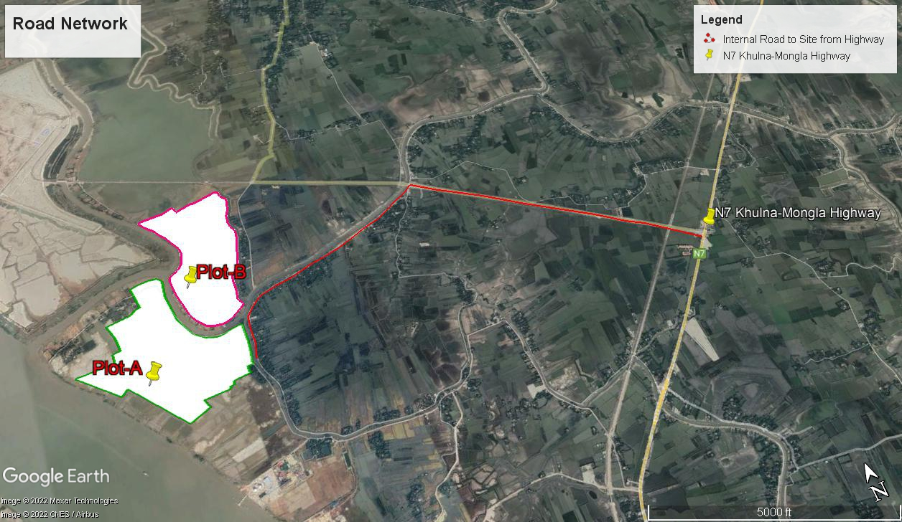
Map 3-1: Road network Map

Project Site Setting
The project site was primarily scrubland with sparse vegetation. The site has mixed topography of terrain. The elevation within project site, ranges from 1.6 m to 2.3 m above MSL.
The project area does not fall within any sensitive receptors viz. wildlife sanctuaries, biosphere reserves, national parks, etc. there are no archaeological and historical monuments in, along or near (10 km) the project site. Structures of religious importance will not be affected by the project. There are natural water bodies within the project boundary and will not be affected by the project activities.

Project Description and Associated Activities

Project Components
The project utilizes Polycrystalline Silicon modules on fixed structures. The modules are fixed type. The type of modules and mounting systems used is as presented in Table 3.1. The plant layout plans are presented in Annex-2(i), Annex-2(ii) and Annex-2(iii).
Table 3-2: Equipment Details of ERBL solar project
Sl. No. | Main Equipment | Details
1 | PV module | Origin: Longi Solar Technology Company Limited, China  Specification: 535, 540, 545 Wp
2 | Mounting type | Fixed
3 | Number of modules | 248136  Plot-A: 145544  Plot-B: 102592
4 | Number of modules per string | 28
5 | Number of SCB | Plot-A: 337  Plot-B: 242
6 | Total number of strings | Plot-A: 5198  Plot-B: 3664
7 | Total number of Inverters | Origin: Sungrow, China  Specification: 3125 kVA  Nos.: 36
8 | Power Transformer | 75MVA, 33kV/132kV * 2Nos
9 | Inverter Transformer | 9.375MVA, 0.6kV/33kV * 12 Nos
10 | MV Switchgear | 33kV,1250A *19Nos
11 | RMU Panel | 33kV,630A * 12Nos
12 | SCADA & ACDB | 12 Nos
13 | SCB | 1500V, 400A * 579 Nos

Associated Facilities and Other Plant Infrastructure
The development of associated facilities such as external transmission line connecting the solar plant to the PGCB Electrical Power Station and internal road was under the scope of ERBL. 4.4 km internal road (4m wide) was constructed for accessing the different part of the solar plant.
The project will include scrap yard to be developed within the project site. The scrap yard will consist of discarded panels and other hardware components such as wood/ steel, oil barrels, wires/ cables and domestic components.
ERBL also constructed a 2.2 km external road (5.4 m wide) along with the boundary of the plant for the Moidhara villagers with an investment of approximately BDT 80 Lac.
A bamboo bridge was constructed to connect Burirdangga union with Rajnagar Union with an investment of BDT 50,000.
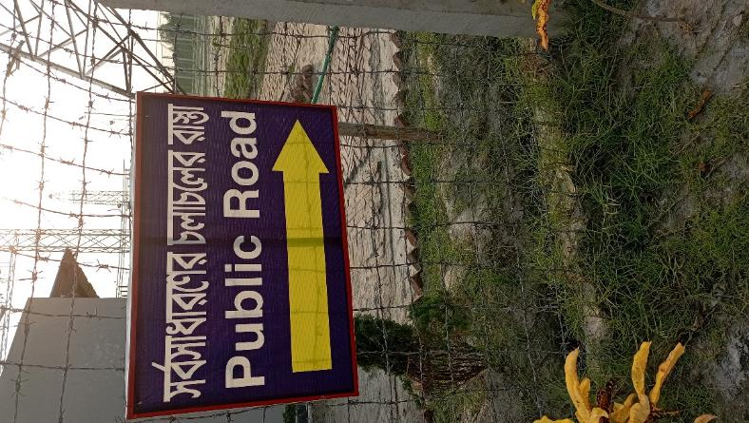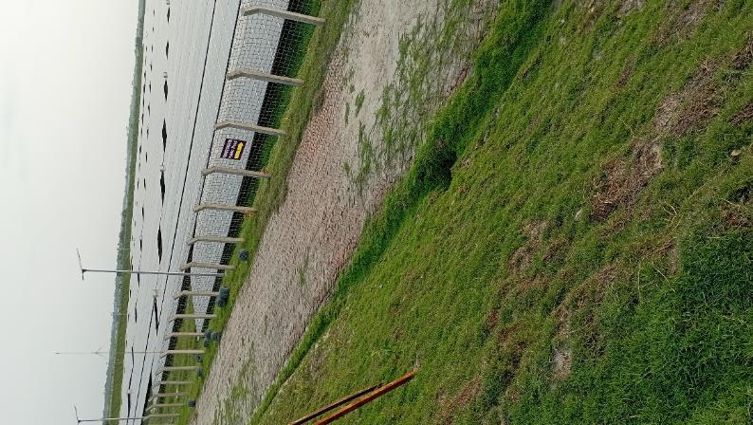
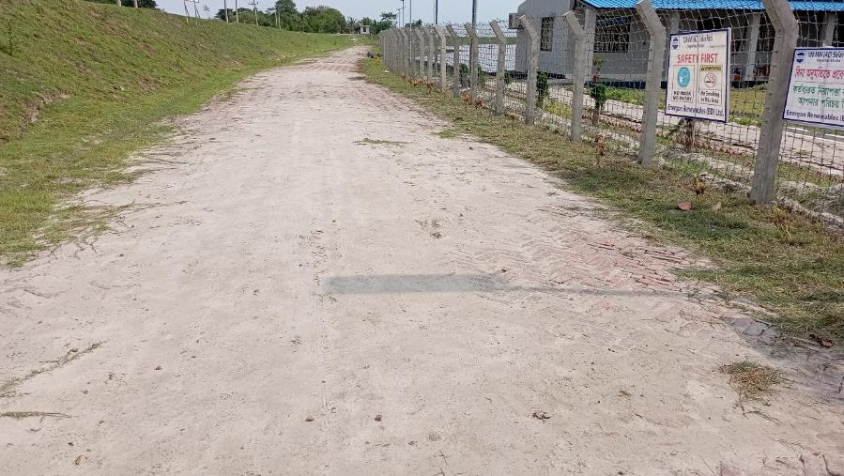
Photo 1:External Road built by ERBL for the Villagers

Power Generation through Solar Module
A PV cell (can be called as a solar cell) is a semiconductor device that converts the sunlight energy into electricity without going through any energy conversion steps. This conversion takes place by photovoltaic effect and hence they are called Photovoltaic (PV) cells. It generates voltage and current at its terminals when sunlight incident on it.
The way and the amount of power generated by a solar cell depend on the sunlight falling on it. This also includes some factors such as intensity of light, angle at which the light falls on it and area of the cell. The more is the power generated, if higher is the light intensity. If the area of the cell is more, the power generated is also more. And the optimum power is generated by it when light falling is perpendicular to the front side of the cell. The solar cells are made with silicon semiconductor material and is treated with phosphorous and boron to make a thin silicon wafer. The wafer layers are then aligned together to make the solar cells, once they are doped. Irrespective of the technology and material used, every solar cell has two terminals (positive and negative terminals) so as to take the electric current from it. Typically, a solar cell consists of front contact at the top, PN junction in the middle and back contact at the bottom. Basically, the sunlight consists of bundles of photons, where each photon has a finite amount of energy. To generate the electricity from a solar cell, these photons must be absorbed by it. The energy of the photon and also the band-gap energy of semiconductor material decide the absorption of a photon. Here is the term Electron-volt (eV) which is the unit of energy that expresses the photon energy and the band-gap energy of a semiconductor material.
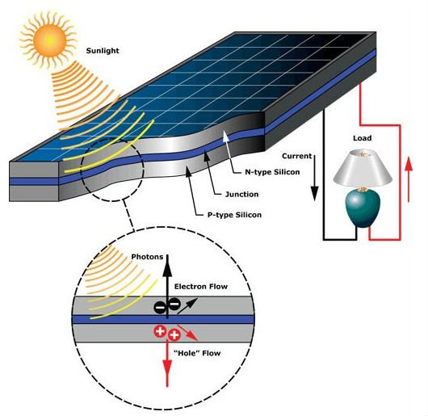
Photo 2: Power Generation Through Solar PV
The semiconductor material of the solar panel absorbs the photons in the sunlight. Due to this, electron-hole pairs are generated at the junction. When the solar cell is connected to the load, electrons and holes at the junction are separated from each other where the electrons are collected at the negative terminal and holes at positive terminal. Thus, the electric potential is built between the terminals and hence the voltage is developed across it. This further drives the current (DC) to the DC loads, inverter, or battery charging circuit. If more photons are absorbed, greater will be the current generated. However, much of the solar radiation fall on the solar cell is not converted into electricity. This is because light is composed of photons of different wavelengths. Some photons hit the solar cell and then reflected and prevented from entering to the cell. In some materials, generated electrons recombine with other molecules before being drawn into current.

Power Transmission Process
Power generated from the project will be evacuated to Mongla PGCB Grid Sub-Station. Before commissioning to Mongla 132/33 kV grid substation, power generated from Solar power plant will be evacuated through 600V/33kV tranformer to Ring Main Unit (RMU). With a 9 km 132 kV transmission line, solar power is transmitted to Mongla Grid substation.

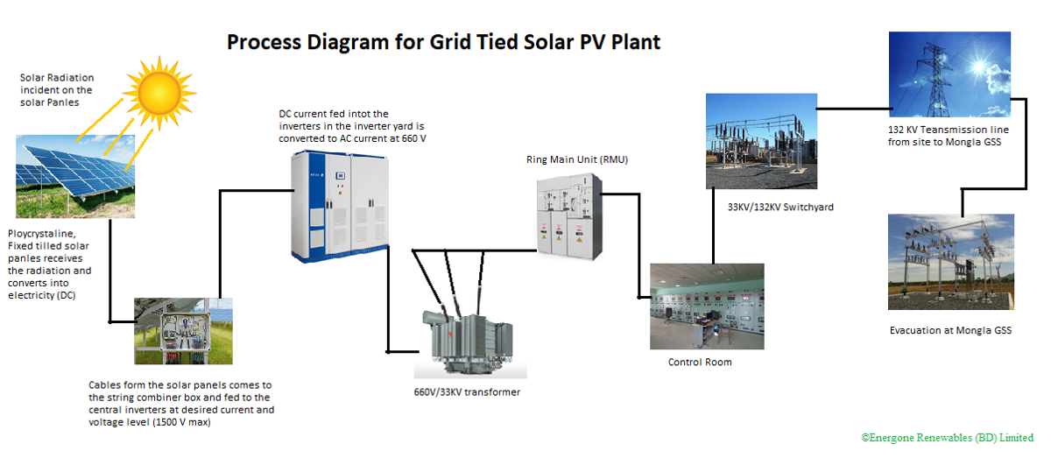
Figure 3-1: Flow Diagram of Transmission Process
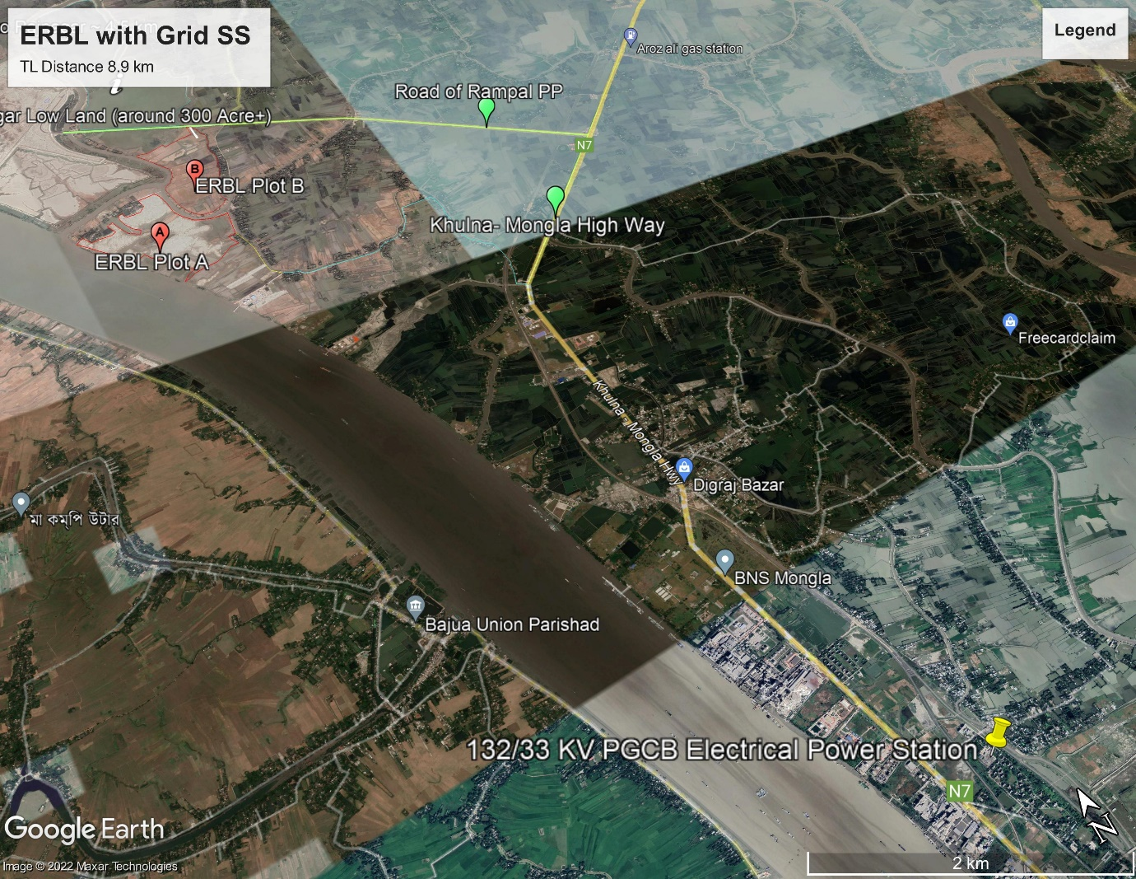
Map 3-2: Mongla PGCB Grid Substation

Resource Requirement

Workforce Requirement
Various contractors were required for the construction period. The engagement of workforce during operation phase would reduce significantly in numbers and would comprise of Engineers, technicians, and housekeeping workers. Refer to the Labor Assessment Report, the current manpower of the solar plant is as follows:
Table 3-3: Current manpower of ERBL in Operation Phase
S. No | Name of Company/ Contractor | No of Permanent Staff |  | No of Contractual Staff |  | Total Staff | Responsibility | Status of Job  (Completed/ ongoing)
S. No | Name of Company/ Contractor | Male | Female | Male | Female | Total Staff | Responsibility | Status of Job  (Completed/ ongoing)
1 | Energon Renewables (BD) Ltd | 51 |  |  |  | 51 | Plant Operation and Maintenance | Continuous Job (Ongoing)
2 | Saatco Cleaning Service ltd |  |  | 20 |  | 20 | House Keeping | Continuous Job (Ongoing)
3 | Land Force Security Service Ltd |  |  | 64 |  | 64 | Security Service | Continuous Job (Ongoing)
4 | Diaggram Security Service ltd |  |  | 32 |  | 32 | Security Service | Continuous Job (Ongoing)
5 | Module Cleaning Team |  |  | 32 |  | 32 | Module Cleaning | Continuous Job (Ongoing)

Water Requirement and Source
Water requirement for Operation phase is mainly for solar module cleaning and domestic purpose. The groundwater is extracted from 1200-1500 ft deep borewells and as the water is saline, it is treated in Water Treatment Plant (RO system) and reserved in 6 reserve tanks each 10,000 Ltr capacity in different locations in the plant. Each RO capacity 1000 L/hour.
Reverse Osmosis (RO) is a water treatment process that removes contaminants from water by using pressure to force water molecules through a semipermeable membrane. During this process, the contaminants are filtered out and flushed away, leaving clean water. The raw water pump is filtered by multimedia filter which removes TSS, Oil and Grease. There is also a carbon filter which removes color, odor etc. Then this water transfer into the RO system In the RO system there are two types of filters, one is micron filter and another is reverse osmosis membrane. By using pressure pump the water flows from RO system to water tank. One interconnecting pipe is connected from the outlet of filtered pump to the inlet of water tank.
Summary of the number of Ros installed with their locations is shown in the below table:
RO System Installed | Location
RO-1 | Admin Building (Plot-A)
RO-2 | near Inverter Station 1(Plot-A)
RO-3 | near Inverter Station 4 (Plot-A)
RO-4 | near Inverter Station 5 (Plot-A)
RO-5 | near Inverter Station 9 (Plot B)
RO-6 | near Inverter Station 11 (Plot B)

Detailed Specification, model, brand etc. and location of RO systems is provided in Annex-4.
Based on the data provided from ERBL, monthly water consumption for domestic purpose (toilet, kitchen cleaning) and solar module cleaning is shown in below bar chart:

Based on the data provided by ERBL, for drinking and cooking purpose, supply water is purchased from vendor on regular basis. Monthly supply water is about 30,000 Liter.

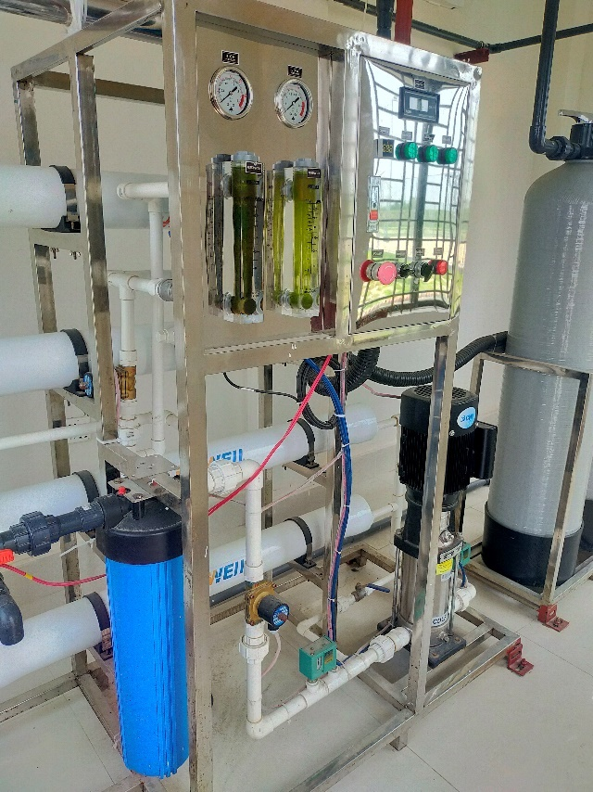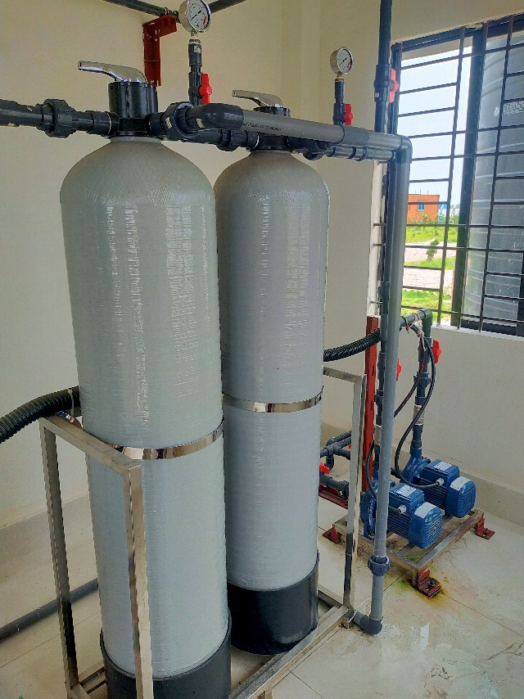
Photo 3: RO System for groundwater treatment
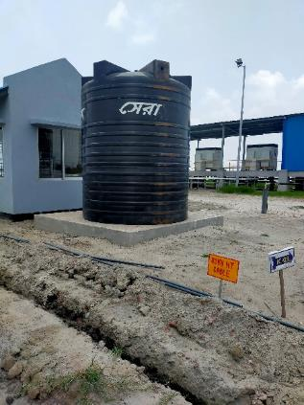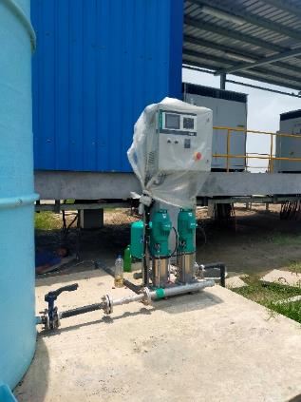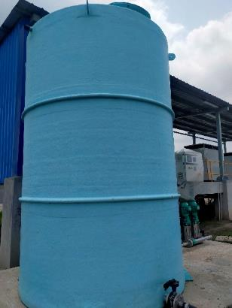
Photo 4: Water Reserve Tanks
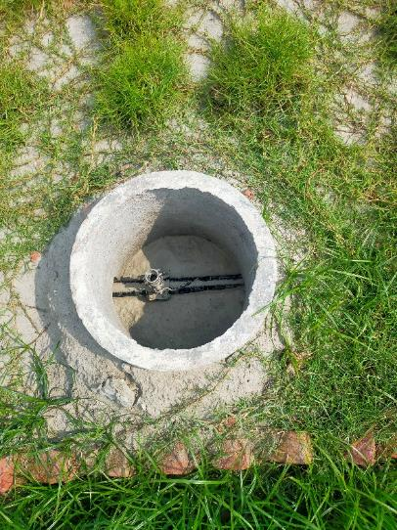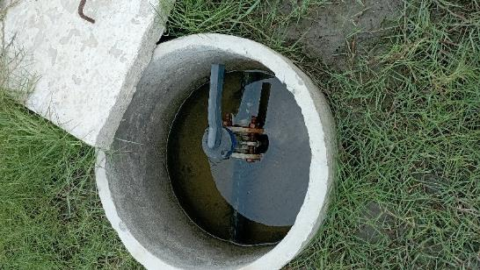
Photo 5: Water Valves for Module Cleaning

Raw Material Requirement
There will not be major requirement of raw materials during the operation phase except for maintenance purpose viz. consumable spares.

Power Requirement
Power requirement during the operation period is met through auxiliary generation and grid. In case of power-cut, 20 kVA UPS is used as backup.
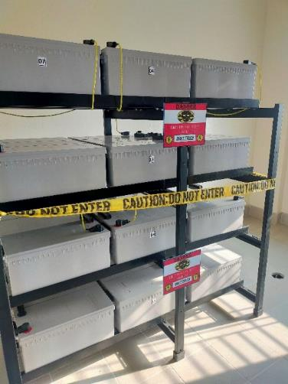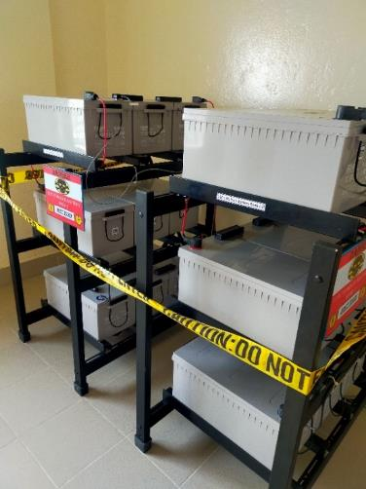
Photo 6: 20 KVA Battery backup
The grid consumption of ERBL is shown in the below bar chart:

Project Cost
The total Project cost has been estimated USD 200.28 Million including finance cost. The investment includes land and site development, machinery cost, PV panel and mounting structures, cost of civil works and erection works. Detailed breakdown of the project cost is shown in Table 3.4. Out of the total investment, ERBL is seeking finance help for 46% of the debt financing USD 69.34 Million from World Bank via Bangladesh Bank IPFF-II.
Table 3-4: Breakdown of project Cost and Debt Financing
Particulars | Cost (USD Million) | % | Cost (USD) | Cost (BDT) | Cost (BDT Crore)
Land & Site Development | 78.01 | 39.0% | 78,012,504 | 6,631,062,798 | 663.11
Imported Machinery Cost | 43.53 | 21.7% | 43,530,000 | 3,700,050,000 | 370.01
PV Panel | 33.430 | 16.7% | 33,430,000 | 2,841,550,000 | 284.16
Module Mounting Structure | 10.10 | 5.0% | 10,100,000 | 858,500,000 | 85.85
EBOP EPC | 14.22 | 7.1% | 14,220,000 | 1,208,700,000 | 120.87
General Civil | 31.85 | 15.9% | 31,850,000 | 2,707,250,000 | 270.73
Installation and Erection Works | 5.20 | 2.6% | 5,200,000 | 442,000,000 | 44.20
Transmission Line | 4.41 | 2.2% | 4,410,000 | 374,850,000 | 37.49
Hard Cost (A) | 177.22 | 88.5% | 177,222,504 | 15,063,912,798 | 1,506.39
Insurance | 0.88 | 0.4% | 880,000 | 74,800,000 | 7.48
Transportation | 1.85 | 0.9% | 1,850,000 | 157,250,000 | 15.73
Project Management Consultancy | 1.58 | 0.8% | 1,580,000 | 134,300,000 | 13.43
Contingencies | 0.23 | 0.1% | 230,000 | 19,550,000 | 1.96
Finance Cost | 18.52 | 9.2% | 18,521,458 | 1,574,323,898 | 157.43
Preliminary Expenses (B) | 23.06 | 11.5% | 23,061,458 | 1,960,223,898 | 196.02
Project Cost (A+B) | 200.28 | 100.0% | 200,283,961 | 17,024,136,697 | 1,702.41

Particular | USD Million | BDT Crore | %
Equity | 50.07 | 425.60 | 25%
Debt | 150.21 | 1276.81 | 75%
Total Financing | 200.28 | 1,702.41 | 100%
Equity Financing | USD Million | BDT Crore | %
Sponsor's Equity | 50.07 | 425.60 | 100%
Total | 50.07 | 425.60 | 100%
Debt Financing | USD Million | BDT Crore | %
IDCOL | 5.56 | 4,826 | 4%
OPEC Fund | 25.00 | 21,700 | 17%
CDC | 50.00 | 43,400 | 33%
IPFF-II (Bangladesh Bank) | 69.34 | 60,188 | 46%
IDCOL Term Loan | 49.34
IDCOL Infrastructure Bond | 20.00
Total | 149.90 | 130,114.42 | 100%

Project Schedule
The project is now in operation phase. After PPA signing in 2019, basic engineering works and procurement of major equipment started. Civil works began in 2020. After testing and commissioning, the commercial operation started in December 2021. Detail work schedule and implementation status is shown below:
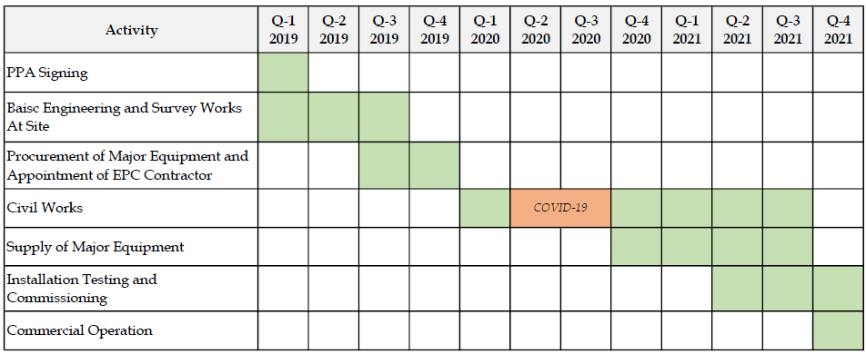
Figure 3-2: Project Schedule

Environmental Policy, Legislative and Institutional Framework

National Environmental Policies and Laws Related to the Sector
The GOB has developed a policy framework that requires environmental issues to be incorporated into economic development planning. The Key tenets of the various applicable national policies are described in Table 4.1.

Renewable Energy Law/ Policy
The Renewable Energy Policy of Bangladesh was approved on December 18, 2008 with the target of developing renewable energy resources. This Policy laid out the target of meeting 5% of total power demand from renewable energy sources by 2015 and 10% by 2020. The policy provides an overall guidance of
- Institutional arrangements
- Resource, technology, and program development
- Investment and fiscal incentives
- Regulatory policy
The objectives of the Renewable Energy Policy of Bangladesh include: to harness the potential of renewable energy resources and dissemination of renewable energy technologies in rural, peri-urban and urban areas; to enable, encourage and facilitate both public and private sector investment in renewable energy projects; and to develop sustainable energy supplies to substitute indigenous non-renewable energy supplies.
The policy promotes the appropriate, efficient and environmentally friendly use of renewable energy. It also suggests that for large biomass electricity projects (i.e., greater than 1 MW) the project developer must demonstrate that the biomass is being sustainably harvested and that no adverse social impact will result from that development. It also restricted the larger scale production and use of biofuels which may jeopardize the existing crops.

Table 4-1: National Legal Instruments relevant to the Project
Act/ Rule/ Law/ Ordinance | Enforcement Agency – Ministry/ Authority | Key Features | Applicability to ERBL Project
The Environment Conservation Act, 1995 and subsequent amendments in 2000 and 2002 | Department of Environment  Ministry of Environment, Forest and Climate Change | - Define Applicability of environmental clearance  - Regulation of development activities from environmental perspective  - Framing applicable limits for emissions and effluents  - Framing of standards for air, water and noise quality  - Formulation of guidelines relating to control and mitigation of environmental pollution, conservation and improvement of environment  - Declaration of Ecologically critical areas | Applicable
Environmental Conservation Rules, 1997 and subsequent amendments in 2002 and 2003 | Department of Environment  Ministry of Environment, Forest and Climate Change | - Declaration of Ecologically critical areas  - Requirement of environmental clearance certificate for various categories of projects  - Requirement of IEE/EIA as per category  - Renewal of the environmental clearance certificate within 30 days after the expiry  - Provides standards for quality of air, water and sound and acceptable limits for emissions/discharges from vehicles and other sources | - Applicable  - Projects falls under Orange B Category and require environmental clearance
Environment Court Act, 2000 and subsequent amendments in 2002 | Ministry of Environment, Forest and Climate Change, and Judiciary | - GOB has given highest priority to environment pollution  - Passed ‘Environment Court Act, 2000 for completing environment related legal proceedings effectively | - Applicable for completing environmental legal requirements effectively
The Vehicle Act, 1927;  The Motor Vehicles Ordinance, 1983; and  The Bengal Motor Vehicle  Rules, 1940 | Bangladesh Road Transport Authority | - Exhaust emissions  - Vehicular air and noise pollution  - Road/traffic safety  - Vehicle Licensing and Registration  - Fitness of Motor Vehicles  - Parking by-laws. | - Applicable for ERBL Project in relation to road transport
Water Supply and Sanitation Act, 1996 | Ministry of Local Government, Rural Development and Cooperatives | - Management and Control of water supply and sanitation in urban areas. | - Not directly applicable, however, indirectly applicable when considering water usage management and sanitation facilities for the project
The Forest Act, 1927 and subsequent amendments in 1982 and 1989 | Ministry of Environment, Forest and Climate Change | - Categorization of forests as reserve, protected and village forests  - Permission is required for use of forest land for any non-forest purposes | - Applicable
Bangladesh Wild Life (Preservation) Act, 1974 | Ministry of Environment, Forest and Climate Change;  Bangladesh Wild Life Advisory Board | - Preservation of Wildlife Sanctuaries, Parks, and Reserves | - Applicable
National Biodiversity Strategy and Action Plan (2004) | Ministry of Environment, Forest and Climate Change  Bangladesh Wild Life Advisory Board | - Conserve, and restore the biodiversity of the country for well-being of the present and future generations  - Maintain and improve environmental stability for ecosystems  - Ensure preservation of the unique biological heritage of the nation for the benefit of the present and future generations  - Guarantee the safe passage and conservation of globally endangered migratory species, especially birds and mammals in the country  - Stop introduction of invasive alien species, genetically modified organisms and living modified organisms | - Applicable for conservation of bio-diversity in the study area
Ozone Depleting Substances (Control) Rules, 2004 | Ministry of Environment, Forest and Climate Change | - Ban on the use of Ozone depleting substances  - Phasing out of Ozone depleting substances | - Applicable
Noise Pollution (Control) Rules 2006 | Ministry of Environment, Forest and Climate Change | - Prevention of Noise pollution  - Standards for noise levels | - Applicable

World Bank Operational Policy OP 4.03
To provide consistent approaches to the private sector investors the World Bank Group developed the Operational Policies (OP) 4.03 which closely parallel procedures followed by the IFC environmental and social specialists during project preparation and supervision. This OP 4.03 depicts the circumstances under which the Performance Standards may be applied, the roles and responsibilities of the Private Entity implementing the project and of the Bank in supporting environmental and social sustainability aspects of the project.
There are eight key Performance Standards against which the impacts of the project would be evaluated to identify the impacts and affected stakeholders to help with the preparation of the management and mitigation plan. They are:
Performance Standard 1: Assessment and Management of Environmental and Social Risks and Impacts;
Performance Standard 2: Labor and Working Conditions;
Performance Standard 3: Resource Efficiency and Pollution Prevention;
Performance Standard 4: Community Health, Safety, and Security;
Performance Standard 5: Land Acquisition and Involuntary resettlement;
Performance Standard 6: Biodiversity Conservation and Sustainable Management of living Natural Resources;
Performance Standard 7: Indigenous Peoples; and
Performance Standard 8: Cultural Heritage.

Project Categorization

World Bank Categorization of Projects
As part of its review of a project’s expected social and environmental impacts, World Bank uses a system of social and environmental categorization. This categorization is used to reflect the size of impacts understood as a result of the client’s social and environmental assessment and to specify WB’s institutional requirements.
The Project Activity is categorized by the Bank as Category A, B, C, depending on the nature of the activity and financing mechanism, as follows:
Table 4-2: World Bank's Categorization for Projects
Category | Justification
Category A | Projects are those whose impacts are sensitive, diverse, and unprecedented, felt beyond the immediate project environment and are potentially irreversible over the long term.
Category B | Projects involve site specific and immediate project environment interactions, do not significantly affect human populations, do not significantly alter natural systems and resources, do not consume much natural resources and have adverse impacts that are not sensitive, diverse, unprecedented and reversible.
Category C | Projects are mostly benign and are likely to have minimal or no adverse environmental impacts.
Category FI | A proposed project is classified as Category FI if it involves investment of Bank funds through a financial intermediary, in subprojects that may result in adverse environmental impacts.
Source: World Bank Environmental and Social Safeguard Policy
World Bank therefore categorizes project primarily according to the significance and nature of impacts. WB defines the project's area of influence as the primary project site(s) and related facilities that the client (including its contractors) develops or controls; associated facilities that are not funded as part of the project (funding may be provided separately by a client or a third party including the government), and whose viability and existence depend exclusively on the project and whose goods or services are essential for the successful operation of a project; areas potentially impacted by cumulative impacts from further planned development of a project; and areas potentially affected by impacts from unplanned but predictable developments caused by the project that may occur later or at a different location. The area of influence does not include potential impacts that would occur without a project or independently of a project.
With reference to the WB’s environmental and social screening criteria, it is anticipated that the Project will fall under Category B for the following reasons:
- Potentially limited risks/impacts and reversible: Environmental and social impacts of the project are anticipated during the construction phase and will encompass changes in land-use, local drainage and water logging, increased noise levels, changes in air quality, use and changes in water quality, impacts on terrestrial ecology, occupational health & safety, etc. Further, there is no physical displacement involved in this project. Thus, most of these impacts are limited to the project sites and their immediate vicinity and can be minimized through application of mitigation measures as proposed in the ESMP.
- Unprecedented: Development of solar power projects is occurring in different parts of Bangladesh. A solar power project can therefore not be considered an unprecedented activity.
- Limited adverse impacts on the baseline: Solar based energy development is a non-polluting source of energy and thus is not likely to lead to any adverse impacts on the baseline environment during the operation phase. In terms of social impacts, the land was purchased and owned by the Orion Group. The project site does not involve any anticipated settlements and physical displacement.

E&S Risk Rating as Per Bangladesh Bank IPFF-II Guidelines
E&S risk rating considers multiple factors that PFIs shall take into account in their risk exposure with regard to E&S issues, including its reputational and contextual risks. The ESPP document for the IPFF-II project provides guidance for sub-project risk rating; which are presented in the table below:
Table 4-3: E&S Ratings of Sub-projects
Category | Description
High risk | Sub-projects that are likely to have significant adverse E&S impacts that are diverse, irreversible, or unprecedented.  Examples of significant impacts can be impacts on critical habitats, impacts on vulnerable groups or ethnic minorities, large-scale involuntary resettlement or economic displacement, or critical cultural heritage.  PFIs will always rate sub-projects that may involve activities on the List of E&S Sensitive Activities as High risk. In should be noted that there may be other high-risk situations beyond those included in this List. Therefore, E&S risk rating will be based on a confluence of various factors in specific sub-project circumstances where sector of operation represents only one of many considerations. Both specific nature of impacts and their scale should be considered.
Medium risk | Sub-projects that are likely to have adverse E&S impacts that are few in number, generally site-specific, largely reversible and readily addressed through mitigation measures and international best practice. Potential adverse environmental and/ or social impacts on communities or environmentally important areas are smaller in scale than those of High-Risk transactions.
Low risk | Sub-projects that do not have the characteristics of High or Medium risk sub-projects are classified as Low risk category and typically involve business activities with minimal or no adverse E&S impacts.  While PFIs would have Low risk rating within their overall ESMS, IPFF II sub-projects may not be rated Low risk.
Source: Bangladesh Bank IPFF-II ESPP Guidelines
The ESIA prepared in line will IPFF-II guidelines indicates the risks to the local environment during pre-construction and construction phase is Medium due to generation of dust and intermittent noise due to the construction machineries used. These impacts are largely reversible and were mitigated. Though the risks in the operation phase is low, the project can be categorized as “medium risk” due to the construction phase.

DoE Categorization
Depending upon location, size and severity of pollution loads, projects/ activities have been classified in the ECR, 1997 into four categories: Green, Orange A, Orange B and Red, respectively, to nil, minor, medium and severe impacts on important environmental components (IECs).
As per SRO No. 349- act/2017 (24 December 2017) issued by the DOE on the categorization to the Environment Conservation Rules 1997, Solar Power Plants (above 1 MW) falls under category “Orange B”. The DOE approved this project under this category.

Triggering of the IFC Performance Standards (PSs) in the Present Project
The triggering of the IFC Performance Standards (PS) in the present project with explanations are given in the Table 4.4 below. The applicable GOB laws, Rules, Policies, and Guidelines are listed alongside the IFC PS. The International Conventions signed by Bangladesh are also included, as once signed these are equivalent to the laws.
Table 4-4: Triggering of the IFC Performance Standards (PS)
Sl. | PS and Title | Triggered | Applicable Bangladesh Laws/Rules and conventions to which Bangladesh is a Party
Sl. | PS and Title | Yes/No
1 | Performance Standard 1:  Assessment and Management of Environmental and Social Risks and Impacts | Yes | - Bangladesh Environmental Conservation Act (ECA95), 1995 and amendments;  - Environment Conservation Rules (ECR), 1997 and amendments;  - National Environmental Policy, 1992;  - National Environmental Management Action Plan, 1995.
Explanations: PS1 is an umbrella Standard as Assessment and Management of Environmental and Social Risks and Impacts are important in all projects with land-based activities (i.e. during construction, operation and decommissioning phases). PS1 is triggered in this project. The issues that may pose potential E&S risks and/or impacts include air emissions and GHG benefits, electronic wastes, ecological impacts and engagement of labor etc. These issues have to be assessed to determine the extent of the risks and impacts.
2 | Performance Standard 2:  Labor and Working Conditions | Yes | - Bangladesh Factories Act (1965);  - Bangladesh Labor Act, 2006;  - Bangladesh labor Rules (2015),  - Bangladesh Children’s Act 2013;  - ILO Conventions 29, 87, 98, 100, 105, 111 and 182.
Explanations: PS2 is triggered in this project; as during all phases of the project, labor force will be needed and mobilized, to carry out various duties to construct and operate the project. It is therefore necessary for the Project to maintain appropriate labor and working conditions.
3 | Performance Standard 3: Resource Efficiency and Pollution Prevention | Yes | - Bangladesh Environmental Conservation Act (ECA), 1995  - Environment Conservation Rules (ECR), 1997 (subsequent amendments in 2002 & 2003)
Explanations: PS3 is triggered in this project; as it will involve use of a lot of resources both raw, semi-manufactured, manufactured components and energy. Thus, pollutants will be produced and these need to be minimized to comply with standards; resources and energy conservation are also prime needs.
Construction works are likely to generate wastes during the construction phase hence PS3 is triggered.
4 | Performance Standard 4: Community Health, Safety, and Security | No | - Bangladesh Environmental Conservation Act (ECA), 1995  - Environment Conservation Rules (ECR), 1997 (subsequent amendments in 2002 & 2003)
Explanations: PS4 is not triggered in the project as there is no adverse effect in terms of water, air and noise on the local community.
5 | Performance Standard 5:  Land Acquisition and Involuntary Resettlement | No | Acquisition and Requisition Ordinance, 1982.
Explanations: PS5 will not be triggered in the project. Land has been purchased outright from landlords on voluntarily basis and no resettlement was required. This Performance Standard does not apply to resettlement resulting from voluntary land transactions (i.e., market transactions in which the seller is not obliged to sell and the buyer cannot resort to expropriation or other compulsory procedures sanctioned by the legal system of the host country if negotiations fail).
6 | Performance Standard 6: Biodiversity Conservation and Sustainable Management of Living Natural Resources | No | - Bangladesh Environmental Conservation Act (ECA), 1995  - Environment Conservation Rules (ECR), 1997 (subsequent amendments in 2002 & 2003)
Explanations: PS6 is not triggered as the project does not involve in any adverse impact on biodiversity.
7 | Performance Standard 7: Indigenous Peoples | No | Chittagong Hill Tracts Regional Council Act, 1998.
Explanations: PS7 is not triggered in the project. There are no indigenous people living in the impact zone of the project.
8 | Performance Standard 8:  Cultural Heritage | No | Antiquities Act, 1968; Convention Concerning the Protection of the World Cultural and Natural Heritage, Paris, 1972 (World Heritage Convention) (Ratified 1983).
Explanations: PS8 is not triggered in the project. Based on current knowledge, there are no known cultural heritage installations (10 km) in the project impact area. Existing communities in the area do not have significant intangible heritage also.

Salient E&S Features of Agreement Between BPDB and ERBL
- The construction and operations of the Project must comply with the applicable standards and guidelines of World Bank/IFC or Department of Environment (DoE), Bangladesh.
- Site environmental clearance from DoE shall have to be obtained by the Company.
- The noise level shall be as per Standard of Department of Environment (DoE), Bangladesh.
- Emissions for PV based Grid Tied Solar Plant shall be as per the requirement of Department of Environment (DoE).
- The Company shall be responsible for mitigating environmental impact (if any) as per requirement of DoE.

Approach and Methodology

General Approach and Scoping
The ESIA study focuses on developing the environmental profile of the project area to assess existing (baseline) conditions on the physical and biological environment, and the social environment along with anticipated environmental impacts and proposed mitigation measures. The detailed evaluation of the social and biological environment of the area was carried out through a field study and the area of influence of the environmental impacts is considered to be 5 km.
The main purpose of ESIA study is to ensure that:
- Any major adverse impact on the environment (physical, ecological and social) during different phases of projects viz. siting, design, construction and operation are identified.
- Adverse impacts are appropriately addressed and adequate mitigation measures are incorporated in the siting, design, construction and operation phases of project.
- Socioeconomic aspects are identified, and mitigation measures have been identified.
- Alternatives to achieve the objectives are analyzed.
- Environmental and Social Management Plan (ESMP) for sustainable development and operation of the project is developed for implementation and monitoring of the project activities.
The present ESIA report has identified significant environmental and social aspects and evaluated the potential aspects to ensure that the likely impacts due to the proposed activities during the construction, the installation of Solar PV and the operation of the proposed project, and the residual impact on the adoption of mitigation measures have been critically evaluated with respect to compliance with the Environmental Conservation Rules 1997 and the World Bank Performance Standards.

Methodology
The ESIA has been undertaken following a systematic process that predicts and evaluates the impacts the project could have on aspects of the physical, biological, socio-economic and cultural environment, and identifies measures that the project will take to avoid, minimize/ reduce, mitigate, offset or compensate for adverse impacts; and to enhance positive impacts where practicable. The stages of the ESIA process are described below:
Project Data Compilation: A generic description of the project activities relevant to environmental assessment was compiled with the help of primary and secondary data collection through literature, EHS guidelines, national and international standards and in field studies and environmental tests. A list of possible environmental and social problems was developed. An analysis of the interested parties was carried out for the subsequent consultation.
Published Literature Review: Secondary data on weather, soil, water resources, wildlife, and vegetation were collected from internet, published literature and books. The data was then reviewed and compiled.
Legislative Review: Information on relevant legislation, regulations, guidelines, and standards was reviewed and compiled.
Identification of Potential Impacts: The information collected in the previous steps was reviewed and potential environmental and social issues identified.
Baseline Data Collection:
Primary data: To collect primary data, a field visit was conducted to verify and collect primary data about site alternatives. A questionnaire was developed and views of the local inhabitants were taken on the Solar Energy Project. It also includes social surveys, including social and biological surveys, and laboratory tests carried out by the third party in order to analyze the environmental parameters in order to quantify whether they comply with the national and international standards.
Secondary data: Reasonable data was available for reference information on the Project area from some alternative resources that include existing literature, online help, existing available information, field surveys and associated departments.
Impact Assessment: The environmental, socioeconomic and project information collected was used to evaluate the potential impacts of the proposed activities. The subjects studied included possible impacts of the project on:
- Geomorphology
- Groundwater and surface water quality
- Ambient air quality and ambient noise levels
- Ecology of area, including flora and fauna
- Local communities
- Noise impact
- Visual Impact
- Shadow Impact
Wherever possible and applicable, the discussion covers the following aspects:
- The present baseline conditions
- The potential change in environmental parameters likely to be affected by project related activities
- The identification of potential impacts
- The evaluation of the likelihood and significance of potential impacts
- The definition of mitigation measures to reduce impacts to as low as practicable
- The prediction of any residual impacts, including all long-term and short-term; direct and indirect; beneficial and adverse impacts
- The monitoring of residual impacts
- An Environment and Social Management Plan (ESMP) for the mitigation measures identified during the project
List of studies and work steams required in compliance with the applicable laws, regulations and IFC PSs are given in the table 5.1 below. Larger studies are included in annexes and others are integrated in the chapters.
Table 5-1: List of studies and work streams
Study Topics | Application IFC PS, ESHG or other national/ international guidelines | Reference  Chapter/ Annex
Project Justification and Purpose, Project Location, Project Description and Associated Activities | PS1: Assessment and Management of Environmental and Social Risks and Impacts | Chapter 3  Annex-1  Annex-2  Annex-3
Environmental Policy, Legislative and Institutional Framework | PS1: Assessment and Management of Environmental and Social Risks and Impacts | Chapter 4
Project Categorization | World Bank Environmental and Social Safeguard Policy;  Bangladesh Bank IPFF-II ESPP Guidelines;  Environment Conservation Rules 1997 | Chapter 4.4
Triggering of IFC Performance Standards | PS1-8 | Chapter 4.5
Environmental and Social Baseline Study | PS1: Assessment and Management of Environmental and Social Risks and Impacts  PS6: Biodiversity Conservation and Sustainable Management of Living Natural Resources | Chapter 6  Annex-5  Annex-6  Annex-7  Annex-10.1  Annex-10.2
Analysis of Alternatives |  | Chapter 7
Stakeholder Consultation, KII, FGD and public consultation | PS1: Assessment and Management of Environmental and Social Risks and Impacts  PS4: Community Health, Safety, and Security | Chapter 8  Annex-8
Grievance Redress Mechanism | PS4: Community Health, Safety, and Security | Chapter 9  Annex-9
Risk Analysis and Identification | PS1: Assessment and Management of Environmental and Social Risks and Impacts | Chapter 10
Impact Identification And Evaluation | PS1: Assessment and Management of Environmental and Social Risks and Impacts | Chapter 11
Mitigation Measures | PS1: Assessment and Management of Environmental and Social Risks and Impacts | Chapter 11
Environmental And Social Management Program (ESMP) | PS1: Assessment and Management of Environmental and Social Risks and Impacts  PS2: Labor and Working Conditions to be done  PS3: Resource Efficiency and Pollution Prevention | Chapter 12
Monitoring, Evaluation and Reporting |  | Chapter 13
Labor Assessment | PS2: Labor and Working Conditions | Chapter 13.5  Annex-12  Annex-13
Environmental and Social Audit | PS1: Assessment and Management of Environmental and Social Risks and Impacts | Chapter 13.6  Annex-14
Environmental and Social Action Plan (ESAP) | PS1: Assessment and Management of Environmental and Social Risks and Impacts | Chapter 13.7  Annex-15

Assumptions, uncertainties, and Constraints
Energon Renewables (BD) Ltd engaged BCAS for Conducting the ESIA on March 2022. The assignment was completed with desk-based assessment with the data shared, site visits, telephone/ email conversation with the related persons.
In evaluating subject site, consultant relies in good faith on information provided by client’s management or employees. The Consultant assume that the information provided is factual, accurate and accepts no responsibility for any deficiency, misstatement or inaccuracies contained in this report as a result of omission or misrepresentation of any person interviewed or contacted. However, the consultant notifies the contradictions and errors in the data, where it seems appropriate. It should be recognized that the information given in the report is time specific and with the passage of time the relevancy of data and analysis may suffer. Specific circumstances and condition of site can change due to which conclusion and opinions may also change.
As the construction period is over and the plant has been in operation, all the risks identified, impacts and mitigation measures are reported based on Operation phase.
More time was required to carry out a more detailed Social Impact Assessment (SIA) of the relevant stakeholders. The ESIA has been prepared with an emphasis to cover all important environmental impacts and formulate pragmatic recommendations for mitigating any adverse environmental impacts.
BCAS is not responsible for implementation of any aspect of ESMP or in disclosure process, post approval of ESIA report.
No translation work has been scoped in under this assignment. All the documents are developed and shared in English language only.

Environmental and Social Baseline Study
This section presents environment, ecological and socio-economic baseline of the study area for the 100 MW solar power project in Bagerhat district, in order to provide a context within which the impacts of the 100 MW solar power project are to be assessed. To characterize baseline environmental and socioeconomic conditions, information was acquired through desk studies and was supplemented with field surveys and observations.
Baseline refers to the physical, biological, cultural and human conditions that will prevail in the absence of the project, including interactions amongst them. Establishing baseline helps in understanding the prevailing environmental, ecological and socio-economic status of the study area. It provides requisite information of the biophysical and social environment for decision makers to take appropriate measures regarding the project.
Establishing baseline provides the background environmental and social conditions for prediction of the future environmental characteristics of the area before setting up of the project. It also helps in environmental and social management planning and provides a basis to finalize a strategy for minimizing any potential impact due on surrounding environment due to setting up of the project.

Environmental Baseline Conditions

Land Use
The total study area was considered at 5 km radius of the solar power project. The gross study area is about 7867 hectares. 35% of the area is used for vegetation, 24% area is sand bar, 20% is agricultural land, 15% is River area and 5% of the area is used for settlement. Detail land use of the study area is presented in following table and the map is shown in Annex-2(A) and Annex-2(B).
Table 6-1: Land Use of Both Project and Study Area
Land Use | Study Area
Land Use | Area (Ha) | Percentage (%)
River | 1185.32 | 15
Settlement | 412.55 | 5
Agricultural land | 1593.24 | 20
Vegetation | 2781.63 | 36
Sand bar | 1894.06 | 24
Total | 7866.80 | 100
*1Ha= 2.47 Acres

Topography
The project area is located in the southwest region of Bangladesh, which is part of the alluvial delta formed by the main rivers originating in the Himalayas to the north. The landscape of the project site is characterized by plain coastal lands with a very gentle slope and tidal streams. Intensive culture of shrimp, mangrove scattered along rivers and canals, family forest, roadside planting are common features of the landscape. The action of the tides is predominant in the rivers Passur and Maidara-Ichamoti.
The general landscape of the study area as well as the project area is a flat topography with low marsh areas, intertidal canals, intensive shrimp farming areas, rural areas, plantations and mangroves scattered along the coast of the river and intertidal channels. The entire agricultural area (including the shrimp pond) is protected from tidal flooding by the raising of the river level by shrimp farmers. The study area is characterized by numerous tidal creeks of the Maidara-Ichamoti system. Similar tidal streams also exist at the project site that are occupied by shrimp farming activities and the tidal flow in the streams is controlled by the local population by building indigenous water control structures (wooden structure).

Geology
Physio-graphically, the area consists of the tidal delta with a dominant tidal current and a shallow aquifer enriched with saline. The area is located in the Bengal Basin - a vast alluvial plain of Quaternary sediments established by the Ganges-Brahmaputra-Meghna River system.
Stratigraphically, the area is covered by a paludal deposit composed of alluvial deposits, meanders, meanders and Holocene swamps (Mentioned in following map) with a sequence of quaternary sediments 16,000 m thick (Alam et al., 1990 and USGS-Bangladesh Gas Assessment Team, 2001).
According to the tectonic classification, the area lies beneath the Faridpur pit on the west flank of the platform which is adjacent to the hinge line (Mentioned in following map). Tectonically, this zone is inactive and no apparent major structure such as fault or fold exists in the region. (Sir William Halcrow and Partners Ltd., 1993).
Lithology shows that the area includes clay in the upper part and sand in the depth. The upper surface layer is composed of clay, the intermediate layer of mainly fine sand and the deeper layer contains mainly fine to coarser sand.
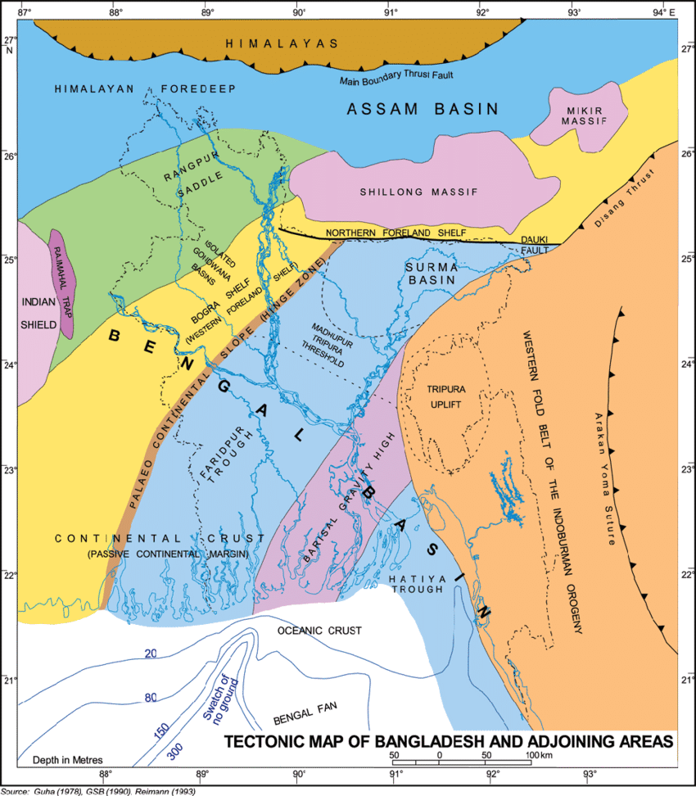
Figure 6-1: Tectonic Map of Bangladesh
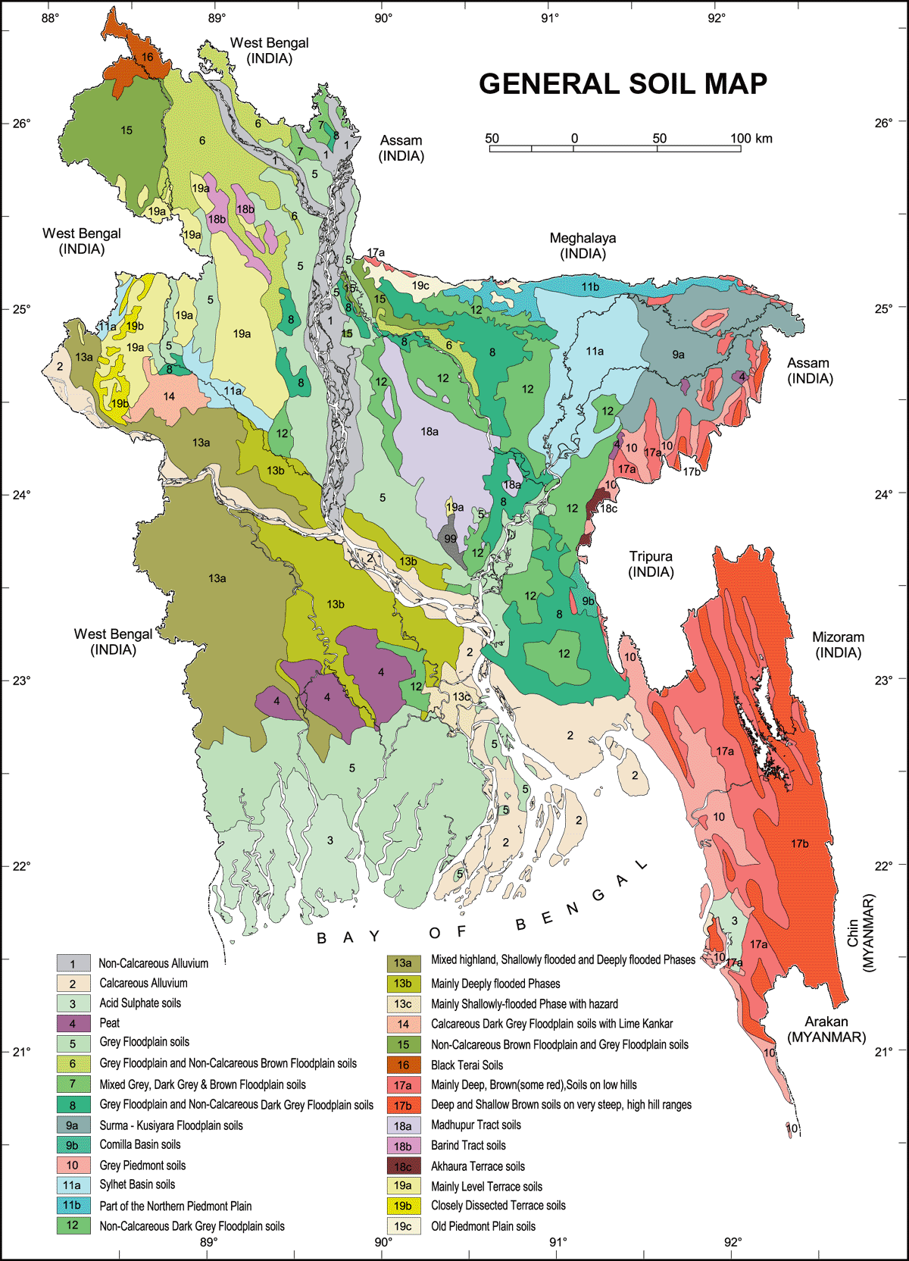
Figure 6-2: General Soil Map of Bangladesh

Hydrology and Drainage
The solar power plant site is located along the Passur River at Biddarbon & Borodurgapur Mauza, Rampal & Mongla Upazila, Bagerhat District, approximately 67 km from Akram Point.
The river flowing along the project site is a combination of upstream stream flows and tidal movements. The flow of the Passur River is dominated by the rivers Atai and Bhairab. The rainy season brings additional Ganga water through Gorai-Nabaganga-Atai into the system, adding slightly the speed of the ebb tide. According to the recent study (IWM, 2004), the volume of freshwater crossing the Passur River has been reduced over the last 38 years due to upstream diversions of rivers, including the Farakka Dam, the polders and increased sediment.
The drainage map of the plant is shown in Annex-2(iv).

Water Resources
Surface Water
There are two river systems around the project site, the Passur River and the Maidara-Ichamoti River. The Maidara-Ichamoti River system serves as a watercourse and extends outside the project area, supporting mangrove vegetation along the banks. The river is a favorite fishing spot for a large number of fishermen where there are several behundi nets.
The Passur River is the main river in the study area as an extension of the Rupsha River. South of Khulna, the Bhairab or Rupsha flows farther south and is renamed Passur near Chalna and falls into the Bay of Bengal flowing to the right of Trikona and Dubla while the Mongla River flows through the Sundarbans. The maximum flow of the Gorai-Madhumati passes in this river through the Nabanganga. The Mongla Canal joins the river about 32 km south of Chalna. Flowing further south, the river meets the Sibsha about 32 km north of its mouth and leads into the sea keeping its original name Passur.
In the study area, a large dighi (artificial lake) - Kalekarber Boro dighi - was found, considered "sacred" by the local population. The dighi contains a lot of water lilies for biofiltration and dighi water is used for consumption purposes. The Dighi embankment supports many species of timber, and other species of common property tree found as koroi, etc. A large number of Arjun trees have also been observed along the pond and not seen anywhere else. Freshwater ponds are rare and are mainly concentrated on the east side of the study area.
Water Quality
Surface and Groundwater samples have been collected from the nearest water body and tube wells of the nearby community of the study area respectively to understand the surface and groundwater quality. There are one surface water and groundwater samples were collected from SW1 & GW1 locations (see Table 6.2 and Annex-2(L) for map). The tube well mouth was washed by pumping up of a certain volume of ground water and the contamination would be prevented before the sampling time. After conducting some onsite water quality tests (e.g. temperature, pH, etc.), water samples were carried at the laboratory to conduct the remaining water quality test.

Table 6-2: Water Quality Monitoring Points
Serial No. | Description | Latitude | Longitude
SW1 | Surface Water | 22°34'39.03"N | 89°34'0.86"E
GW1 | Ground Water | 22°34'35.08"N | 89°34'29.32"E

Table 6-3: Surface Water Quality Monitoring Results
Sl No. | Surface Water Test Parameter | Concentration of Surface Water | Unit | ECR 1997 (Schedule-3) Standards for Drinking Water | Methods of Analysis
1 | pH | 7.53 | - | 6.5-8.5 | pH meter
2 | Temperature | 27.8 | $$℃$$ | 40 | Thermometer
3 | DO | 4.23 | mg/L | 6 | DO meter
4 | COD | 18 | mg/L | 200 | Titrimetric
5 | BOD | 6.8 | mg/L | 50 | 5 Day Incubation
6 | Salinity | 9.6 | ppt | - | Multi-meter
7 | Nitrate | 7 | mg/L | 10 | UVS
8 | Total Phosphorus | 4 | mg/L | 8 | UVS
9 | TSS | 109 | mg/L | 150 | Gravimetric Method
10 | Arsenic | 0.02 | mg/L | 0.2 | AAS
11 | Iron | 0.26 | mg/L | 2 | AAS
12 | Lead | 0.01 | mg/L | 0.1 | AAS
Source: Environmental Monitoring Report, Envirocare International Ltd (Sampling Date: 24th to 26th April 2022) (please refer to Annex-10.1)
Table 6-4: Groundwater Quality Monitoring Results
Sl No. | Ground Water Test Parameter | Concentration of Ground Water | Unit | ECR 1997 (Schedule-3) Standards for Drinking Water | Methods of Analysis
1 | pH | 7.2 | - | 6.5-8.5 | pH meter
2 | TDS | 953 | mg/L | 1000 | Multi-meter
3 | Temperature | 28.6 | $$℃$$ | 40 | Thermometer
4 | Turbidity | 8 | NTU | 10 | Turbidity meter
5 | Chloride | 410 | mg/L | 150-600 | Titrimetric
6 | Fluoride | 0.3 | mg/L | 1 | Titrimetric
7 | Hardness | 163 | mg/L | 200-500 | Titrimetric
8 | Manganese | 0.01 | mg/L | 0.1 | AAS
9 | Arsenic | 0.001 | mg/L | 0.05 | AAS
10 | Iron | 0.24 | mg/L | 0.3-1 | AAS
11 | Total Coliform | 2 | N/100 ml | 0 | MFM
12 | Fecal Coliform | 0 | N/100 ml | 0 | MFM
Source: Environmental Monitoring Report, Envirocare International Ltd (Sampling Date: 24th to 26th April 2022) (please refer to Annex-10.1)
The test result shows that all the tested parameters are found within the national standard (ECR 1997) set by government of Bangladesh except total coliform for ground water sample. It is observed that the tube well areas were found quite uncleaned which might cause of total coliform however fecal coliform is found zero.

Ambient Air Quality
The objective of the ambient air quality monitoring during the ESIA study for a solar project is to record the baseline ambient air quality in the area prior to project and identify current sources of air pollution.
Ambient air quality monitoring was carried out during 24th to 26th April 2022. Ambient concentrations of major air pollutants viz. particulate matters (PM10 and PM2.5), Sulphur dioxide (SO2), nitrogen oxides (NOx), Carbon monoxide (CO), Lead (Pb) and Ozone (O3) were monitored at four locations (see Table 6-5 and Annex-2(M) for map) on 24 hourly basis.
Table 6-5: Air Quality Monitoring Points
Sl. No. | Description | Latitude | Longitude
AQ1 | North side of Energon Renewable (BD) Ltd. | 22°34'59.17"N | 89°34'17.31"E
AQ2 | West side of Energon Renewable (BD) Ltd. | 22°34'34.47"N | 89°34'11.08"E
AQ3 | South side of Energon Renewable (BD) Ltd. | 22°33'57.50"N | 89°34'19.97"E
AQ4 | East side of Energon Renewable (BD) Ltd. | 22°34'37.30"N | 89°34'37.36"E

Table 6-6: Ambient Air Quality Monitoring Results
Sl. No | Sample locations | Concentration present different parameters in ambient air average result (µg/m3)
Sl. No | Sample locations | PM2.5 | PM10 | SO2 | NOx | CO | Pb | O3
1 | AQ1 (72 hrs) | 33 | 75 | 3 | 5 | 406 | 0.0 | 7.5
2 | AQ2 (72 hrs) | 36 | 70 | 3 | 5 | 409 | 0.001 | 2.4
3 | AQ3 (72 hrs) | 28 | 54 | 3 | 4 | 413 | 0.001 | 5.2
4 | AQ4 (72 hrs) | 39 | 64 | 3 | 3 | 424 | 0.0 | 3.7
Test Durations (Hrs) |  | 24 | 24 | 8 | 8 | 24 | 24 | 8
Method of Analysis |  | Gravimetric | Gravimetric | West-Gaeke | Jacob & Hochheiser | Electro-Chemical Sensor | AAS | Spectro-photometric method
Bangladesh Govt. Standard (ECR 1997, schedule-2 Amendment 2005) |  | 65 | 150 | 365 | NYS | 10,000 | 0.5 | 157
IFC/WB Standard |  | 45 (24 hr) | 150 (24 hr) | 125 (24 hr) | 200 (1hr) | 7000 (24 hr) | - | 160
Source: Environmental Monitoring Report, Envirocare International Ltd (Sampling Date: 24th to 26th April 2022) (please refer to Annex-10.1)

To conclude, Ambient air quality of the area has been analyzed for the concentration of parameters CO, CO2, SO2, NOX, Pb, O3, and Particulate Matter (PM10, PM2.5) of different sizes within the range of .2μm~1 μm. From the analysis it has been observed that in all locations the value of CO, CO2, SO2, NOX, Pb, O3, and SPM, PM10, PM2.5 are within the permissible limit of National standard (ECR 1997).

Ambient Noise Quality
The noise levels were measured with the help of a portable precision digital sound level meter (Model-Sl-4033 SD, made in Taiwan). The instrument calibration was achieved using manufacturer supplied pistaphone calibrator capable of producing known sound pressure level. Sampling was done to measure the Sound Level for day time and night time of the project area.
Table 6-7: Instrument Specification for measuring Ambient Noise level
Specification:  SD Card real time data recorder SOUND LEVEL METER, class 1  Model : SL-4033SD  Real time data logger, save the data into the SD memory card and can be downloaded to the Excel  Extra software is no need.  Frequency and time weighting meet IEC61672 class 1. | Auto range: 30 to 130 dB.  Manual range: 3 ranges 30 to 80 dB, 50 to 100 dB, 80 to 130 dB.  A/C frequency weighting.  Fast/slow time weighting  Peak hold, Data hold.  Record (Max., Min.).  RS232/USB computer interface.  Optional wind shield ball, SB-01. Patented.

Ambient noise levels within the project area were monitored at eight locations (see Table 6-8 and Annex-2(N) for map) for 24 hours. Details regarding the samples collected and the results obtained have been presented in the following tables:
Table 6-8: Ambient Noise Level Monitoring Points
Serial No. | Description | Latitude | Longitude
NL1 | North side of Energon Renewable (BD) Ltd | 22°34'58.94"N | 22°34'58.94"N
NL2 | West side of Energon Renewable (BD) Ltd | 22°34'32.12"N | 89°34'11.13"E
NL3 | South side of Energon Renewable (BD) Ltd | 22°33'57.59"N | 22°33'57.59"N
NL4 | East side of Energon Renewable (BD) Ltd | 22°34'35.33"N | 22°34'35.33"N
NL5 | Residential Area | 22°34'13.95"N | 22°34'13.95"N
NL6 | Local Bazar | 22°34'24.24"N | 22°34'24.24"N
NL7 | Near an industrial LPG production Unit | 22°33'48.95"N | 22°33'48.95"N
NL8 | Governmental School (Kalrabunia) | 22°33'36.73"N | 22°33'36.73"N

Table 6-9: Ambient Noise Level Monitoring Results
Location | Noise level, dB(A) |  |  |  |  |  | ECR 1997 |  | Zone
Location | Leq (Day) | Lmax | Lmin | Leq (Night) | Lmax | Lmin | Day | Night | Zone
NL1 | 53.8 | 69.4 | 41.8 | 43.6 | 59.4 | 35.8 | 55 | 45 | Residential Area
NL2 | 49.7 | 69.7 | 39.5 | 42.9 | 58.3 | 34.2 | 55 | 45 | Residential Area
NL3 | 57.5 | 67.4 | 42.4 | 45.4 | 61.7 | 38.7 | 60 | 50 | Industrial Zone
NL4 | 52.6 | 64.8 | 38.6 | 44.5 | 54.8 | 36.7 | 55 | 45 | Residential Area
NL5 | 56.3 | 63.67 | 41.6 | 41.7 | 58.4 | 36.7 | 55 | 45 | Residential Area
NL6 | 73.7 | 86.3 | 43.7 | 57.6 | 74.6 | 35.8 | 70 | 60 | Commercial Area
NL7 | 56.6 | 72.4 | 35.4 | 42.3 | 53.3 | 38.4 | 70 | 65 | Industrial Area
NL8 | 50.0 | 75.5 | 45.3 | 38.5 | 45.2 | 31.7 | 50 | 40 | Silent Zone
Source: Environmental Monitoring Report, Envirocare International Ltd (Sampling Date: 24th to 26th April 2022) (please refer to Annex-10.1)
Standard:
Bangladesh Standard | Day Time | Night Time | WB/ IFC Standard | Day Time | Night Time
Industrial Area | 75 | 70 | Industrial Area | 70 | 70
Commercial | 70 | 60 | Residential; Institutional; Educational | 50 | 45
Mixed Area | 60 | 50 | Residential; Institutional; Educational | 50 | 45
Residential Area | 55 | 45 | Residential; Institutional; Educational | 50 | 45
Silent Area | 50 | 40

Eight sample points from the selected area from the project site have been identified to check the noise inspection for environmental monitoring. It is observed that most of the sample points were meet the noise level standard (ECR 1997) except NL3, NL5 and NL6 in day time and NL3 at night time. During sample collection it is found that NL3 is near the industrial area and NL6 is in commercial area that’s why sound is comparatively high and exceeds the standard. On the other hand, NL5 in in residential area where in sample collection time there was a program running on that’s why this point also exceeds the standard.

Soil Type
The study area comprises of the Ganges Tidal Floodplain, which has 2 (two) sub-regions: A) Non-saline, and B) Saline. The first sub-region occupies a major part of the study area, but the second one occurs in minor areas.
Non-Saline: This sub-region occupies the Northeastern part of the study area where grey or dark grey, calcareous, silt loams to silty clays occupy river banks and basin margins and grey to dark grey, non-calcareous, heavy silty clays occupy basin centers. Some basin soils overlie a peaty layer within 1 meter. These soils are mainly non-saline. Most of the soils are shallowly flooded during high tide, except where embanked. Some basin centers are more deeply flooded and stay wet for most or the entire dry season.
Saline: The soil of this sub-region is mainly saline in the dry season. Calcareous silt loams to silty clays occupy riverbanks and basin margins, and non-calcareous silty clays occupy river basin centers. The proportion of calcareous soils and the proportion of soils with peaty substratum are higher than the former sub-region. Tidal flooding is mainly shallow (outside of the embanked areas), but some basin centers are more deeply flooded and stay wet round the year.

Traffic Movement
The plant construction and operation will require movement of goods and people. Therefore, it is required to have information about present traffic scenario in the locality. The major machineries and materials for the project was brought by riverway. The existing road communication system is very poor. Most of the internal rural roads are quite narrow.
Passur River is the main water communication system in the proposed project area. There are two ports in the study area. These are the port of Mongla as a seaport and the port of Chalna as a river port. The depth range of the Passur River is now 8 to 11 meters during high tide. The river is very deep and navigable throughout the year and large marine vessels can easily enter the port of Mongla from the point of Akram.

Forests and Protected Areas
There is no designated ecological sensitive area like National Park, Wildlife Sanctuary in 10 km radius area of the solar power project site. There is no natural forest in the 5.0 km radius area of the solar power project site. Homestead plantation, block plantation and road side plantation was observed during site visit.
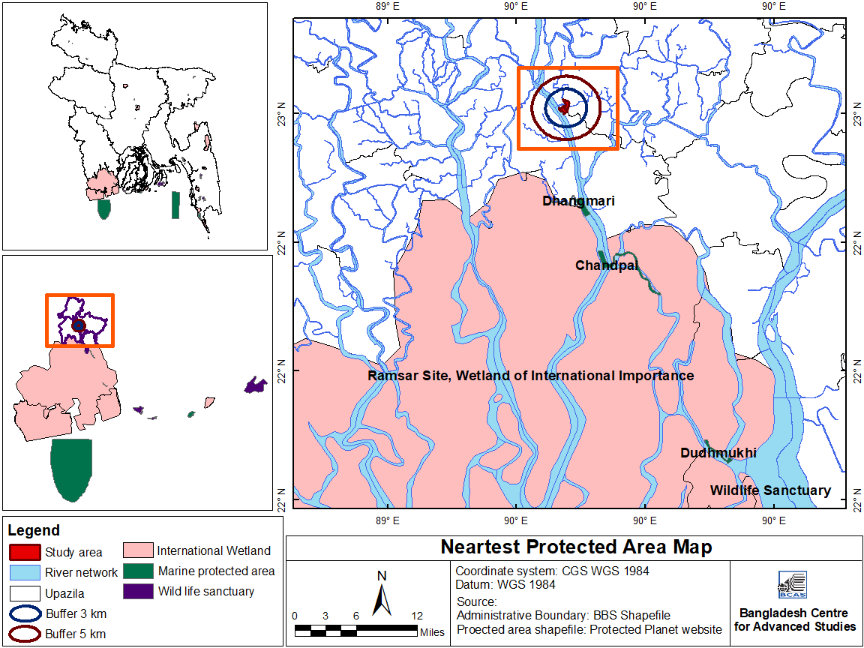
Map 6-1: Map of Nearest Protected Areas

Climate and Meteorology
The project area lies in the South-central climate zone of the country and shows tropical monsoon climate with three prominent seasons:
- Summer/Pre-monsoon - March to May;
- Rainy season/monsoon - June to October; and
- Winter season - November to February.
The monsoon arrives in June and recedes at the end of October. The seasonal variation of precipitation, temperature and humidity is the remarkable aspect of the climate. The rainy season is hot and humid and characterized by heavy rainfall, a tropical depression and a cyclone. Winter is mostly cool and dry. Summer is hot and dry interrupted by occasional heavy rains. The mild north / northwest winds with occasional violent thunderstorms called northwest during the summer and the southerly wind with the occasional cyclonic storm during the monsoon are prominent wind features of the region. The meteorological condition was established using data on various metrological parameters accumulated from the nearby Mongla Station of the Meteorological Department of Bangladesh. A summary of the metrological parameters analysis is given in the following sections.
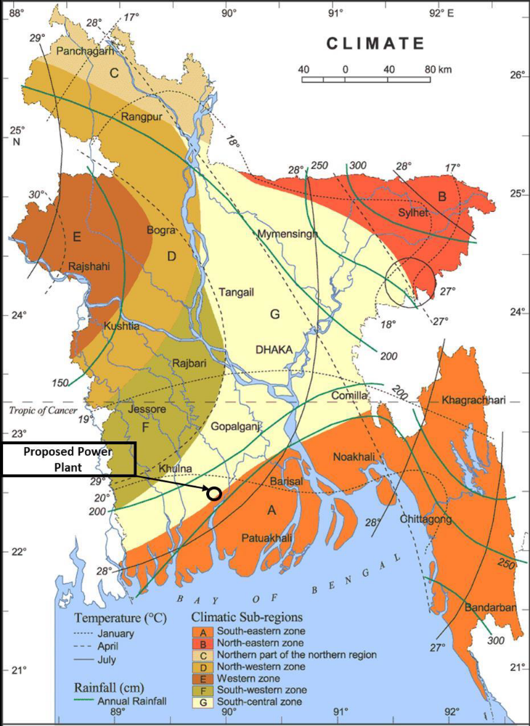
Map 6-2: Climatic Sub-regions of Bangladesh

Rainfall
The average annual rainfall is about 1,929 mm for the period of year 2011 to 2019 and approximately 80% of it occurs during the monsoon. Average monthly rainfall during monsoon period varies between 82 mm to 891 mm. Maximum monthly rainfalls during this period recorded in July 2015 is 891 mm.
The rainfall follows the general climate pattern with the highest rainfall in the summer month of May to October and minimum rainfall in the cooler and drier months of November to April. It is evident that extreme rainfall events occurred during the monsoon (June-September). Average yearly and monthly rainfall values for Mongla area are presented in the following tables:
Table 6-10: Annual Rainfall (in mm) from 2011 to 2019
Year | 2011 | 2012 | 2013 | 2014 | 2015 | 2016 | 2017 | 2018 | 2019
Annual Rainfall in mm | 2,247 | 1,784 | 1,831 | 1,508 | 2,110 | 2,118 | 2,100 | 1,710 | 1,952
Source: Bangladesh Environment Statistics 2020
Table 6-11: Monthly Rainfall (in mm) from 2015 to 2019
Year | Jan | Feb | Mar | Apr | May | Jun | Jul | Aug | Sep | Oct | Nov | Dec
2015 | 18 | 3 | 23 | 95 | 98 | 396 | 891 | 270 | 284 | 21 | 4 | 7
2016 | 16 | 53 | 20 | 21 | 270 | 366 | 538 | 544 | 76 | 159 | 55 | 0
2017 | 0 | 0 | 81 | 55 | 115 | 335 | 534 | 355 | 207 | 342 | 17 | 59
2018 | 0 | 0 | 1 | 69 | 254 | 526 | 388 | 254 | 177 | 100 | 0 | 2
2019 | 0 | 100 | 41 | 101 | 82 | 286 | 301 | 389 | 290 | 97 | 265 | NA

Humidity
As would be expected, relative humidity during the wet season is significantly higher than those occurring at other period of the year. This is well depicted by the data as shown in the following table for humidity of Mongla during the period 2015 to 2019:
Table 6-12: Monthly and Yearly Humidity (in %) from 2015 to 2019
Year | Jan | Feb | Mar | Apr | May | Jun | Jul | Aug | Sep | Oct | Nov | Dec | Avg.
2015 | 78 | 74 | 66 | 76 | 78 | 84 | 91 | 87 | 85 | 83 | 81 | 78 | 80
2016 | 78 | 78 | 75 | 76 | 77 | 84 | 90 | 88 | 86 | 84 | 81 | 81 | 81
2017 | 73 | 71 | 75 | 75 | 76 | 85 | 88 | 88 | 88 | 87 | 79 | 84 | 80
2018 | 75 | 72 | 72 | 73 | 80 | 86 | 88 | 86 | 86 | 82 | 84 | 76 | 80
2019 | 71 | 71 | 72 | 76 | 77 | 83 | 86 | 86 | 88 | 85 | 83 | 80 | 79
Source: Bangladesh Environment Statistics 2020

Temperature
The seasonal variation in temperature is distinct but does not vary widely. Data for the last 5 years (2015 to 2019) from Mongla show that the maximum monthly temperature recorded was 30.9$℃$ for the month of May 2019. May is the hottest month with temperature varies from 29.3$℃$ to 30.9$℃$ and while January is the coldest month with temperature varies from 17.5$℃$ to 19.2$℃$.
Table 6-13: Monthly and Yearly average Dry Bulb Temperature from 2015 to 2019
Year | Jan | Feb | Mar | Apr | May | Jun | Jul | Aug | Sep | Oct | Nov | Dec | Annual
2015 | 19.2 | 22.8 | 26.3 | 28.7 | 30.8 | 29.4 | 28.0 | 29.0 | 29.1 | 27.7 | 24.6 | 20.8 | 26.3
2016 | 19.1 | 24.5 | 27.9 | 30.7 | 30.0 | 29.4 | 28.4 | 28.8 | 29.0 | 28.1 | 23.9 | 20.4 | 26.8
2017 | 19.2 | 23.0 | 25.9 | 29.3 | 30.6 | 29.7 | 28.7 | 28.8 | 29.0 | 27.4 | 24.0 | 20.9 | 26.4
2018 | 17.5 | 23.1 | 27.4 | 28.6 | 29.3 | 29.3 | 28.9 | 29.1 | 29.2 | 27.1 | 24.0 | 19.4 | 26.2
2019 | 19.1 | 22.0 | 26.3 | 29.1 | 30.9 | 30.3 | 29.5 | 29.3 | 28.6 | 27.4 | 24.6 | 19.7 | 26.5
Source: Bangladesh Environment Statistics 2020

Wind Speed and Directions
The region of the project site is characterized by the south wind of the Bay of Bengal during the monsoon and northwestern Himalayan wind in winter. Data from the year of 2015 to 2019 (Annex-5) show that the maximum monthly wind speed in the Mongla meteorological station area ranges from 2 to 21 knots (1 knot = 1.852 kilometer/per hour) with an average highest speed of 7.6 knots.
Wind rose gives very succinct but information-laden view of how wind speed and direction are typically distributed at a particular location. Presented in a circular format, the wind rose shows the frequency of winds blowing from particular directions. The length of each "spoke" around the circle is related to the frequency of time that the wind blows from a particular direction. Each concentric circle represents a different frequency, emanating from zero at the center to increasing frequencies at the outer circles. The wind roses shown here contain additional information, in that each spoke is broken down into discrete frequency categories that show the percentage of time that winds blow from a particular direction and at certain speed ranges. All wind roses shown here use 16 cardinal directions, such as north (N), NNE, NE, etc.
From the meteorological point of view, climate of Bangladesh is divided into Pre-Monsoon (March to May), Monsoon (June to September), Post-Monsoon (October to November) and winter (December to February). The seasonal wind rose plot for the four seasons have been generated with monthly highest speed over the period of 2015 to 2019.

Figure 6-3: Seasonal Wind Rose Plots

Figure 6-4: Monthly Maximum Wind Speed (2015-19)
The wind roses indicate the prevalent wind direction in an area varies during the different seasons. The seasonal wind roses indicate that in Mongla, the predominant wind direction are from South East direction in the monsoon months and from North West in the winter months. Also, analysis of 5 years data (2015-19) of maximum speed shows that above 35% of the highest wind speed is from the south direction.
EPC contractor of ERBL, Mahindra EPC also conducted a site-specific wind climate assessment through third-party vendor in July 2020 to provide suitable, accurate design wind speeds. The report is in Annex-5.1 for reference.

Sunshine
The yearly average sunshine hour in Mongla varies from 5.3 to 6.4 hour/day in a year from 2015 to 2019. In general, maximum sunshine hour of 8.9 hours in a day is found in March 2015.
Table 6-14: Monthly and Annual Avg. Sunshine Hours (2015-19)
Year | Jan | Feb | Mar | Apr | May | Jun | Jul | Aug | Sep | Oct | Nov | Dec | Annual Avg.
2015 | 5.8 | 7.4 | 8.9 | 6.4 | 6.9 | 3.1 | 1.7 | 3.1 | 4.2 | 6.6 | 6.8 | 2.6 | 5.3
2016 | 4.7 | 5.3 | 6.7 | 7.6 | 6.9 | 5.4 | 2.5 | 4.1 | 4.9 | 6.2 | 7.2 | 6.1 | 5.6
2017 | 7.7 | 6.9 | 7.1 | 6.7 | 7.9 | 4.4 | 3 | 3.6 | 4.2 | 5.7 | 7.9 | 6.4 | 6
2018 | 7.3 | 7.7 | 7.5 | 8.1 | 6.4 | 3.8 | NA | 4.5 | 5.2 | 6.8 | 7 | 5.7 | 6.4
2019 | 7.7 | 7.1 | 8.1 | 8.7 | 8.1 | 4.1 | 3.2 | 5 | 3.4 | 6.6 | 7.5 | 5.3 | 6.2
Source: Bangladesh Environment Statistics 2020

Natural Hazards
Bangladesh can be regarded as being susceptible to natural calamities. This is due to its unique combination of physiographic, morphological and other natural features, which have led to direct loss of life and physical property on a massive scale. Important natural calamities include cyclones & tidal surge, floods, storm and earthquakes.
Bangladesh is one of the largest deltas in the world and it is formed mainly by the Ganges-Brahmaputra-Meghna River system, except for the hilly regions in the northeast and southeast and terrace land in northwest and central zones. It has about 710 km long coastline. About 28% of the populations live in coastal region. The coastal region of Bangladesh is prone to multi hazard threats such as cyclones, storm surges and floods, as well as earthquakes and above all, climate change. It is frequently visited by the cyclone-induced storm surge.

Cyclone and Tidal Surge
Bangladesh very often becomes the landing ground of cyclones formed in the Bay of Bengal. This is because of the funnel shaped coast of the Bay of Bengal, most of the damage occurs in the coastal regions of Khulna, Bagerhat, Patuakhali, Barisal, Noakhali and Chittagong and the offshore islands of Bhola, Hatiya, Sandwip, Manpura, Kutubdia, Maheshkhali, Nijhum Dwip, Urir Char and other newly formed islands. The coastal zone of Bangladesh is disaster prone. Mongla is in the exposed coastal area which is frequently subjected to cyclone and storm surges.
The country is one of the worst sufferers of all cyclonic casualties in the world. The high number of casualties is due to the fact that cyclones are always associated with storm surges. Storm surge height in excess of 9m is not uncommon in this region. For example, the 1876 cyclone had a surge height of 13.6 m and in 1970 the height was 9.11 m (WARPO, 2005). The storm surge height with respect to ground was within the range of 3.0 m to 3.7 m. A list of major cyclones in Bangladesh is given in Table 6.15.
Table 6-15: List of major Cyclones in Bangladesh
Timeline | Maximum Wind speed (km/hr) | Storm Surge height (meters) | Death Toll | Location
May 11, 1965 | 160 | 3.7-7.6 | 19,279 | coastal areas
December 15, 1965 | 217 | 2.3-3.6 | 873 | coast near Cox's Bazar and Patuakhali.
October 1, 1966 | 139 | 6-7 | 850 | Sandwip, Bakerganj, Khulna, Chittagong, Noakhali and Comilla
November 11, 1970 | 222 | 10.6 | 300,000 | entire coast of Bangladesh
May 25, 1985 | 154 | 3.0-4.6 | 11,069 | Chittagong, Cox's Bazar, Noakhali and coastal islands (Sandwip, Hatiya, and Urirchar)
November 30, 1988 | 162 | 4.5 | 5,708 | Jessore, Kushtia, Faridpur and coastal islands of Barisal and Khulna
April 29, 1991 | 225 | 6.0-7.6 | 138,000 | Chittagong district of southeastern Bangladesh
May 19, 1997 | 230 | 3.5 | 155 | coastal islands and chars near Chittagong, Cox's Bazar, Noakhali and Bhola districts.
November 15, 2007 | 223 | - | 3,363 | southern Bangladesh
May 25, 2009 | 120 | - | 150 | 15 districts of south-western part of Bangladesh
May 16, 2013 | 85 | - | 17 | Chittagong
May 21, 2016 | 100 |  | 26 | Chittagong

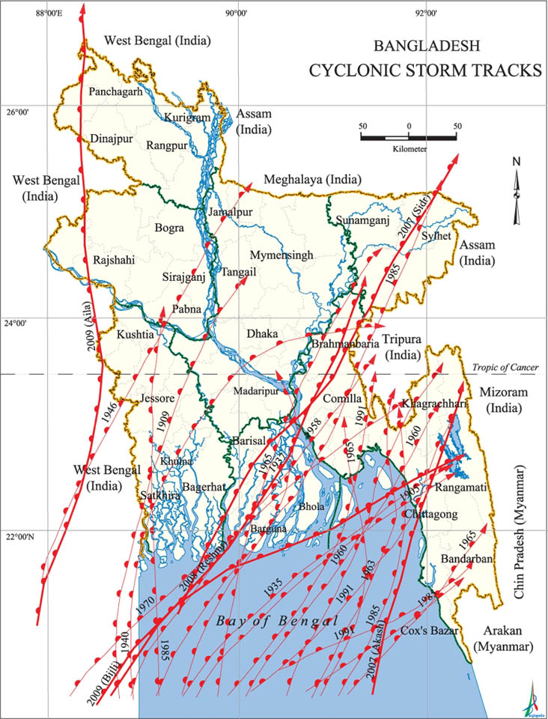
Figure 6-5: Tracks of Major known Cyclones in the Bay of Bengal
A tropical cyclone needs more than 27◦C sea temperature for its initial formation. Such a high surface temperature is necessary to produce a steep lapse rate for maintaining the vertical circulation in a cyclone. This condition is met throughout the year in regions of the Bay of Bengal where cyclones are formed, mostly the Andamans. They usually occur at latitudes greater that 5◦N or 5◦S. Cyclones in the Bay of Bengal usually move northwest in the beginning and then curve eastwards. The tracks of major known cyclones landfalls in Bay of Bengal are shown in Figure 6-5.
Energon Renewables (BD) Ltd, (previously proposed as Orion Power Khulna Ltd), conducted a flood flow vulnerability assessment in 2014. This study has been carried out to assess flood flow vulnerability for the proposed power plant site along the bank of the Passur River in Mongla Upazila of Bagerhat district. In this assessment, along with the wind generated waves, the impact of cyclonic storm surge was also considered as the study site is located in the southwest parts of the country within the 50km of the coast. In Bangladesh, the maximum value of the storm surge has been reported to be as high as 12.2m. However, the storm surge height has been varied and depends on the wind direction.
After the vulnerability assessment, it has been found that due to flat topography and shallow depth of the channel, storm surge is not able to travel much longer. As cyclone storms are occurred during the pre-monsoon and post-monsoon seasons when the water level is much below the monsoon water level of the river, wave run-up height of cyclone storms is not considered for design purpose.

Floods
Floods are the country's largest natural hazard, causing significant damage to life and property. The country lies on the downstream part of three major river basins: Brahmaputra, Gange and Meghna and is therefore often flooded. There have been many destructive floods in Bangladesh, including very severe floods in 1987, 1988 and 1998. The 1988 floods set a new record for flooded areas, while the 1998 floods were unprecedented with their long duration. The potential for flood damage in Bangladesh is increasing due to possible causes of climate change, urban concentration in the three watersheds, floodplain encroachment and the safety of flood protection works such as dikes and reservoirs. There are two types of floods in Bangladesh: annual floods (barsha) flooding up to 20% of the land area; and large-scale low frequency floods that flood more than 35% of the area (bonna).
The major floods of 1954, 1955, 1974, 1984, 1987, 1988, 1993, 1998, 1999, 2000 and 2007 have been very destructive and have seriously threatened life and the economy. In the context of human exposure in flood risk areas, there are some 19,279,960 people in these areas, and Bangladesh ranks first among 162 countries. Similarly, the modeled amount of GDP in hazardous seismic zones places Bangladesh third out of 162 countries. The flood risk map of the project area is illustrated in the Annex-2(J).
The flood flow vulnerability assessment has been conducted based on the existing ground elevation and the design flood levels. The project site is actually a floodplain of the Passur river which is inundated during monsoon. The average existing ground level is found to be 2.22 m PWD. The design flood level corresponding to 100-year return period at the proposed plant location has been estimated to be 5.10 m PWD while the normal flood level corresponding to 2.33-year return period is found to be 4.37 m PWD. It is seen that the proposed project area is highly vulnerable to flood. The difference between the existing ground elevation and 100-year flood level is 2.41 m while the difference between the existing ground level and the 2.33-year normal flood level is 1.71 m. Filling the whole study area requires huge amount of soil and it takes huge amount of money as well. Thus, filling the whole area is not a viable solution for flood protection of the area. In order to make the area flood-free, a flood wall has been suggested as it takes much less area than flood embankments.
The detailed assessment report of flood flow vulnerability is attached as Annex-6. Based on the recommendation suggested in the assessment report, ERBL constructed a dyke 5.5 m above MSL was constructed around the plant in 2020.

Earthquakes
According to BNBC (2006), Bangladesh has three seismic zones with severe, moderate and low seismic activity. The Project area falls in Zone III, which is also called Low intensity seismic zone. Little earthquake shivering has been reported in the project area in recent years or recent past. Having location in Zone-III the land buildings and land-based structures for this project should be designed to withstand maximum lateral load of 50% of gravity load. The earthquake risk map of the project area is illustrated in the Annex-2(K).

Socio-economic Baseline
The socio-economic baseline condition of the study area is captured to have a picture of the current situation to allow comparison with that of any potential impact associated with the proposed project. The study included an assessment of the baseline condition of the local stakeholders including the local community, governmental organizations, and community development agencies such as NGO/Self Help Groups etc. amongst other as well as taking into account their perceptions on the impacts and benefits from this existing power plant.

Approach and Methodology
The approach and methodology adopted for the socio-economic baseline assessment relied on readily available secondary information and primary information collected through consultations with a range of stakeholders for the project as well as sample socio-economic survey of households within the impact zone of study area. The key activities that were carried out for primary and secondary data collection are summarized as follows:
- Desk-Based Review of available project documentation and profile of the project site;
- Reconnaissance Survey to visually observe the social setting in and around 1 km of the area;
- Secondary Information is used from the Bureau of Statistic data for 1-2 km of study area.
- Consultations with the Various Stakeholders ranging from governmental institutions, local administration (municipality & village administration), local community, landowners, project proponent etc.
- Socio-Economic Survey of the key settlements within close proximity of the existing power plant. The Socio-Economic survey was conducted for 50 households and data was collected based on a pre-developed questionnaire to ascertain general socio-economic indicators of the area;

Demarcation of the Project Area for Socio-Economic Study
From the social perspective, considering that the distances between 1-2 km radius might entail quite large for primary socio-economic landscape, which may not be entirely relevant from the point of studying the social impact for this power plant, the administrative boundaries of the unions, villages and settlements that lie in the immediate vicinity within 1m radius of the plant site and adjacent rural settlement have been taken for primary socio-economic survey of the study area.

Reconnaissance Survey
The site visit was conducted by a team comprising of four social specialists of BCAS. The entire site visit was conducted in June 2022. The socio-economic survey as well as the stakeholder consultations was concluded during this period.

Consultations with Stakeholders
The team consulted with a diverse range of stakeholders associated with the project. These included governmental agencies and departments, local administration, NGO, as well as the community. Furthermore, in order to assess the community and household level impacts, a socio-economic survey for a sample of 50 household within the close settlement of the existing power plant is undertaken. This survey helped to establish the baseline conditions of the community living in the vicinity of the project footprint as well as to get their opinions, expectation and apprehensions about the upcoming solar power plant. The analyses of this data and the inferences drawn have been provided in the following sections.

Collection and Review of Documents
During the field assessment and stakeholder meetings, documents of relevance to this study were collected and data from the same was utilized in developing this social baseline. Bangladesh Population Census 2011 Data for Mongla and Rampal Upazila were collected and reviewed during this site assessment.

Socio-Economic Baseline Profile of the Project Impact Area

Findings of Socio-Economic Survey
The baseline assessment also comprised a questionnaire based socio-economic survey which was conducted in the closest rural settlement of the existing ERBL Solar project and data collected from randomly selected 100 households in order to gain first-hand information about the key household level socio-economic indicators. The following sections provide results from the analysis of the data collected.

Demographic Trends
Household Size
According to the survey data, the majority of the households in the study area have 4-6 members. A significant percentage (64%) has 4-6 members followed by (30%) households having 2-3 members. Only 6% of the total sample constituted of households having more than 6 members. Figure 6-3 shows the household size of the study area.
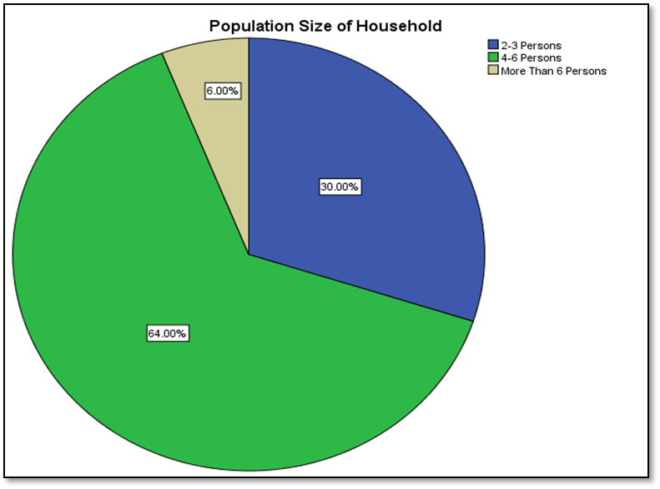
Figure 6-6: Household Size of the Study Area
Population
According to the BBS 2011, there are 366 households in the villages Chalkgona and Moidhara. The total population is 1696 and the average household size is 4.6 persons. The field survey reveals that there are 217 people living in 50 households in the area giving an average of 4.34 persons per household. Table 6-16 below depicts the no. of households regarding household size at the study area:
Table 6-16: No. of Households Regarding Household Size at the Study Area
Household Size | No. of HHs | Percent
2 | 2 | 4.0
3 | 13 | 26.0
4 | 16 | 32.0
5 | 9 | 18.0
6 | 7 | 14.0
7 | 2 | 4.0
9 | 1 | 2.0
Total | 50 | 100.0

Population Age and Sex Distribution
According to the BBS 2011, among 1696 people of Chalkgona and Moidhara, there are 857 male and 839 female which expresses that the sex percentage is 51% and 49% respectively. On the other hand, according to the survey data, among 217 people there are 111 male and 106 female. There are about 49% women and 51% men living in the study area. When it is time for age there are several age groups of people living in the study area. In the study it is seen that it is just nearly half of the people who are in the 18-59 age cohort – the income earning group. The 5-9- and 10-14-years age groups have count of 9.22% and 12.44% respectively. And 15-17 years age group is about 17.51%. Further, 0-4 years (newborn) are 6.91% and 60+ years are 4.61% each. Table 6-17 below shows the population distribution of sample households by age groups:
Table 6-17: Population Distribution of Sample Households by Age Groups
Age Group | Frequency | Percentage
0-4 | 15 | 6.91%
5-9 | 20 | 9.22%
10-14 | 27 | 12.44%
15-17 | 38 | 17.51%
18-34 | 55 | 25.35%
35-59 | 52 | 23.96%
60+ | 10 | 4.61%
Total | 217 | 100.00%

Religious Status of the Study Area
According to the BBS 2011, among the total population of Burirdangga union of Mongla Upazila, 35% are Muslims and rest of the 65% are Hindus. And in Rajnagar union of the Rampal Upazila, 47% are Muslims and 53% are Hindus. Within 5km of the project site, in Moidhara village, 95% of the population are Hindus and 5% are Muslims. In Borodurgapur village, 95% of the population are Hindus and 5% are Muslims. In Chalkgona village, 90% of the population are Hindus and 10% are Muslims
According to the survey, 78% of the sample survey population in the study area are Hindu by religion and rest of the 22% are Muslim. Table 6-18 below depicts the religious profile of the study area:
Table 6-18: Religious Profile of the Study Area
Religious Status | Frequency | Percent
Muslim | 11 | 22.0
Hindu | 39 | 78.0
Total | 50 | 100.0

Marital Status
Table 6-19 presents marital status of the sample surveyed population in the study area. It is revealed from the table that, 58.06% of the population in the study area is married. The unmarried population is 19.82%. However, 3.23% and 0.92% of the population in the study area are widow and divorced respectively. Although almost 18% people of the study area who are not applicable as they are below 18 years of age.
Table 6-19: Marital Status of the Sample Surveyed Population in the Study Area
Marital Status | Frequency | Percentage
Married | 126 | 58.06%
Unmarried | 43 | 19.82%
Divorced | 2 | 0.92%
Widow | 7 | 3.23%
Not Applicable | 39 | 17.97%
Total | 217 | 100.00%

Occupational Profile
As per the survey data it can be observed that almost 30% of the respondents are involved in farming followed by business (26%), Labor (20%), service holder (14%), fishermen (4%) and housewife (2%) in the study area. There is other 6% who are not engaged in any works as they are too old to work but are obeyed as family head. Among the 20% Labor there are rickshaw-puller, construction worker, driver, garments worker, electrician etc. It can also be observed that majority of the women respondents are housewives or involved in household activities. Besides these, there are only two household heads who are engaged in secondary occupation as well. Figure 6-4 below shows the occupational profile of the study area:
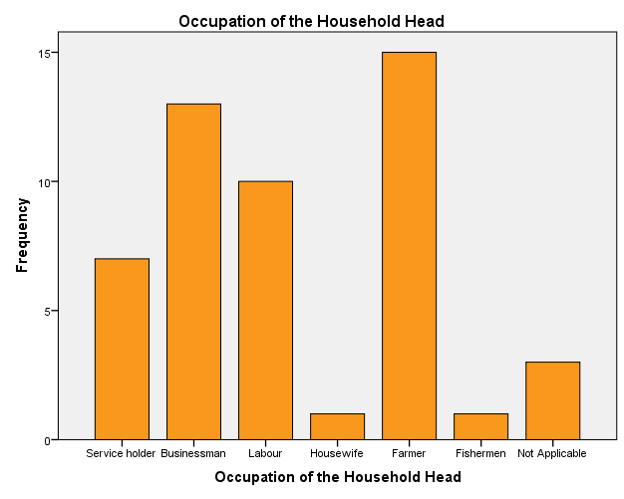
Figure 6-7: Occupational Profile of the Study Area

Education & Literacy
According to the BBS 2011, the literacy rate for 7+ years population of Chalkgona and Moidhara was 45.3%. But the sample survey revealed that 76% of the household heads of the study area were literate. Majority of the respondents (38%) were found to have primary level education. High School level education is attained by 28% of the total sample respondent. Significant proportion is illiterate (24%). Also, only 8% of the household heads complete SSC and HSC level education. A mere 2% household completed degree level education. Table 6-20 below shows the education and literacy of the HH heads of the study area:
Table 6-20: Education Status of the HH Heads of the Study Area
Education of HH Head |  | Frequency | Percent | Cumulative Percent
 | Illiterate | 12 | 24.0 | 24.0
 | Primary | 19 | 38.0 | 62.0
 | High School | 14 | 28.0 | 90.0
 | SSC | 2 | 4.0 | 94.0
 | HSC | 2 | 4.0 | 98.0
 | Degree/Honors or Higher | 1 | 2.0 | 100.0
 | Total | 50 | 100.0

Access to Utilities & Resources
Property of Household
According to the BBS 2011, 97.3% people have their own house, 1.1% people are renting houses and 1.6% are rent free regarding the study area. In the present survey, data on household land ownership reveals that 94% respondents reside in their own houses while only 6% have been found to be staying in rented houses. Figure 5.3 below depicts the house ownership status of the surveyed households:
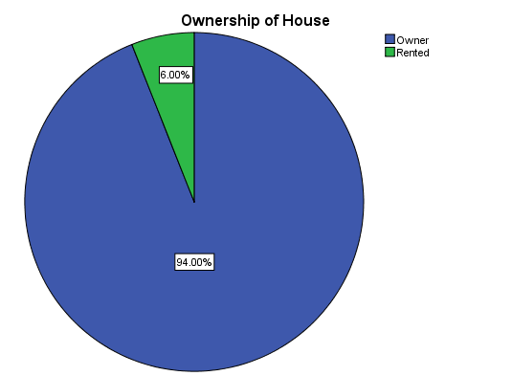
Figure 6-8: House Ownership Status of the Surveyed Households
Sanitation Facilities
According to the BBS 2011, 18.6% latrine is septic (water-sealed), 69.6% are sanitary (non-water-sealed), 8.2% are non-sanitary and 3.6% have no latrine in Chalkgona and Moidhara. But the sample survey revealed that majority of the households (74%) in the study area have septic latrines (water-sealed) and 22% households have pit latrine facilities (sanitary: non-water-sealed). But it is a matter of regret that the remaining 4% households have open latrine, which is not hygienic at all and is open to the two rivers. Table 6-21 below shows the status of sanitation facilities at the sample surveyed households:
Table 6-21: Status of Sanitation Facilities at the Sample Surveyed Households
Sanitation Facility |  | Frequency | Percent | Cumulative Percent
 | Septic Latrine | 37 | 74.0 | 74.0
 | Pit Latrine | 11 | 22.0 | 96.0
 | Open Latrine | 2 | 4.0 | 100.0
 | Total | 50 | 100.0

Sources of Drinking Water
According to the BBS 2011, almost all households (99.7%) use tube-well, and only 0.3% 32% households use tap for their drinking water in the Chalkgona and Moidhara. But it can be observed from the sample survey that majority of the households or approximately 58% in the project study area use tube-well and 42% household use tap for drinking water. Figure 6-6 depicts Sources of drinking water for the sample surveyed households:

Figure 6-9: Sources of Drinking Water for the Sample Surveyed Households

Source of Fuel for Cooking
Households in the study area use fuel for cooking purposes from mainly two different sources including firewood and cylinder gas. Sources of fuel for 88% household is firewood and for 12% household is cylinder gas. Table 6-22 below shows the sources of fuel for the sample surveyed households:
Table 6-22: Sources of Fuel for the Sample Surveyed Households
Cooking Materials |  | Frequency | Percent | Cumulative Percent
 | Firewood | 44 | 88.0 | 88.0
 | Cylinder Gas | 6 | 12.0 | 100.0
 | Total | 50 | 100.0

Access to Resources
Among the surveyed household within the project study area, certain questions were asked with respect to access to key resources such as water sources, grazing land, educational facilities, hospital and markets. All surveyed households reported to have immediate access to resources way within a distance as reported in the following Table 6-23:
Table 6-23: Access to Resources
Access to Resources | Less Than 1 km | 1-3 km | >3 km | Total Households
Water Source | 50 |  |  | 50
Hospital/Medicine | 41 | 8 | 1 | 50
Masjid/Temple | 50 |  |  | 50
Grazing Land | 50 |  |  | 50
Surface Water Sources | 50 |  |  | 50

Asset Ownership
Land Ownership
The survey has revealed that about 69% of land used by the households as cultivated land whereas 23% of land used as own homestead and 8% of land used in other purpose. The household have average 8.06 decimal land as their homestead and 24.06 decimal land for their cultivation. And a mere average of 2.66 decimal land is used for other purposes. Figure 6-7 below depicts the use of land by the landowners:

Figure 6-10: Use of Land by the Landowners
House Type
According to the BBS 2011, 1.1% houses are pucca, 14.5% houses are semi-pucca and 83.3% houses are katcha at Chalkgona and Moidhara villages. But majority of the houses in the sample surveyed area are semi-pucca (80%) followed by pucca houses (12%). And only 8% houses have been observed as mud (katcha) houses. All the pucca houses are 1 story buildings. In the study area there are two types semi-pucca house. About 65% semi-pucca houses are built with ‘pucca wall, pucca floor, and tin roof’ while 35% semi-pucca houses are built with ‘tin wall, pucca floor, and tin roof’. Half of the mud (katcha) houses are built with ‘mudwall, mud floor, and straw roof’ and the rest half were built with ‘bamboo/straw wall, mud floor, and straw roof’. Table 6-24 below shows the types of houses at the study area:
Table 6-24: Types of Houses at the Study Area
Types of House |  | Frequency | Percent | Cumulative Percent
 | Pucca | 6 | 12.0 | 12.0
 | Semi-Pucca | 40 | 80.0 | 92.0
 | Mud | 4 | 8.0 | 100.0
 | Total | 50 | 100.0

Domestic Animals
The percentage of households possessing domestic animals is observed to be moderate in the study area with 56% not owning any form of domestic animals. However, within the remaining 44% most of the household owned or reared cows, goats, hens, ducks and pigeon. About 63% domestic animals are duck and hen, 27% animals are cow, about 5% animals are goat and about 5% animals are pigeon. Table 6-25 below shows the no. of households having different types of animals:
Table 6-25: No. of Households Having Different Types of Animals
Types of Livestock |  | No. of HH | Percent | Cumulative Percent
 | Cow | 6 | 27.3 | 27.3
 | Goat | 1 | 4.5 | 31.8
 | Duck, Hen | 14 | 63.6 | 95.5
 | Others | 1 | 4.5 | 100.0
 | Total | 22 | 100.0

Household Income
Various income sources of the household members of the study area were agriculture and livestock, agriculture Labor, fisheries, non-agriculture Labor, industry, business, hawker, transport, construction, service, rent, remittance, and others. Among the surveyed households, 24% households earn less than Taka 10,000 per month – this group might be considered as poor. 48% households earn Taka 10,000-19,999 per month – this group might be considered as lower middle class. 22% households earn Taka 20,000-39,999 per month – this group might be considered as middle class. Only 6% households earn Taka 40,000 -74,999 per month – this group falls under upper middle-class category. No household above Taka 75,000 income range was found in the study area, who could have been considered as rich. In general, the household head is found as the main income-earner of the family. But there are few joint families, where income-earners are more than one. Table 6-26 below shows income level of the households of the study area:
Table 6-26: Income Level of the Households of the Study Area
Income Range |  | Frequency | Percent | Cumulative Percent
 | < 10,000 | 12 | 24.0 | 24.0
 | 10,000-19,999 | 24 | 48.0 | 72.0
 | 20,000-39,999 | 11 | 22.0 | 94.0
 | > 40,000 | 3 | 6.0 | 100.0
 | Total | 50 | 100.0

Household Expenditure
The sample survey data reveals that 6% households have average expenditure below Taka 5,000 per month, while 48% households expend Taka 5,000-9,999 per month on average, 34% households have expenditure of Taka 10,000-19,999 per month and 12% households spend Taka 20,000-39,999 per month on average. Table 6-27 below depicts the Expenditure Ranges of the Households of the Study Area.
Table 6-27: Expenditure Ranges of the Households of the Study Area
Expenditure Range |  | Frequency | Percent | Cumulative Percent
 | < 5000 Taka | 3 | 6.0 | 6.0
 | 5000-9999 Taka | 24 | 48.0 | 54.0
 | 10000-19999 Taka | 17 | 34.0 | 88.0
 | 20000-39999 Taka | 6 | 12.0 | 100.0
 | Total | 50 | 100.0

It can be observed from the survey that the majority of the expenditure is attributed to food and consumable resources with almost half of the monthly income being allocated for the same. Other significant expenditures include clothing, education and healthcare, transportation and recreation. Figure 6-8 below depicts the fields of expenditures of the households:

Figure 6-11: Fields of Expenditures of the Households
Field survey also revealed a great finding that just over 50% households have savings on their earnings.

Availability of Health Care Facility
There are two upazila health complex near the project site. Both Mongla Upazila Health Complex and Rampal Upazila Health Complex are about half an hour away from the project site. In Burirdangga union of Mongla Upazila, there is no govt. hospital, but a family planning center and a private health center is available. In Rajnagar union of Rampal Upazila, Union Health and Family Welfare Center and Community Clinic is available. Sheba Clinic and Diagnostic Center is about 30 minutes away from the ERBL project site.

Availability of Education Facility
Available educational facilities in Burirdangga union of Mongla Upazila and Rajnagar union of Rampal Upazila are listed out below:
Institute | Burirdangga (Mongla) | Rajnagar (Rampal)
Number of Government primary school (class I-V) | 08 | 03
Number of registered primary school (class I-V) | 04 | 08
Number of Non-government secondary school | 04 | 01
College | 01 | 00
Number of madrasah | 02 | 08

Educational facilities nearby the ERBL project site are Chalkgona Primary School, Selabunia Gov. Primary School, GMS High School, etc.

Physical and Cultural Resources in The Project Area
Available physical and cultural resources in Mongla and Rampal are:
Resources | Mongla | Rampal
Public library | 3 | 1
Rural club | 12 | 45
Cinema hall | 2 | 0
Playground | 16 | 146

Beside these, Burirdangga and Rajnagar Union also have sports and cultural organizations-
Institute | Burirdangga (Mongla) | Rajnagar (Rampal)
Sports Organization | - Shapla Youth Association | - Kalika Prasad Green Society  - Kalekharber Youth Association  - Buzbunia Meteor Society
Cultural Organization | - Mahendra Cultural College | - Rajnagar Women Development Center  - Kalikaprasad Green Cultural Society

Availability of Indigenous Settlement
According to the Bangladesh Bureau of Statistics (BBS) 2011, there is no indigenous/ ethnic settlement in Mongla and Rampal Upazila of Bagerhat.

Presence of Cultural Heritage and Religious Structures
The number of religious structures in Burirdangga and Rajnagar union are:
Union | Mosque | Eid-Gah | Temple (Mandir) | Church (Girza)
Burirdangga | 9 | 6 | 13 | 01
Rajnagar | 17 | 5 | 22 | 00

Within 5km of the project site, in Moidhara village, there is one temple; in Borodurgapur, there are three temples and two mosques; and in Chalkgona village, there are five temples and one mosque.
The archaeological heritage and relics of Bagerhat,
- Shatgumbad Mosque (30km from Project site),
- Nine-dome Mosque (31km from Project site),
- Khan Jahan's tomb Complex (32km from Project site),
- Ghora Dighee (29km from Project site),
- Kodla Math or Ayudha Math (43km from Project site),
- Shiva Temple (40km from Project site).

Involvement with NGOs
Sample household survey reveals that 78.0% households in the study area are not involved with non-governmental organizations (NGOs) whereas only a 22.0% family member has involvement with NGOs. BRAC and ASA work with local people for social and economic development – people have involvement with NGOs for taking loan and saving their money.
Burirdangga NGOs: BRAC, Rupantar, Grameen Bank, World Vision, Save, BRIDGE, Oriental, Bachte Shekha, Sushilon, Bangladesh Nejarin Mission, Friendship, Karitash,
Rajnagar NGOs: Rupantar, Karitash, Nobolok, JIZ, ASA, Grameen Bank, DoE, Protiva, Biva

Satisfaction Level in Lifestyle
The analysis of the households’ lifestyle has focused on accessibility and affordability regarding food, clothing, educational facilities, medical facilities, transport facilities, recreation etc. With respect to availability of food, it is considered “satisfactory” by 68.0% of the households under the survey. Food availability is considered “good” by 20.0% of the households in the study area. The situation with respect to clothing is considered “satisfactory” by 70.0% of the respondents and considered “good” by 16.0% of the respondents in the study area. As for housing /accommodation facilities, it is found “satisfactory” by 60.0% of the respondents, 12.0% of the respondents found it “good” and 28.0% of the respondents found it “unsatisfactory”. Educational facilities are considered “good” and “satisfactory” by 24.0% and 58.0% respondents respectively. Medical facilities are generally considered “satisfactory” by only 28.0% of the respondents in the study area whereas 68.0% of the respondents found them “unsatisfactory”. However, transportation facilities were scored as “satisfactory” by only 22.0% of the respondents, while a great 74.0% considered them as “unsatisfactory”. Entertainment facilities are considered “satisfactory” by 30.0% of the respondents whereas 52.0% of the respondents found them “unsatisfactory” in the study area. So, it is matter of regret that in case of medial, transportation and recreation facilities the “unsatisfactory” percentage is far greater than “satisfactory” level. Figure 6-9 below shows the satisfaction level of the household in their daily lifestyle:

Figure 6-12: Satisfaction Level of the Household in their Daily Life Style

Overall Perception about the Power Plant
Almost all the people know about the project to be implemented. Majority of the respondents have a positive perception about the power plant. They express their opinion that the power plant is a national asset and support to meet our electricity demand. Positive expectations of the surveyed household are primarily with respect to overall development in the area, improved road facilities and employment opportunity for the local people.

Ecology and Biodiversity Baseline
The project area does not fall within 10km radius of any significant sensitive receptors like Wildlife Sanctuaries, Biosphere Reserves and National Parks etc. Removal of herbaceous vegetation from the soil and loosening of the topsoil generally causes soil erosion. However, such impacts would be primarily confined to the project site during initial periods of the construction phase and will be minimized through adaptation of mitigation measures like paving and water sprinkling.
In view of this, this study assesses the terrestrial and aquatic flora and fauna within the impact zone of ERBL project. The section below outlines the scope of work or core components of this study.
The scope of work of this study includes:
a) Identify the terrestrial plants within the impact zone of ERBL project.
b) Identify the terrestrial fauna (vertebrate) within the impact zone of ERBL project.
c) Identify the aquatic macro fauna/fish species within the impact zone of ERBL project.

Flora
Major trees recorded during the visits are papaya, banana, palms, coconut, ladyfinger, tomato, mahagony, jack fruit, watermelon, cucumber, Neem, Bamboo, Castor, Hibiscus, Rongi, Sisoo, Sapota, Lime, Baroi, Jujubi, Arjun, Mango, Peyara, Safeda (Manilkara zapota), Akashmoni (Accacia), Golpata etc. List of the plants found in study areas are given in Annex-7 Table-1.

Fauna
There are 42 species of amphibian species, 157 reptilian species, 124 species of mammals and 718 bird species reported from Bangladesh (Khan 2010, Sarker and Sarker 1988). However, in the current study, a total of 9 amphibians, 17 reptiles, 10 mammals and 43 birds were identified in the impact zone of the project.
A total of 9 amphibian species were identified in the present project area (Annex 7 Table-2). On the basis of frequency of occurrence or relative abundance, Common Toad, Skipper Frog, Indian Bull Frog and Cricket Frog were commonly (55.55%) found and less common (33.33%) species were Pierries Cricket Frog, Nepal Cricket Frog etc. Furthermore, Ornate Narrow-mouthed Frog was rare. Species found on the impact areas were Least Concern (LC) on the basis of IUCN-Bangladesh (2000) threatened category. Although Cricket Frogs have not been evaluated by IUCN Bangladesh yet, but the species of cricket frog found in the impact areas were not subject to any threats.
A total of 17 reptiles species were identified in the present study area (Annex 7 Table-3). On the basis of frequency of occurrence or relative abundance Common Garden Lizard, Common skink, Yellow-bellied House Gecko, Bengal Monitor, Common Smooth Water Snake, Checkered Keelback Water Snake, Common Smooth Water Snake and Spectacled Cobra were found as common (41.18%). Among them Tokay Gecko, Oriental Leaf- Toed Gecko, Common Wolf Snake and Indian Rat Snake/Western Rat Snake were fewer common species (23.53%). Indian Roofed Turtle, Vine Snake, Striped Keelback, Monocllate Cobra and Common Indian Krait were found as rare species (35.29%). On the other hand, according to IUCN-Bangladesh (2000) Red list Threatened category Monocllate Cobra, Common Indian Krait species were Vulnerable and Common Smooth Water Snake was endangered.
A total of 10 mammalian species were identified in the impact area (Annex 7 Table-4). On the basis of frequency of occurrence or relative abundance Bengal Fox, Indian Grey Mongoose and House Rat were commonly (30%) found in the study area. Golden Jackal, Mole Rat, Greater Bandicoot Rat, Indian Flying Fox and Asian House Shrew were not common or less common (50%) in the study area. Rare (20%) species found in this area were Jungle cat and Five-Stripped Palm Squirrel. On the other hand, according to IUCN-Bangladesh (2000) Red list Threatened category Jungle Cat categorized as endangered.
A total of 39 birds species were found in the project area (Annex 7 Table-5). On the basis of frequency of occurrence or relative abundance commonly (66.67%) found species were Red Jungle fowl, Burmese Hoopoe, Common Kingfisher, Pied Kingfisher, Asian Cuckoo, House swift, Rock Pigeon, Spotted Dove, Little Cormorant, Great Cormorant, Indian Pond Heron, House Crow, Grey Drongo, White-rumped Shama, Jungle Myna, Common Myna, House sparrow etc. Bar-headed Duck, Red headed Bay Woodpecker, Black-rumped Flameback, Barn Owl, Brahminy Kite, Little egret, Hill Myna and Forest wagtail were not so common or less common (20.51%). Greylag Goose, Black-hooded Orile, Rose-ringed Parakeet, Crested Goshawk and Blue-throated Barbet were found as rare species (12.82%). On the other hand according to IUCN-Bangladesh (2000) Red list Threatened category most of the species found in the impact area were categorized as Least Concern.

Aquatic Fauna/ Fish
Mongla River, Pasur River and river Gona are present within the study area. Apart from this various storm water ponds, khal and beel area present within the study area. All of these water bodies support aquatic life. List of the fishes present in these waters is given in Annex-7 Table-6.

Endangered/Vulnerable Species
From the ecological study and biodiversity baseline, the identified endangered or vulnerable species are listed below:
Table 6-28: List of Endangered or Vulnerable Species in the Study Area
No. | Common Name | Bangla Name | Scientific Name | Type | ICUN Status
1 | Indian Bread Root | Lata Kosturi | Cullen corylifolium | Herb | EN
2 | Green Frog | Sabuj Bang | Euphlyctis hexadactylus | Amphibian | EN
3 | Tokay Gecko | Takkok | Gekko gecko | Reptile | VU
4 | Common Smooth Water Snake | Paina-shap | Enhydris enhydris | Reptile | EN
5 | Common Wolf Snake | Shadaraon Gharginni Shap | Lycodon aulicus | Reptile | VU
6 | Indian Rat Snake/Western Rat Snake | Daraj Shap | Ptyas mucosus | Reptile | VU
7 | Monocllate Cobra | Gokhra Shap | Naja kaouthia | Reptile | VU
8 | Spectacled Cobra | Khoia Gokhra Shap | Naja naja | Reptile | VU
9 | Common Indian Krait | Kalkeotey | Bungarus caeruleus | Reptile | VU
10 | Golden Jackal | Pati Shial/ Shial | Canis aureus | Mammals | VU
11 | Bengal Fox | Khek Shial | Vulpes bengalensis | Mammals | VU
12 | Jungle cat | Ban Biral | Felis chaus | Mammals | EN
13 | Indian Grey Mongoose | Beji | Herpestes edwardsi | Mammals | VU
14 | Cuchia, Rice eel | Kuchia, Kuicha, Kunche | Monopterus cuchia | Fish | VU
15 | Great snakehead | Gajar | Channa marulius | Fish | EN
16 | smooth-breasted snakefish, Walking snakehead | Gachua, Raga, Cheng | Channa orientalis | Fish | VU
17 | Engala barb | Along, Sephatia | Bengala elanga | Fish | EN
18 | Darkina | Gangetic scissortail rasbora | Rasbora rasbora | Fish | EN
19 | Karia labeo | Ghainna, Goni, Kurchi | Labeo gonius | Fish | EN
20 | Orange fin labeo | Kalibaus, Baus, Kalia | Labeo calbasu | Fish | EN
21 |  | Bara | Labeo bata | Fish | EN
22 |  | Bhagna, Raik, Tatkini, Bata, Laacho | Cirrhinus reba | Fish | VU
23 | Olive barb | Sarpunti, Sarnaputi, Saralpunti | Puntiussarana | Fish | CR
24 | Two-spot barb | Tit punti | Puntius ticto | Fish | VU
25 | Butter catfish | Kani pabda, Boali pabda, Pupta, Pafta | Ompok bimaculatus | Fish | EN
26 | Grey eel-catfish | Gang magur | Plotosus canius | Fish | VU
27 | Silond catfish | shillong | Silonia silonia | Fish | EN
28 | Long whiskered catfish | Ayre | Sperata aor | Fish | VU
29 | Giant river catfish | Guizza, Guizza air | Sperata seenghala | Fish | EN
30 | Gangetic mystus | Kabashi-tengra, Golsha-tengra, golsha | Mystus cavasius | Fish | VU
31 | Feather back, Clown knife fish | Chital | Chitala chitala | Fish | EN
32 | Asiatic knife fish, Bronze feather back | Foli | Notopterus notopterus | Fish | VU
33 | Elephant trunk fish. Lesser spiny eel | Tara baim | Macrognathus aculeatus | Fish | VU
34 | Zig-zag eel, Spiny eel | Baim, Bam, Sal baim | Mastacembelus armatus | Fish | EN
35 | Frail gourami | Neftani | Ctenops nobilis | Fish | EN
36 |  | Meni, Bheda | Nandus nandus | Fish | VU
37 |  | Koi Bandi | Badis badis | Fish | EN
38 | Indian glass fish | Chanda, Ranga-chanda, Lal chanda | Pseudambassis ranga | Fish | VU

Analysis of Alternatives
The project has considered alternatives in terms of design and technology options. An analysis of these alternatives has been undertaken for the project including consideration of a no-project scenario.

“No Project” Scenario
The generation and supply of electricity has a significant impact on the national economy of any country. Presently, 99.5% of the total population has access to electricity and per capita generation is 560 kWh (Power Division 2020-21). The present installed generation capacity as on 2020-21 is 25,235 MW, which includes 1160 MW of imported electricity.
In the public sector a number of the generation units have become a very old and have been operating at much reduced capacities. As a result, their reliability and productivity has been poor. For the last few years actual electricity demand in the country has not been met due to a shortage of available generation capacity. In addition, due to a shortage of gas supply, some power plants are unable to reach their full generation capacity.
The current supply-demand in Bangladesh also has a knock-on effect on all other key sectors including agriculture, industry, commercial and domestic sectors. There is therefore no alternative to adding more power generating units to the existing power system of Bangladesh, to help improve and meet the energy demand for both domestic and industrial requirements. Furthermore, most of the power production in Bangladesh is concentrated towards the central, eastern and coastal areas, whereas in the western and north-west region power projects development was limited due to non-availability of indigenous gas and higher cost of transportation of fuel oil to these areas.
The “No Project Scenario” is also likely to have a negative effect on opportunities for employment, both directly from the power project and its dependent sectors such as agriculture, industries and manufacturing that require stable power supply in order to operate and be competitive.

Analysis of Site Alternatives

Considering important parameters for a power plant project, initially Orion Group procured 141 acres of land in the name of Orion Power Khulna Limited to set up a coal power plant during the year of 2011 to 2015. Later on, the 141 acre of land was transferred in the name of Energon Renewables (BD) Limited (ERBL) in 2020. ERBL also procured additionally 142 acres of land for solar power project. the land was limitedly used as aquaculture purpose. No agricultural activities were done on this land. Also, there was no residential unit within the project site; therefore, resettlement and rehabilitation issues are not applicable for this project. As the project site is kept unutilized for most of the months of each year, the landowners were voluntarily interested to sell the land with reasonable purchase price. Hence, the location was considered suitable for implementation of the grid-tied solar project.

Analysis of Technological Alternatives
GOB is looking for various options for Renewable Energy resources. Under the existing generation scenario of Bangladesh, Renewable Energy has a very small share to the total generation. The share of Renewable Energy is around 3.5% as of 2022 (Source: SREDA, 2022). The present government is placing priority on developing Renewable Energy resources to improve energy security and to establish a sustainable energy regime; alongside of conventional energy sources. Government has already launched ‘500MW Solar Power Mission’ to promote the use of Renewable Energy to meet the increasing demand of electricity. Considering the scenario, solar energy generation is the most feasible technological alternative amongst renewable options.

Stakeholder Engagement and Public Disclosure

Introduction
Stakeholder refers to individuals or groups who are affected or likely to be affected by the project and the term “stakeholder engagement” refers to a way to describe the process of engagement between a project developer and those potentially affected by the subprojects or way of supporting the implementation. Stakeholder engagement can cover a range of activities and approaches and those are consultation, engagement, external relations, information disclosure and dissemination, community participation etc. In the 100 MW (AC) Solar Park of Energon Renewables (BD) Limited project, Orion has already designed a common Stakeholder Engagement Plan (SEP) for all of the activities under Energon Renewables (BD) Limited project following ESS10 of WB ESF.
For the ESIA of 100 MW (AC) Solar Park of Energon Renewables (BD) Limited the stakeholders’ consultation, Focus Group Discussions (FGDs) and key Informant Interviews (KIIs) were carried out (from 10 April 2022 to 25 April 2022) in the project influence area to seek opinion and suggestion of the stakeholders as indicated in the SEP.

National and International Requirements on Stakeholder Engagement
The consultation specified in this plan conform to country (Bangladesh) legislation including ratified by Bangladesh international conventions and the World Bank Performance Requirement and for information disclosure and stakeholder engagement. The project will be designed to meet best international practice.

International Requirements (World Bank)
The World Bank’s Environmental and Social Framework (ESF) came into effect on October 1, 2018. The Framework includes Environmental and Social Standard (ESS) 10, “Stakeholder Engagement and Information Disclosure”, which recognizes “the importance of open and transparent engagement between the Borrower and project stakeholders as an essential element of good international practice”. ESS10 emphasizes that effective stakeholder engagement can significantly improve the environmental and social sustainability of projects, enhance project acceptance, and make a significant contribution to successful project design and implementation.
As defined by ESS10, stakeholder engagement is an inclusive process conducted throughout the project life cycle. Where properly designed and implemented, it supports the development of strong, constructive and responsive relationships that are important for successful management of a project’s environmental and social risks. Key elements of ESS10 include:
• “Stakeholder engagement is most effective when initiated at an early stage of the project development process and is an integral part of early project decisions and the assessment, management and monitoring of the project.”
• “Borrowers will engage with stakeholders throughout the project life cycle, commencing such engagement as early as possible in the project development process and in a timeframe that enables meaningful consultations with stakeholders on project design. The nature, scope and frequency of stakeholder engagement will be proportionate to the nature and scale of the project and its potential risks and impacts.
• Borrowers will engage in meaningful consultations with all stakeholders. Borrowers will provide stakeholders with timely, relevant, understandable and accessible information, and consult with them in a culturally appropriate manner, which is free of manipulation, interference, coercion, discrimination and intimidation.
• The process of stakeholder engagement will involve the following, as set out in further detail in this ESS:
(i) stakeholder identification and analysis;
(ii) planning how the engagement with stakeholders will take place;
(iii) disclosure of information;
(iv) consultation with stakeholders;
(v) addressing and responding to grievances; and
(vi) reporting to stakeholders.
• The Borrower will maintain and disclose as part of the environmental and social assessment, a documented record of stakeholder engagement, including a description of the stakeholders consulted, a summary of the feedback received and a brief explanation of how the feedback was taken into account, or the reasons why it was not.”
Borrowers are required to develop a Stakeholder Engagement Plan (SEP) proportionate to the nature and scale of the project and its potential risks and impacts. Stakeholders have to be identified and the SEP has to be disclosed for public review and comment as early as possible, before the project is appraised by the World Bank. ESS10 also requires the development and implementation of a grievance redress mechanism that allows project-affected parties and others to raise concerns and provide feedback related to the environmental and social performance of the project and to have those concerns addressed in a timely manner.

Summary of the project Stakeholders Engagement and Information Disclosure Process
Carry out meaningful consultations with affected persons, host communities, and concerned nongovernment organizations. Inform all displaced persons of their entitlements and resettlement options. Ensure their participation in planning, implementation, and monitoring and evaluation of resettlement programs. Pay particular attention to the needs of vulnerable groups, especially those below the poverty line, the landless, the elderly, women and children, and Indigenous Peoples, and those without legal title to land, and ensure their participation in consultations.
Establish a grievance redress mechanism to receive and facilitate resolution of the affected persons’ concerns. Support the social and cultural institutions of displaced persons and their host population.

Stakeholder Categorization
A stakeholder is “a person, group, or organization that has a direct or indirect stake in a project/ organization because it can affect or be affected by the Project/organization's actions, objectives, and policies”. Stakeholders thus vary in terms of degree of interest, influence and control they have over the project. While those stakeholders who have a direct impact on or are directly impacted by the project are known as Primary Stakeholders, those who have an indirect impact or are indirectly impacted are known as Secondary Stakeholders.
Keeping in mind the nature of the project and its setting, the stakeholders have been identified and listed in the Table given below.
Table 8-1: Stakeholder Group Categorization
Stakeholder Groups | Primary Stakeholders | Secondary Stakeholders
Community | - Land Sellers  - Sub-contractors  - Local laborer  - Fisherman | - Local community  - Agricultural laborer  - Vulnerable Community  - Women laborer  - Small enterprise  - Outside laborer
Institutional Stakeholders |  | - Union Parishad Chairman, members  - School teachers  - NGO workers  - Project entrepreneurs
Government Bodies | - Regulatory Authorities.  - District Administration  - Upazila Nirbahi Officer (UNO)  - PGCB, PBS, PDB  - BIWTA  - DOEF

Approach and Methodology for Stakeholder Analysis
The approach undertaken for information sharing and consultation involved the following key processes.
- Mapping and identification of key stakeholders such as primary (directly influenced by the Project) and secondary (indirectly influenced by the Project) stakeholders;
- Undertaking expert consultations, interviews and Focus Group Discussions (FGD) with the respective stakeholders;
- Assessing the influence and impact of the Project on these stakeholder groups;
- Summarizing key findings and observations from the consultations; and
- Preparing a future stakeholder engagement strategy for a more detailed assessments at a more detailed level considering the various Project lifecycle phases and their implications on the stakeholder.

Table 8-2: Stakeholder and Information Disclosure Methods
Stakeholder | What to disclose | How and where | When
5 No. Rajnagar Union Council | SEP, bulletins employment plans, Corporate Social Responsibility (CSRP) discussion results | Telephone, email, formal letters hand delivery if required and meetings at the council office | As soon as possible
District and country regulatory  bodies | ESIA, vacancies, formal reports | Formal submissions through Public Servicing Center, Job Center and Social Protection Office | As required by legislation
Project workers | Employment conditions, Grievance Redress Mechanism (GRM) with changes | Information board at onsite office | During construction starts and operation period
Suppliers of goods and services | Early warning on required services and significant changes in demand.  EHS project requirements | Project related website and email after subscribing on the website | As soon as possible
Job seekers | Vacancies and list of professions that would be required at the plant during operation | Project information board at project office, project entry gate point shop, union parishad office notice board, notes to local newspapers, points of contact, formal reports to Energon Renewables (BD) Ltd. job center and Social Protection Office, website | As soon as possible
Plant site | NTS, SEP, bulletins, vacancies, Corporate Social Resp. Program | Project information board at project site entry shop, WhatsApp group on request | Before construction starts bulletins once a month
Vulnerable groups | NTS, SEP, bulletins Specific impact and work schedule, LRP | Visits, telephone, email bulletins, text messaging of any changes | Before construction starts bulletins once a month
Local media | NTS, SEP, detailed project information on request | Website, Emails to points of contact, press-releases | At start of construction and on commissioning
Local and international NGOs | NTS, SEP, project schedule, extracts from annual report | Website notes and mailing if registered | As per IFC, WB disclosure requirements

Summary of Stakeholder Consultation
BCAS the E&S consultant undertook consultations/ meetings with identified stakeholders during site visit. The identified major stakeholders for this project were landowners, project officials, contractors, government officials and NGOs working in the community and vulnerable groups or affected communities i.e., day laborers. The key points discussed with each of these stakeholders are provided in Table 8.3:
Table 8-3: Stakeholder Consultation and Key Points Discussed
Stakeholder Category | Key Points Discussed | Outcomes in brief
Owners of land to be procured for Energon Renewables (BD) Ltd.  Project | - Issues/ grievances with respect to the land purchase process.  - Community perception towards the project  - Socio-economic condition of the people inhabiting the study area. | - The land area of the project site remains inundated by the sea water for almost six months every year. The surface of the land is hugely sandy and salty and not suitable for agricultural farming. It was only suitable for very limited saline aquaculture.  - Land holders have received entire amount of compensation for the land sold through negotiated settlement and cash compensation  - Previously the land, which they sold was non-agricultural land. The land they (landowners) purchased with the compensation money, or the land they received as land for land compensation is multiple cropped (2-3 times cultivation is done) land. Mostly they cultivate paddy, Mustard, vegetables. The landowners have benefited in terms of land for land compensation three times more than the GOB mouza rate.  - People also additionally bought better quality of land with the compensation money.  - Most of the land sellers invested the compensation amount in different savings plan at Banks, Post offices, etc.  - Compensation money had also been saved or utilized for the higher education or marriage purposes of the children, as informed by land sellers.  - Some land sellers invested the compensation amount for start-up of businesses like establishment of shop, purchase of pond for fishery, poultry business  - It was informed that the land sellers have received the land price as per the market rate and they are satisfied with the land price received.  - The landowners who bought another land with the compensation amount the registration cost of the land was paid by Energon Renewables (BD) Ltd.
Affected Local Community | - Land holding pattern in the study area;  - Impact of land purchase on livelihood;  - Perception of agricultural laborers towards the project;  - Current engagement scenario –alternate livelihood options; | - Hand pump is main source of drinking water in the area  - Drinking water is highly contaminated with salt, and iron  - Laborers are expecting employment in the project  - Local community is experiencing influx of migrated workers in the project and increase in local business opportunities.
Affected Agriculture labor/ sharecropper | Socio-economic condition  Current engagement scenario – alternate livelihood options | Six agricultural laborers attended.  - They leased land (1-2 pakhee) from landowner. (Pakhee is a land area unit use in Bangladesh).  - They pay BDT 1500 to 2000 per year to their landowner.  - Mostly they cultivate Khesari grass (Lathyrus sativus or Indian pea) as fodder for cows.
Project Proponent | - Location of the project  - Requirement of water, manpower, power etc. during operation phase of the project  - Land requirement for the project  - Project status and timeline  - Power evacuation  - No of landowner  - Status of land procurement  - Land purchase process  - Land Compensation  - Circle price of land | - Total number of land seller, who sold their land for the solar project is 205  - Land purchase was based on negotiated settlement and was based on willing buyer and willing seller.  - The land rate was BDT 45,000 per decimal when they sold their land 3 years ago. Presently the land rate is BDT 65,000 and Circle rate is BDT 26,100.  - The compensation was disbursed in two phases. 75% of the total amount was paid at the time of land deed agreement and 25% at the time of registration.  - Negotiation of the compensation amount with landowners happened verbally.  - The landowners who bought another land with the compensation amount the registration cost of the land was paid by Energon Renewables (BD) Ltd  - Land compensation was already paid to every landowner  - 5 No. Rajnagar Union Parishad assisted the landowners to identify and purchase better land parcels with their compensation money on request.  - Power generated from the Project will be evacuated to proposed Grid Sub-Station. Before commissioning of 132/33 kV grid substation, power generated from Solar Power Plant will be evacuated through 33 kV double circuit line to PGCB Substation
EPC contractor | - Resource requirement (water, manpower, power, raw material etc.) during construction phase of the project.  - Subcontractor to be involved for the project | - The major raw materials required for the construction phase are fencing material, construction materials like cement, sand, aggregate that is sourced from local areas.  - One contractor (Exellon) is presently working at the construction site for retaining wall.  - It was informed that after the completion of site development work, Contractor will start the civil construction work for the power plant.  - During the peak construction phase, it is reported, maximum 200 workers including the laborer will be working at the e site level.
NGOs  (BRAC, ASA) | - Running schemes  - Beneficiaries | Microloan support to women for entrepreneurship and income generation program
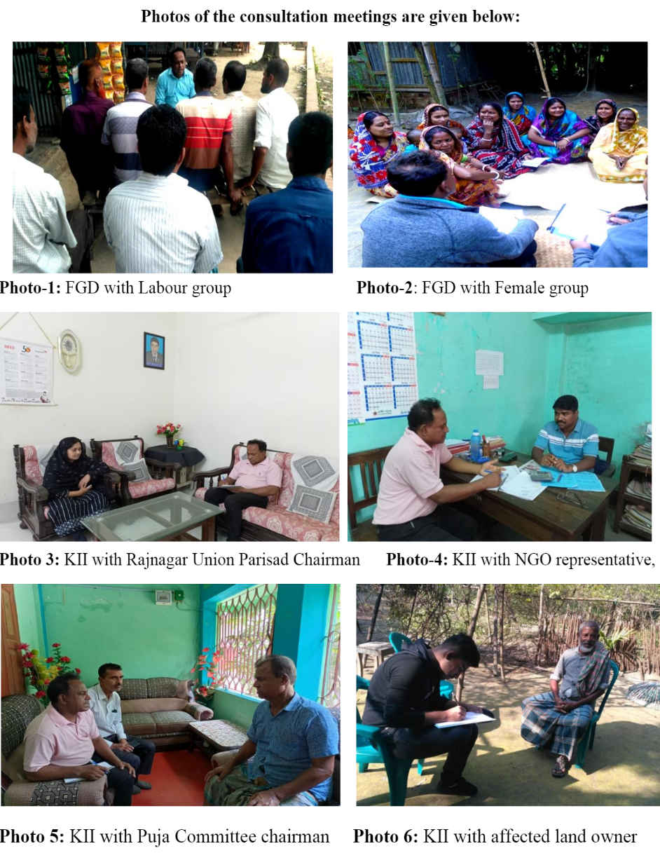

Participants of the Stakeholder Consultation
- Business Group
Location: House Yard of Sabuj Shekh, Chalkgona, Rajnagar Union, Rampal, Bagerhat
Date: 13.4.2022, Time: 11:30am
Sl. No | Participant | Mobile No.
1 | Sabuj Sheikh | 01944836140
2 | Seikh Ayub Ali | 01710623897
3 | Mojaffar Sheikh | 01926942362
4 | Sharif | 01786344280
5 | Masud Rana | 01760091507
6 | Al Mamun | 01799801464
7 | Abid | 01775123226
8 | Jatish Kumar Hawlader | NA
9 | Azharul Islam | 01912612877
10 | Zihad Hawlader | 01909390994
11 | Md. Litu Sheikh | 01924183439
12 | Suman Shikder | 01790478431
13 | Mamun | 01982663375
14 | Majid | 01761855000

- Women Group
Location: House Premises of Renuka Das, Moidhara, Rajnagar Union, Rampal, Bagerhat
Date: 14.4.2022, Time: 11:30am
Sl. No | Participant | Mobile No.
1 | Renuka Das | 01408702886
2 | Monisha Dhali | 01948925597
3 | Ripa Das | 01993883985
4 | Rita Das | 01929613328
5 | Chockla Das | 01961171690
6 | Bishakha Sarker | 01934705361
7 | Binota Boiragi | 01921781792
8 | Biporna Roy | 01856070237
9 | Lovely Sarker | NA
10 | Archana Sarker | NA
11 | Asha Lata | NA

- Civil Society
Location: House of AbuBakar, Kaliker Ber, Rajnagar Union, Rampal, Bagerhat
Date: 15.4.2022, Time: 11:30am
Sl. No | Participant | Mobile No.
1 | Md. Abu Bakar | 01957256129
2 | Chanchal Hawlader | 01772426327
3 | Md. Habil Khan | 01610474886
4 | Md. Raju Sheikh | 01997687171
5 | Md. Milon Hawlader | 01932248299
6 | Md. Helal Sheikh | 01913474805
7 | Rupam Das | 01926440112
8 | Md. Hafiz | 01919278425
9 | Md. Abu Hasan | 01922654375
10 | Md. Azizul | 01757546601
11 | Munna Khan | 01671087778
12 | Md. Ismail Molla | 01763863081
13 | Ziaur Rahman | 01905803950
14 | Kabir | 01947268902
15 | Hanif | 01979944536
16 | Tahmim Hasan | 01970998122

- Fishermen Group
Location: Project Gate, Rajnagar Union, Rampal, Bagerhat
Date: 16.4.2022, Time: 11:30am
Sl. No | Participant | Mobile No.
1 | Boidanath Mistry | 01765593908
2 | Krisnapada Biswas | 01920504062
3 | Subrata Das | 01758686365
4 | Suman Mandal | 01791430387
5 | Liton Shikder | 01791953925
6 | Pankaj Mistry | 01757828681
7 | Utpal Mistry | 01915244451
8 | Sanjib Mistry | 01754457965
9 | Ocinta Das | 01952729535
10 | Bisna Das | 01986606296

Signed participant lists are provided in Annex-8.1.

Stakeholder Identification and Mapping

Stakeholders and Information Needs
For the purposes of the SEP, as defined in the World Bank Environmental and Social Framework, “stakeholder” refers to individuals or groups who:
(a) are affected or likely to be affected by the Project (project-affected parties); and
(b) may have an interest in the Project (other interested parties).
The stakeholders were identified on the following criteria:
- Confirm the stakeholders and groups who were identified in initial scoping exercises and further revise and update the stakeholder list with input from key stakeholders;
- Analyze the level of impact the Project have on each stakeholder group, their level of interest, influence and importance, to identify the level of engagement required for each group; and
- Identify engagement strategy with each stakeholder group and assign responsibility to team members.
- Mapping and identification of key stakeholders such as primary (directly influenced by the Project) and secondary (indirectly influenced by the Project) stakeholders;
- Undertaking expert consultations, interviews and focus group discussions (FGD) with the respective stakeholders;
- Assessing the influence and impact of the Project on these stakeholder groups;
- Summarizing key findings and observations from the consultations; and
- Preparing a future stakeholder engagement strategy for a more detailed assessments at a more detailed level taking into account the various Project lifecycle phases and their implications on the stakeholder

Local Authorities and Regulators
The Community Liaison Officer (CLO) has established communication with the Rajnagar union parishad. The local chairman and members are expected to play key role in identifying local needs and project related problems and apprehensions. They shall receive the project related information in paper copy or over email, as appropriate. The CLO will maintain regular telephone contact with the chairman and during construction period conduct several meetings in relation to the development and implementation of the Corporate Social Responsibility Program (CSRP). The councilor is expected to be a driving force in organizing the local community if this is required to implement the CSRP. The rural area union council will be informed about the results of the CSRP discussion and employment plans.
Communication with the regulators will be formal and within the required by the legislation framework. No additional information will be addressed to them directly.

Project Workers
The project workers and the contractors will be informed on the employment conditions, on changes to the work requirements and likely duration of their involvement. The grievance handling mechanism will also be explained.

Suppliers of Goods and Services
The Company will ensure fair selection and allow potential suppliers to have sufficient time for building qualitative and quantitative capacity for the required services. The Company management will conduct meetings with managers of the businesses that may benefit from the project or be negatively affected by them and ensure that the businesses are aware of the services (character and volume) that are planned to be procured locally and the contractor selection process.
The Company will be responsible for establishing communication with suppliers and will ensure that health, safety, environmental and social requirements are incorporated in the contracts. The suppliers will be informed in advance that their EHS and social performance, work sites and documentation will be monitored via regular audits. The Company will provide early information on changes in demand to enable timely adjustment without jeopardizing the contractor business and personnel security. The supplier personnel involved in the project will be included in the information disclosure process and grievance mechanism.

Local Population
The local population is represented by the rural area by the rural Union Parishad Chairman. The villagers are expected to be interested in the project related jobs and qualification improvement opportunities in the nearest future and in a longer perspective. The CLO will disclose the list of professions that will be required by the project at each phase, regular information on the work progress and the grievance mechanism.
The project information location will be disclosed through the local mass media. The media will also be fed with the project updates regularly and will be expected to disclose it. A local shop at the central crossing of Chalkgona village was suggested to be the most appropriate place for sighting the project information.

Local Media
The CLO will identify a point of contact in the popular regional newspaper and provide him with initial project information, impacts, benefits and opportunities, explain grievance mechanism and give detailed project information on request. The paper is expected to disclose the project information to a wider audience in an accessible and culturally acceptable form.

Non-Governmental Organizations
The Community Liaison Officer (CLO) will establish email contact with representatives of the regional environmental and social NGOs like BRAC, ASA, Grameen Bank etc. to provide them with initial information on the project. The missed NGOs are expected to apply to the CLO through the grievance mechanism. International NGOs with an interest in the project may obtain information in Energon Renewables (BD) Ltd. website.
Table 8-4: Summary of issues and concerns raised by the people and responses provided
Questions to the Respondents | Participants opinion, comments and suggestions
Are you aware about the activities of the 100 MW Grid Tied Energon Renewables (BD) Ltd Solar Park project? If yes, what are they? | Yes, the project proponent has shared this information with us. The owner will establish the solar plant, which will be connected to the main grid, and then government will distribute electricity among us. It is a good initiative for the local people.
How will the project impact on surrounding environment? Please mention both positive and negative sites. | The project will have less environmental impact because the project area is surrounded by boundary wall and the project area is far away from the residential area. Most importantly the project will not have toxic emissions nor it will not produce any harmful liquid effluent.
Any air pollution in the area due to the project activities during construction? If yes, how to mitigate? | The air quality will not be affected significantly because the area is situated in the char island where the community people is living outside of construction activities. Roads need to be constructed dust free paved for carrying construction materials. Transportation of materials will be used river vessels and boat. Construction of building for workers shed and other facilities will decrease the local air quality temporarily. As the project site is far away from the residential dwellings so there is minor possibility of anticipated impact but proper care about panels, sensitive equipment etc. should minimize the anticipated impact. The proponent needs to take some attention to reduce this impact
Any noise- impact of the project during construction and operation at the locality? If yes how to mitigate? | The noise level will increase a bit because of running construction machineries and movement of workers. The effect will be temporary. After the construction is finished, the noise level will return to the previous limit. Still, there should be proper noise barrier or boundary wall at the noise source to minimize the minor possibility of the anticipated impact. The proponent needs to take some attention to reduce this impact. All construction activities should be stopped after 6P.M.
Any impact on local soil due to the project activities? If yes, how to mitigate? | Agricultural land will decrease because of the implementation of this project. The implementation of this project will hamper the nearest agricultural practices of the proposed plant area. Any spillage of chemicals and toxic materials will degrade the soil quality of the project site. The project proponent should take proper attention regarding this accident. The waste materials should be maintained properly, and it should not be kept at dumping place.
Any impact on ground/ drinking water quality due to the project? If yes, how to mitigate? | There is no problem with the groundwater quality because of the Grid tied Solar Power Plant construction. However, the project proponent should confirm that no accidental spillage or washout of hazardous/waste material to surrounding water bodies during construction; particularly in the monsoon.
Any impact on the surface water body (river, pond, khal, beel, canal etc.)? If yes, how to mitigate? | There is no problem with the surface water quality because of the Solar Power Plant construction. However, the project proponent should confirm that no accidental spillage or washout of hazardous/waste material to surrounding water bodies during construction; particularly in the monsoon.
Is the proposed area inundated during flood? If yes, how much? | The project area is low land and the land used to underwater for six months a year. However, after filling of the project site no significant inundation too place.
Is wildlife (birds, snakes, crabs, fox etc.) available in the area? If yes, mention their name. Among them which are endangered? | The availability of the wildlife (birds, snakes, crabs, fox etc.) is moderate in this area. No endangered species are found.
Are any Environmental Protected Area (EPA) / Environmental Sensitive Area located nearby the project? If yes, where & how far from the project? | Sundarbans is situated here which is about 50km far from the project site and will have no impact on the Sundarbans as there are no air pollution and no toxic effluent is produced
Is there any particular sensitive area nearby the project that you think should be protected? If yes, where & how far from the project location? | No particular sensitive area nearby the project area. But there are schools, mosques, graveyards within 2 to 5 km radius.
Will the project impact on your social and economic sector? If yes, how? | Yes, due to the implementation of this project unskilled and poor women can develop their skills. They will help their family by earning money which in the long run will contribute to the national economy. The local economy will develop after having the access of electricity.  The educational status of this area will develop
Are you in favor of this project? Why? | Yes, we all support the project. We appreciate the initiative. This project in the long run will help to develop the economic and social condition in this area as well as the country also

Stakeholder Engagement Plan (SEP)
Stakeholders are the entities those have stake or share of a project and who are affected directly or indirectly by a project. Generally individual, group, any organization or community within particular projects influence area are considered as stakeholders of the project. The World Bank Operational Policies suggests that the operating company should have a Stakeholder Engagement Plan (SEP) for better development practices.
Stakeholder Engagement Plan is considered to be a useful tool for maintaining communications between the project authority and its stakeholders. It will help to improve and facilitate decision making of the local community and will create an atmosphere in such a way so that the stakeholder groups are provided with sufficient opportunities to improve their livelihood. Major components of Stakeholder Engagement Process are detailed out in Annex-8 for reference.

Public Disclosure
Once the ESIA report is finalized, ERBL should disclose the document on their website for public opinion and comments. After approval, the final version of ESIA report should be accessible to general people. The executive summary should be translated in local language Bangla. The plant should have the final ESIA report and refer to it whenever needed.

Grievance Redress Mechanism

Introduction
Environmental and social complaints will be handled in accordance with the mechanism for repairing project complaints. An open and transparent dialogue will be maintained with the people affected by the project when necessary. The grievance redress mechanism (GRM) for the project provides an effective approach to complaints and the resolution of problems made by the affected community in a reliable manner. This mechanism will remain active throughout the life cycle of the project.
There are two types of grievances to be considered,
1. Internal Grievance
This includes employees hired specifically for the site. Complaints pertaining to amount of wage, salary, other remuneration or benefits, disbursement of remuneration, Working condition, health and safety of the employees etc.
2. External Grievance
Contractor and Labor related Grievances: Community Grievances including those on land and resettlement issues, project activities, CSR, intervention, employee / worker-community conflicts, and other project related issues.
Grievance Redress Mechanism (GRM) adopted by ERBL is described in Annex-9.

Purpose & Objectives
The grievance redressal committee is committed to making available a system to reduce risk for projects, offer communities as an effective avenue for expressing concerns, achieving remedies and promoting a mutually constructive relationship. Grievance redressal committee maintains a locally based, formalized way to accept, assess, and resolve community complaints concerning the performance or behavior of a company, its contractors, or other employees. The specific objectives of the GRC are as follows:
- To allow stakeholders the opportunity to raise comments/concerns;
- To structure and manage the handling of comments, responses and grievances, and allow monitoring of the effectiveness of the mechanism; and
- To ensure that comments, responses, and grievances are handled in a fair and transparent manner, in line with the applicable reference framework.

Membership
- Executive GRC – Level I – Comprising of onsite team of ERBL, stakeholders and community representative(s)
- ERBL Director – Power
- Project Manager
- EHS & CSR responsible person
- Legal Service and Land Procurement Team members-ERBL
- Community Representative
- Corporate GRC- Level II – Comprising of Executive team of ERBL
- ERBL Director – Power
- Head of Coordination & Support Service, Administration Department
- Plant Manager
- Head of Project Engineering
- EHS & CSR responsible person from project

Meetings and Disclosure
- The meetings and discussions to be undertaken for the local community in the villages in and surrounding the project area and will be held at various levels, such as the district headquarters, village levels, wards and camps. The venue and timings of the meetings and discussions will be finalized in consultation with the stakeholder groups and communicated to larger stakeholder group using public addressal systems and pamphlets.
- In addition to these meetings being undertaken across the local community as a whole, specific meetings will be undertaken across critical stakeholder groups such as the vulnerable groups and PAFs. Through these meetings an attempt will be made to allow these groups to give their unique viewpoints and feedbacks for the project while ensuring that these groups are involved in the implementation, review and monitoring of the ESMP in general.
- The proceedings of these meetings and discussions will be properly documented, as minutes and in photographs and copies of the same will be shared with the stakeholders for their records.
- As a part of the disclosure, the stakeholder reports or the key public consultation findings or the grievance related records can also be made available on the ERBL website and on a public notice board outside Power plant complex.
- Stakeholders including employees, contractors, village heads, government agencies, etc. will be informed of the GRM and will be advised to route any complaints received to them, to the CLO/ Grievances Officer of ERBL.

Duties & Responsibilities of GRC
During the project life cycle, the GRM implementation will be the responsibility of the two-tiered Grievances Redressal Committee (GRC) – Corporate GRC and Executive GRC. The two-tiered system, members and their roles and responsibilities are explained below-
a. Review, consider and resolve grievances related to social and environmental aspects received by the Project and its internal stakeholders (including investors, employees, contractors and third-party workers);
b. Entertain grievances of indirectly affected persons and/or persons affected during project implementation;
c. Resolve grievances within a period of two weeks at the GRC level and communication of the resolution to the aggrieved party;
d. The GRC shall not engage in any review of the legal standing of an “awardee” nor shall deal with any matters pending in the court of law;
e. The GRC will not prevent or prohibit access to legal redress that is enshrined in the judicial system of Bangladesh;
f. Arrive at decisions through consensus, failing which resolution will be based on majority vote. Any decision made by the GRC must be within the purview of Environmental and Social Management Plan, Corporate EHS and Social Policies of ERBL or any such documents of relevance of that matter;
g. In case the grievance relates to environmental monitoring results or engineering matters, the GRC will validate the information available to it, as provided by the Project Company’s Project management team/ environmental monitoring team. However, GRC will not be in a position to question the validity of the data provided to it. The GRC team shall meet at least twice a month for review of grievances registered and the resolution vetted out to the concerned parties. The frequency of meeting may increase or decrease depending on the number grievances received;
h. If needed, may undertake field visits to verify and review the issues, dispute or other relevant matters.
Admin In-Charge (ERBL) shall be responsible for ensuring implementation of the grievance redressal procedure at site. He shall review the records pertaining to grievances received during construction phase and inform the Community Liaison Officer (ERBL). He shall also be a member of the Level – I Grievance Redressal Committee at site level.
Community Liaison Officer (ERBL) shall be nominated as the Grievance Officer and will report directly to the Admin Manager (ERBL). He shall be responsible for communicating with the community on resolved grievances and shall maintain records on grievances received and actions taken during construction phase of the project.

Current Practices of ERBL Regarding Grievance Redress
At present, ERBL management has set up two transparent grievance boxes- one inside the plant (in Plot A) and one at the main gate of Plot B. Villagers or nearby community can share their suggestions/ complains to ERBL management through the grievance boxes. During the Environmental and Social Audit, it was observed that ERBL had received one grievance so far. The details are mentioned in Annex-14 Section 5.2.4 Grievance Redress Mechanism.

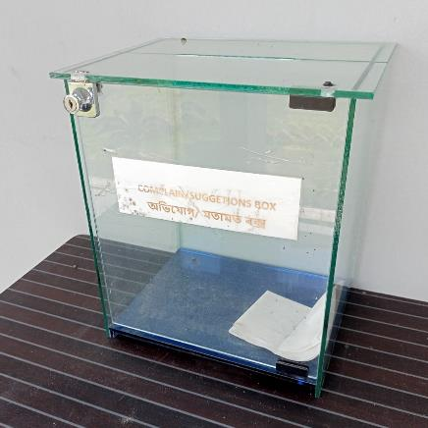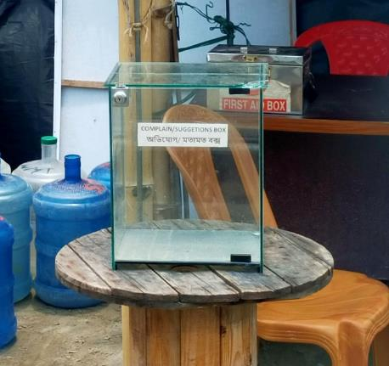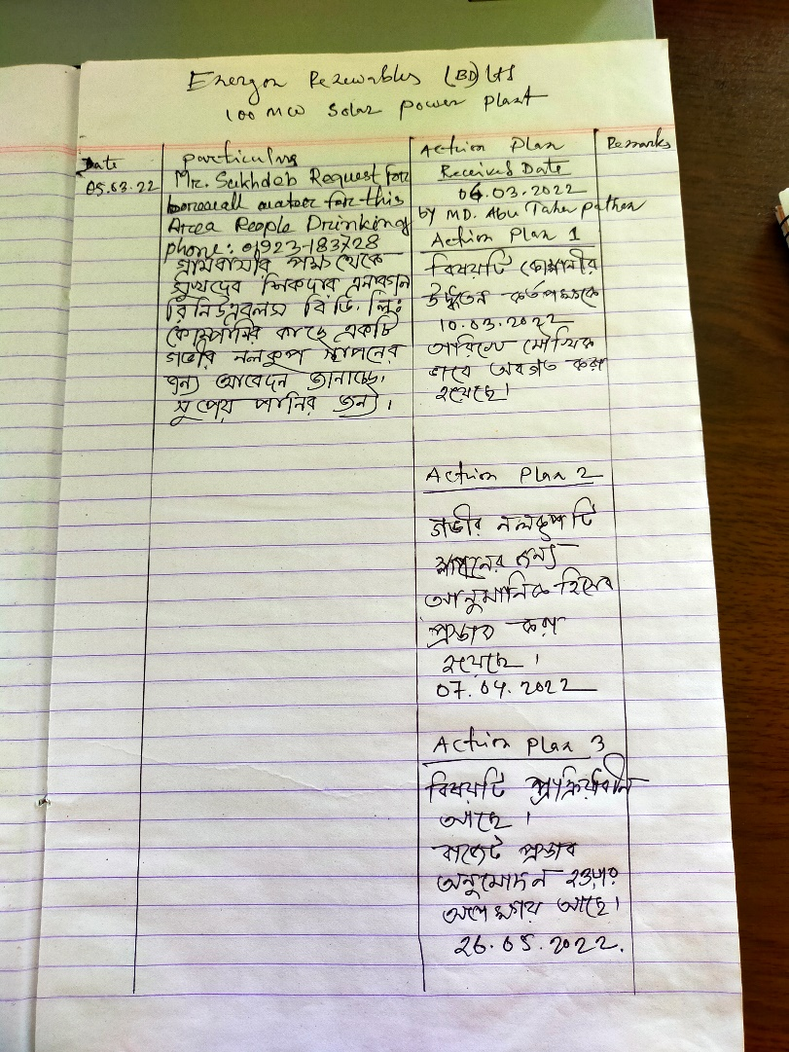

Risk Analysis and Identification
Risk analysis and identification for the operation phase has been carried out on qualitative basis. Each of the impacts has been analyzed and categorization has been made based on the impacts being high, medium and low.
Table 10-1: Anticipated Risks on Important Environmental & Social Components during Operation Phase
Project Stages/Source of Risks | Anticipated Risks on Important Environmental & Social Components during Operation Phase |  |  |  |  |  |  |  |  |  |  |  |  |  |  |  |  |  |  |  |  |  |  |  |  |  | Comments
Project Stages/Source of Risks | Natural Environment |  |  |  |  |  |  |  |  |  |  |  |  |  |  |  |  |  | Socio-economic Environment |  |  |  |  |  |  |  | Comments
Project Stages/Source of Risks | Land / Agriculture |  |  | Air |  |  | Hydrology & Drainage |  |  | Noise |  |  | Vegetation |  |  | Terrestrial/  Aquatic Fauna |  |  | Human Health |  |  | Homesteads |  |  | Employ-ment |  | Comments
Project Stages/Source of Risks | Low | Medium | High | Low | Medium | High | Low | Medium | High | Low | Medium | High | Low | Medium | High | Low | Medium | High | Low | Medium | High | Low | Medium | High | Adverse | Beneficial | Comments
Impacts on Aquatic Ecology |  |  |  |  |  |  |  |  |  |  |  |  |  |  |  |  |  |  |  |  |  |  |  |  |  |  | There will be minimal discharge during operation phase of solid waste and water.  Mitigation measures:  No mitigation measure is required.
Health and Safety |  |  |  |  |  |  |  |  |  |  |  |  |  |  |  |  |  |  |  |  |  |  |  |  |  |  | There will be no emission (Sox, NOx, CO and PM) in the operation phase. So, there will be no adverse risk on workers.  Mitigation Measures:  No measure is required.
Solid Waste Management |  |  |  |  |  |  |  |  |  |  |  |  |  |  |  |  |  |  |  |  |  |  |  |  |  |  | Insignificant amount of solid waste will be generated from the office building and canteen.  Mitigation measures:  The waste should be collected and disposed for recycling purposes outside the project area.
Hazardous Materials Storage |  |  |  |  |  |  |  |  |  |  |  |  |  |  |  |  |  |  |  |  |  |  |  |  |  |  | Hazardous materials like transformer oils/ spent oils and solvents required for coating of PV panel fittings etc. may be stored in the plant site.  Mitigation measures:  Transformer oils/ spent oils should be stored adequately in drums with secondary containment and sealed and marked as hazardous. These should be stored in a designated area. Periodically these materials should be disposed to outside DoE approved contractors for proper disposal.
Transmission line, switch gears and transformers |  |  |  |  |  |  |  |  |  |  |  |  |  |  |  |  |  |  |  |  |  |  |  |  |  |  | Certain amount of electromagnetic radiation will occur near the transformer, switch gear and transmission lines.  Mitigation measures:  - Design of transmission line, switch gear and transformer to comply with the limits of electromagnetic interference  - The electricity transmission area should be fenced and limited accesses of workers are to be ensured.  - The electromagnetic radiation should be monitored by a third party on an annual basis.

Impact Identification and Mitigation/ Optimization Measures

Introduction
This section describes the various interactions of the Project with physical, ecological or social environment thereby leading to potential impacts to resources/ receptors. It has been organized as per the various phases of the project life cycle to understand the risks and impacts associated with each phase.

Scope of the Assessment
The scope of the assessment captures the understanding on the possible risks and impacts assessed during the scoping exercise of this impact assessment study as well as the risks identified during subsequent physical baseline assessment and impact evaluation process. The key environmental and social issues and risks identified are further elaborated in the following section.
As the construction period is over and the solar plant is already in operational phase, the impacts in the construction phase were not considered and excluded from the report.

Identification of Impacts of Landfilling and Land Use Change
During construction phase, sand filling was one of the most challenging works. Approx. 124,957,633 cft sand was used for landfilling. Sand for landfilling was sourced from Batiaghata, Khulna (about 30 km from the project site) and Ghashiakhali, Bagerhat (about 40 km from the project site).
Chemical analysis of soil was done during the geotechnical soil investigation which was conducted by BD Soil & Foundation in June 2020. Please refer to Annex-10.2 for the test results of chemical analysis of soil samples.
Filling and earth work at the Project site may increase the erosion, especially during rainfall, which may increase the suspended sediment concentrations and pollute water sources. The site filling activity may disturb the natural drainage of the site. Construction activities (filling of site, handling of construction material) can cause fugitive and point source emission due to generation of windblown dust. This may have adverse impact on local ambient air quality.
The fugitive dust related impacts were minimal and reversable. As the site development activity is completed, the sensitivity of landfilling is considered to be low and impact significance of landfilling is assessed to be of minor significance.
Previously major portion of the land in the project site was unutilized (Bilan). Except limited aquaculture, most of the land was unutilized. The landowners leased land for aquaculture activities during March to October. The leaseholders engaged labors for fish farming. Also, there was no residential unit within the project site. As the project site is kept unutilized for most of the months of each year, the landowners were voluntarily interested to sell the land with reasonable purchase price. So, the issues related to resettlement and relocation due to project implementation were not required to be undertaken for this site. As a result, the land use change has resulted into minor impacts on landowners, leaseholders and laborers.
Mitigation Measures
- Special care was taken during sand filling at the project site.
- The whole project was divided into many sub sectors for sand filling purpose to minimize disturbed area for dredging water discharge, soil stabilization, slope protection.
- During sand dredging control. the runoff of water also created a sand sedimentation trap for smooth dredging works
- The project implementation will generate employment and increase land price of the locality as positive impacts

Identification of Environmental Impacts in Operation Phase

Impact on Soil Environment
The table below indicates the possible impacts on the soil and its severity during the operation phase of the solar PV power plant.
Sl No. | Impact/ Effect | Assessment of consequence of the impact
Sl No. | Impact/ Effect | Negligible | Low | Medium | High | Extremely Dangerous
1 | Soil of the project area can be damaged due to soil erosion | √
2 | Sediments or hard particle dust containing NOx and SOx may lay down on water and soil surface and spread beyond the local flora and fauna, which may have a negative impact | √
3 | Soil compaction and erosion due to vehicle movement |  | √
4 | Fuel and lubricant leakage, infiltration and soil pollution |  | √
5 | Waste Generation and Soil Contamination |  | √
In the operation phase, soil compaction and erosion as well as fuel and lubricant leakage may occur due to vehicle movement, which only happens during the occasional maintenance activities. Soil compaction for the operation phase has therefore, been considered to be occasional and low.
During the operation phase, the waste generated from the project includes domestic solid waste at office building and substation and hazardous waste like waste oil and lubricants and oil containing jutes and rags will be generated during maintenance activities. The quantity of municipal and hazardous waste generated in the operation phase will be very less and therefore the impact on soil contamination will be low.
Mitigation Measures
Soil Compaction and erosion | - Vehicles will only utilize the existing access road to undertake maintenance activities at the solar power plant.
Waste generation and soil contamination | - The waste generated will be disposed of through approved vendors.  - The hazardous waste will be stored onsite at separate designated covered area provided with impervious flooring and sent for disposal through an authorized vendor.  - It will be ensured that hazardous waste containers are properly labelled and stored onsite provided with impervious surface, shed and secondary containment system.  - It will be ensured that routinely disposal of hazardous waste through approved vendors and records are properly documented.  - Ensure regular maintenance of all equipment and machinery used onsite. If there is a risk of hazardous material spillage during such maintenance, such maintenance shall take place on suitable locations to prevent spilling on the land. Further, dripping pans shall be installed on machinery which is likely to leak hazardous materials such as oil and fuel.  - Spill control kits will be used to contain and clean small spills and leaks during O&M activities.

Impact on Water Environment
Water requirement during O&M phase is primarily for module cleaning. Extracted groundwater is treated with RO system and stored in water tanks for uses. Daily water requirement for solar PV modules cleaning purposes is 23,000 litre/day and for domestic use is 4,000 litre/day during operation phase of the project. Five bore wells have been installed at the site. According to a case study conducted on groundwater availability at Rampal Upazila, it has been concluded that there is considerable amount of water available in the aquifer. (Nahin et al., 2020). Hence, the water consumption of this project is not expected to adversely affect the water availability for the local community.
There shall be minimal discharge of wastewater from cleaning of Solar PV modules. The wastewater originating from cleaning operations will be discharged into the drain without significant impact as the washed off water will only contain soil dust settled on PV panels. So, the impact on the water environment can be considered low.
Mitigation Measures
- Logbook will be maintained for water consumption.
- Water usage will be optimized in the office buildings by the application of water conservation measures such as sensor-based taps, low flush urinals, etc.
- Workers and staffs will be trained about water conservation and encouraged for optimal use of water.
- Regular inspection will be done for the identification of water leakages and preventing wastage of water from water supply pipelines and tanks.

Impact on Noise and Air Quality
The solar power as a facility is not considered to exhibit any significant noisy operations, although the facility’s inverters and transformers may produce noise, but this is not considered a serious issue, since they will not generate any significant noise.
Plant operation would not significantly affect the air quality, as there are no any gaseous emissions during operation phase from the project.
There is no net GHG emission from the project. However, GHG avoidance can be calculated from grid emission calculation.
If the monthly production of 16,320 MWh grid is replaced with Solar PV generation, GHG emission of 0.5635x16,320=9,196 tons of CO2 per month i.e. 110,352 tons of CO2 per year can be avoided.
Here, GHG emission factor of Grid is 0.5635-ton CO2/MWh
* The Green House Gas (GHG) emission factor for Bangladesh has been collected from IFC’s Carbon Emissions Estimation Calculator (CEET)
In ERBL premises, total 28 ACs have been installed. Refrigerants used in these ACs are R410A & R22. R-410A is a hydrofluorocarbon (HFC) which does not contribute to ozone depletion. But R22, hydro-chlorofluorocarbon (HCFC), not only has ozone depletion potential but also has high global warming potential. So, care should be given while choosing the right refrigerant during replacement of ACs.

Mitigation Measures
- For air-conditioning, HCFC refrigerants such as R-22 will not be used as they have ozone depleting potential as well as global warming potential.
- Regular inspection and maintenance of air-conditioning and refrigeration appliances will be conducted to prevent and minimize refrigerant leakage.
- Re-filling records will be kept and maintained.
- For existing air-conditioning and refrigeration appliances that operate on HCFCs, the refrigerant will be recovered or recycled whenever an overhaul of equipment is to be carried out. Replacing or retrofitting such equipment to operate on non-HCFCs refrigerant will also be considered.
- Alternative refrigerants will be looked for future replacement or purchase.

Identification of Impacts of O&M Activities in Operation Phase
Compared to most other power generating technologies, PV plants have low maintenance and servicing requirements. However, proper maintenance of a PV plant is essential to optimize energy yield and maximize the life of the system.
Thorough scheduled maintenance, the requirement for unscheduled maintenance should be minimized; although, inevitably, some failures may still occur. A robust and well-planned approach to both scheduled and unscheduled maintenance is important and will be undertaken. Annex-11.1 describes the possible O&M manual with SOPs for an ideal solar PV plant. ERBL’s Environment, Health & Safety policy is also described in Annex-11.2.

Impacts of Hazardous E-Waste in operation Phase
Various electrical equipment such as solar PV panels, inverter, rectifiers, batteries and electrical cords are used in the power plant. A small quantity, approximately 20 KVA battery bank (VRLA type) is used for internal control & protection relay power supply system. Usual lifetime of such Lead-acid (VRLA) batteries is 2 years. VRLA type battery is using AGM Technology which is non-hazardous and 100% recyclable. It has low self-discharge rate less than 2% per month which ensures long shelf-life. After lifetime expiration, these are required to be disposed through DOE authorized battery recycling companies for reprocessing.
Some of this electrical equipment may get damaged or broken during operation phase. Over the time, the amount may accumulate to a significant quantity. These E-waste can be categorized as hazardous waste. There are now several E-waste disposal companies authorized by DOE; any disposal will be done through these companies.

Mitigation Measures for Hazardous Waste Storage
- Waste will be stored in a manner that prevents the mixing or contact between incompatible wastes and allows for inspection between containers to monitor leaks or spills.
- Hazardous waste will be stored in closed containers away from direct sunlight, wind and rain.
- Secondary containment systems will be constructed with materials appropriate for the wastes being contained and adequate to prevent loss to the environment
- Secondary containment will be included wherever liquid wastes are stored in volumes greater than 220 liters. The available volume of secondary containment should be at least 110 percent of the largest storage container, or 25 percent of the total storage capacity (whichever is greater) in that specific location
- Information on chemical compatibility will be readily available to employees, including labeling each container to identify its contents
- Access to hazardous waste storage areas will be limited to employees who have received proper training
- Clearly identifying (label) and demarcating the area, including documentation of its location on a facility map or site plan
- Periodic inspections of waste storage areas will be conducted and the findings will be documented
- Spill response and emergency plans will be prepared and implemented to address their accidental release.

Mitigation Measures for Hazardous Waste Transportation
- On-site and Off-site transportation of waste will be conducted so as to prevent or minimize spills, releases, and exposures to employees and the public.
- All waste containers designated for off-site shipment will be secured and labeled with the contents and associated hazards, be properly loaded on the transport vehicles before leaving the site, and be accompanied by a shipping paper (i.e., manifest) that describes the load and its associated hazards.

Mitigation Measures for Hazardous Waste Treatment and Disposal
- The technical capability will be developed to manage the waste in a manner that reduces immediate and future impact to the environment
- All required permits, certifications, and approvals will be acquired from applicable government authorities
- It will be ensured that commercial or government waste contractors handling, treating, and disposing of hazardous waste are reputable and legitimate enterprises, licensed by the relevant regulatory agencies and following good international industry practice for the waste being handled.
- Compliance with applicable local and international regulations will be ensured.

Identification of Ecological Impacts in Operation Phase

Collision and Electrical Hazards from Transmission Infrastructure
Transmission lines and poles can potentially constitute an electrocution and collision hazard to birds. Some birds also utilize the transmission towers for nesting.
Transmission line from the pooling substation to the Grid Substation is passing through corridor scrublands, so risk of mature tree cutting is much less. Furthermore, baseline has already established that the study area only provides habitat for only Least concerned species. Faunal Species found in the study area included Least Concern as per the IUCN Red List and Bangladesh Red List.

Impact on Endangered or Vulnerable Species
During the construction period, only scattered shrubs were cleared out for site development. These shrub habitats are important for several common birds, waterfowl, p. Heron and egrets. However, these impacts were limited within the project boundary. In the operation phase, the management planted various native plants which will significantly improve the ecology of the area. This will provide habitat for the avifauna, reptiles and small mammals and will enhance ecology of the area. Plantation also carried out along both side of access road. (Please refer to Photo 14 in E&S Audit report).
Construction work including land filling by dredging, sand lifting, site clearance and physical construction of plant setup, may have impacted on open water fish habitats and fish diversity. Fishing habitats in open waters such as rivers (Passur, Moidhara), khals and the intertidal area may have been affected due to dredging, traffic movements and the spill of oil and chemical substances. But these impacts only lasted for a short period of time as the construction phase is over and the plant is in operation since December 2021.
Assessment of the project impact on flora and fauna in operation phase are shown below:
Sl No. | Impact/ Effect | Assessment of consequence of the impact
Sl No. | Impact/ Effect | Negligible | Low | Medium | High | Extremely Dangerous
1 | May damage or destroy the vegetation within the project area |  | √
2 | Vegetation within the project area may regress |  | √
3 | Vicinity from overgrazing of the vegetation within the project area | √
4 | Wastewater impact on the plant community |  | √
5 | Impact of flammable and lubricating materials on the plant community | √

So, the overall impact of the project on the vegetation within the project area can be classified as "low".
Sl No. | Impact/ Effect | Assessment of consequence of the impact
Sl No. | Impact/ Effect | Negligible | Low | Medium | High | Extremely Dangerous
1 | Certain species of the fauna may flee from their habitat |  | √
2 | Certain species of the fauna may flee from their habitat or extinct |  | √
3 | Wastewater impact on the fauna of the project area | √
4 | Impact of flammable and lubricating materials on the fauna of the project area |  | √
5 | Impact of the vibration caused due to utilization of heavy machinery and technical equipment | √
6 | Hunting effects on the fauna | √

So, the overall impact of the project on the fauna within the project area can be classified as "low".
During the operation phase, no harmful wastewater will be generated from the solar plant. So, there is no long-term impact on endangered or vulnerable aquatic species. Recorded species of plants and fauna, its categorization, documentation and long-term monitoring plan should be coordinated with the competent authorities.

Impact on Migratory Birds
Migration studies of birds in Bangladesh are rare, however in recent years a small number of waterbirds using Bangladesh have been fitted with satellite transmitters. Evidence so far indicates local movements within Bangladesh between wetlands; and some longer-range movements from the north-east to the lower Meghna and coast. In addition, waterfowl wintering in Orissa (India) pass through north-western Bangladesh, ducks wintering in Hakaluki Haor, migrate through Assam and on to breeding grounds spread from the Tibetan plateau and western China to western Mongolia, and even in one case a route through Manchuria to far eastern Siberia.
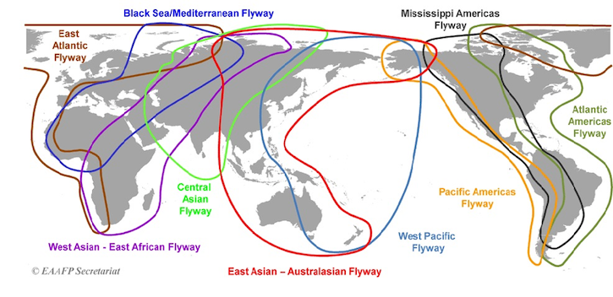
Figure 11-1: Nine Major Migratory Flyways
Flyways for migratory birds, wetlands like haor and breeding grounds of migratory birds do not fall under project area of investigation (AoI). The project area is not located on the migration route or near to sanctuary for migratory birds. Thus, the project activities, structures or transmission lines do not have any impact on the migratory birds in any way.

Identification of Social Impacts in Operation Phase

Impact on Economy and Employment
During the operation phase, the employment will be restricted to the requirement of few security personnel and few housekeeping staff at site office.
While the significance of the impact on economy and employment opportunities during the operations phase is understood to be positive, the following measures should be put in place to ensure that the local community receives the maximum benefit from the presence of the project.
Mitigation Measures
- Sourcing local labor wherever possible should be made obligatory for the sub-contractors and in all major procurement activities. The plant should establish a mechanism to audit subcontractors and suppliers with respect to compliance of utilizing local labor and resources.
- Information on local employment should be communicated to the UP and information on availability of employment opportunities should be displayed at UP office premises in the local language.
- The grievance redress mechanism of the project shall be made available to these groups, including contractual workforce engaged during operation phase in order to provide a platform to share any concerns or grievance. During the operation phase, the requirement for unskilled and semi-skilled labor is expected to drastically reduce. The local procured services will include maintenance work, of the facility, 24-hour security, bush and undergrowth cleaning and housekeeping activities etc.

Identification of the Potential Visual Impacts
The construction activities that are likely to create a visual intrusion and a disruption to aesthetics include: materials lay down, excavation, backfilling, and spoil. The project site consists of areas that are sparsely vegetated or have no vegetative covers, and hence no trees or bushes will need to be removed as part of construction. Also, there are no close densely populated communities that would be within the visual radius of the project. Therefore, visual intrusions were anticipated to be limited to employees. Hence, the visual effects of the construction were of low significance within the project area.
The main impact during operation is the visual impact of the photovoltaic panels during the day. The panels are geometric and reflective and will clearly stand out from the surrounding natural landscape. This visual impact may be perceived as positive and future-orientated rather than negative.
Besides the presence of a large area of PV panels is not expected to constitute a risk for glare since it is situated far from any airports, nor residential dwellings. Therefore, it is not anticipated that visual impacts will be generated due to the PV system design.

Identification of Climate Change Impacts
Bangladesh is located in low lying deltaic region of Ganges, Brahmaputra and Meghna Rivers, between the Himalayas, and Bay of Bengal. The country is reported to constitute of mostly low and flat lands with a network of more than 230 rivers and tributaries. Main hazards impacting Bangladesh are reported to be floods, cyclones and storm surge, tornado, earthquake, landslides, drought, and lightning. Bangladesh is reported to be one of the most vulnerable countries exposed to natural hazards like cyclones and floods. On an average, Bangladesh is reported to be hit by a major cyclone once in three years. Many of the urban areas in Bangladesh are reported to be susceptible to flooding due to storm surge and sea level rise.
Climate change is causing more frequent and more severe extreme weather events. Solar Energy projects may suffer infrastructure damage, project delays and constraints on water supplies, lost production, power supply transmission disruption and variability in energy demand. The health and safety of employees, business reputation, violation of regulatory standards, social license to operate and financial disruptions may become more prevalent.
Anticipated impacts of these climate change induced events were reported to be flooding, damage to building construction, disruption of energy transmission, increased insurance premiums, higher operating costs, early retirement of assets, decreased production capacity, and high variability in availability of water. Following is some of the anticipated impacts of climate change induced natural hazards:
Hazard | Probable impacts | Mitigation measures
Water Availability | - Reduced water availability for panel cleaning  - Reduced availability for domestic usage including sanitation and drinking | Explore opportunities for use of water saving technologies for domestic water use at Site
Riverine Floods and Coastal Floods | - Floods can erode the topsoil and expose the foundation of the PV modules,  - PV modules may get damaged due to floating debris  - Water logging may lead to settlement of foundation  - Prolonged inundation could result in electrical hazard or damage the electrical installation due to short circuiting etc.  - Additional costs for repair or replacements  - Storm surges can severely damage the project infrastructure in form of physical damage to components stationed close to ground level, water damage, washing out of loosely anchored component or temporary structure | Dyke has been constructed with a height of 5.5 m above MSL around both blocs of the project. Dyke height has been selected through a flood risk assessment of 100-year return period.
Cyclone and Wind Speed | - Direct impact on transmission line due to high wind speeds during cyclone is expected.  - However, heavy precipitation and flooding during cyclonic event may have implication similar to the riverine floods  - Damage due to high wind speeds, uprooting of solar modules and loss of electricity production  - Cost for replacement of assets | Review and update the onsite emergency response preparedness plan to include the following:  - Early warning system from national government or international organizations should be monitored.  - Directions issued by government during the cyclonic storm events should be followed.  - Include risk of high wind speed in the general emergency preparedness and response plan.

Identification of Impacts on Gender
The project has been implemented in the southwest coastal region of the country. Being a grid-connected solar project, it has required 283 acres of land. The land ownership of the project site was found both male and female and all of their ownership was considered during purchase of the land from the landowners (Annex 03). Also, during stakeholder consultation and focus group discussion, participation from women group is ensured. The land previously being mostly unutilized, no economic activity involving women employee has been observed. Therefore, based on the available information, project associated impacts on gender related issues have been considered minor and no gender assessment has been conducted for this project.

Identification of Environmental Impacts in Decommissioning Phase

Impact on Soil Environment
The decommissioning activities will cause following impacts on soil:
- Soil compaction due to the increased vehicular and workforce movement, dismantling and storage of plant components on the adjacent land, removal of internal electric lines/ poles etc.
- Waste will be generated in form of dismantling plant components and demolition debris from plant foundations, storage yard and substation complex. Electric components such as transformers, insulators, wires will be generated. The waste will be mainly of inert nature.
The possibility of soil contamination during decommissioning phase is very less though may occur due to leakage from machinery and transportation vehicles and during collection of remaining oil/ lubricants in the plant.
Removal of grounded structures and demolition of during decommissioning phase may affect the top layers of the soil and loss of top soil quality but the effects can be reversed over time. Also, as the plant is spread over 283 acres, number of labors required during the decommissioning phase is assumed to be significant. However, decommissioning phase is anticipated to last for a short period of time. Thus, the impact has been assessed to be small.
Mitigation Measure
- The decommissioning of the solar plant will be carried out in a planned manner.
- The vehicular movement during decommissioning activities should be restricted to the designated route path.
- In addition, in order to protect the surface soil erosion, trees, shrubs and perennials shall be planted and cultivated to prevent soil erosion around the area.
- Ensure regular maintenance of all equipment and machinery used onsite. If there is a risk of hazardous material spillage during such maintenance, such maintenance shall take place on suitable locations to prevent spilling on the land. Further, dripping pans shall be installed on machinery which is likely to leak hazardous materials such as oil and fuel.
- During decommissioning phase, the quantity of waste generated will be high. The waste will be routed through proper collection, storage and disposal. The waste will be evaluated for its recycling/ reuse/ scrap value and disposed accordingly.
- The demolition/ dismantling waste should not be left over in the project area and to be collected and stored at designated area only for further segregation and disposal.
- In consideration of household waste, suitable toilets, garbage and waste containers shall be installed in the project area. Latrines and drainage points shall be installed downwind side of the settlement.

Impact on Water Environment
Water, during the decommissioning phase, will be consumed by labors for drinking and domestic purposes. The source of water is treated groundwater. Also, there is a potential for contamination of groundwater and surface water resources resulting from improper management of sewage and accidental spills/leaks at the storage areas.
Mitigation Measure
- The provisions of septic tank and soak pits will be provided onsite for treatment and disposal of sewage, thereby minimizing the impacts of wastewater discharge. Planning of toilets, soak pits and septic tanks, waste collection areas should be away from natural drainage channels.
- Use of licensed contractors for management and disposal of waste and sludge
- Spill/ leakage clearance plan to be adopted for immediate cleaning of spills and leakages.
- Ensure proper cover and stacking of loose construction material to prevent surface runoff and contamination of receiving water body.
- Labors will be given training towards proactive use of designated areas/ bins for waste disposal and encouraged for use of toilets. Open defecation and random disposal of sewage shall be strictly restricted.
- Construction labor deputed onsite to be sensitized about water conservation and encouraged for optimal use of water.
- Regular inspection for identification of water leakages and preventing wastage of water from water supply tankers.
- Recycling/ reusing to the extent possible.

Impact on Air Quality
Air quality will largely get impacted from the following sources during the decommissioning phase:
- Fugitive dust emissions from site clearing, excavation work, cutting and leveling work at site and internal roads, stacking of soils, handling of construction material, transportation of material, emission due to movement of vehicles and heavy construction machinery etc.
- Emissions from emergency power diesel generator used during decommissioning activity.
The demolition activities are likely to occur for a very small period of time and therefore the impact has been assessed as small.
Mitigation Measure
- Emissions from the emergency DG set and other stationary machines will be controlled by ensuring that the engines are always properly tuned and maintained.
- Minimize stockpiling by coordination excavations, spreading, re-grading and compaction activities.
- Speed of vehicles on site will be limited which will help in minimizing fugitive dust emissions due to vehicle movement
- Idling of vehicles and equipment will be prevented.
- Burning of any waste material shall be prevented.
- Work shall be ceased or phased down if excess fugitive dust is observed. Source of dust shall be investigated, and proper suppression measures ensured.

Impact on Ambient Noise
During decommissioning phase of the project, noise will generate movement of vehicles carrying dismantled structure and equipment. Impact is considered to be small considering the decommissioning period to last for small duration.
Mitigation Measure
- Normal working hours of the contractor to be defined
- If work needs to be undertaken outside these hours, it should be limited to activities which do not generate noise.
- Only well-maintained equipment should be operated on-site
- If it is noticed that any particular equipment is generating too much noise then lubricating moving parts, tightening loose parts and replacing worn out components should be carried out to bring down the noise and placing such machinery far away from the households as possible.
- Machinery and equipment that may be in intermittent use should be shut down or throttled down during non-work periods.
- Minimal use of vehicle horns and heavy engine breaking in the area needs to be encouraged.

Impact from Solid Waste Generation and Decommissioning Requirements
If the facility is to be decommissioned and the solar array is to be removed at the end agreement, the impacts will be similar to the construction phase, but in reverse sequence. All decommissioning of electrical devices, equipment, and wiring/ cabling will be conducted in accordance with local, municipal, provincial and federal standards and guidelines. Any electrical decommissioning will include obtaining the required permits and following procedures before de-energizing, isolating and disconnecting electrical devices, equipment and wiring/ cabling. The procedures will include the following:
- The use of cranes to remove the panels, racking, inverters and transformers and the use of trucks for the removal of panels, racking, inverters and transformers.
- Decommissioning of on-site electrical lines and foundations.
Mitigation Measures
Dismantling PV modules, Racks and Supports
- All modules will be disconnected, removed from the racks, packaged and transported to a designated location for resale, recycling or disposal.
- The solar PV panels should be stored in an enclosed area, so that no contact or contamination can occur.
- If the modules are not to be reused in a different location, the glass and silicon will be reclaimed and the aluminum frames will be recycled. Locally registered electrical good disposal vendor will do the disposal as per the Environmental rules & regulations. The connecting underground cables and the junction boxes will be de-energized, disconnected and removed.
- The steel lattice racks supporting the modules will be unbolted and disassembled using standard hand tools, possibly assisted by a small portable crane. The vertical steel posts supporting the racks and all steel support posts (driven or screwed) will be completely removed by mechanical equipment and transported off-site for salvage or reuse.
- Any demolition debris that is not salvageable will be transported by truck to an approved disposal area. Other salvageable equipment and/or material will be removed from the site for resale, scrap value or disposal depending on market conditions.
Dismantling Electrical Equipment, Buildings and Foundations
- Decommissioning will require dismantling and removal of the electrical equipment, including inverters, transformers, underground cables and overhead lines, the prefabricated inverter enclosures and substation electrical building. The equipment will be disconnected and transported off-site by truck.
- Prior to removal of the transformers, the oil will be pumped into a disposal container and sealed to prevent any spill during storage and/or transportation. Equipment and material may be salvaged for resale or scrap value depending on the market conditions.

Identification of Social Impacts in Decommissioning Phase

Impact on Economy and Employment
The major social impacts associated with the decommissioning phase are linked to the loss of jobs and associated income. This has implications for the households who are directly affected, including their families. However, the impacts are likely to be limited due to relatively small number of permanent employees (mainly security guards) who will be affected.
The decommissioning phase will require removal of machinery, workers and other temporary structures. The mitigation measures for decommissioning shall include the following:
- ERBL should ensure proper communication in terms of decommissioning timelines, and shall evaluate options of internal transfer of employees to other projects before planning for closure, in order to minimize retrenchment linked job losses;
- The contractor shall inform the workers and local community about the duration of work, in advance, to clearly set out and manage expectations;
- Reduction of worker will be done phase wise and corresponding to completion of each activity.
- Develop and implement a Workers Health and Safety Plan which ensures the safety of any employee on the site. Such plan should, among others, include the proper maintenance of any machines and tools used, the proper instruction and training of personnel to use such machines and the supply of adequate equipment for the workers.
- Implementation of a Camp Management and Security Management Plan to ensure the workers access to safe and healthy work and living environment.
- Make sure that health screening is conducted for employees both before their employment and throughout the contract period on an irregular basis. Increase awareness on communicable disease prevention and collaborate with an on-site medical team.

Environmental and Social Management Program (ESMP)

General
This section presents the Environmental and Social Management Plan (ESMP) for the solar project. The purpose of ESMP is to specify the standards and controls required to manage and monitor the environmental and social impacts during the operation phase. To achieve this, the ESMP identifies potential adverse impacts from the planned activities and outlines mitigation measures required to reduce the likely negative effects on the physical, natural and social environment. This is in accordance with IFC Performance Standard 1 which emphasizes the importance of managing social and environmental performance throughout the lifecycle of the project.
The mitigation measures proposed in another chapter of this ESIA Report, which are designed to avoid or minimize impacts during construction, operational and decommissioning phases of the project form the basis of this Chapter. This Chapter presents the specific plan for implementing the mitigation and addressing community grievances within the framework of an Environmental and Social Management Program (ESMP). The following principles were used to guide the preparation of the ESMP:
- Focus on occupational health, safety, and environment risk prevention;
- Affordable, safe technologies are used wherever failure of equipment would have a significant effect on safety, health, or the environment;
- Conformance with relevant standards, codes, and practices will be considered in the application of the safe technologies;
- All activities will be performed in a safe and effective manner and all equipment will be maintained in good operating conditions for the protection of health and safety of all persons and the conservation of the environment and property;
- All necessary precautions are carried out to control, remove, or otherwise correct any hazardous materials leaks and/or spills, or other health and safety hazards;
- All activities and components related to construction of the power station will meet relevant international standards which ensure sufficient technical levels of safety; and
- Necessary measures will be ensured to redress grievances that the communities within and in the proximity of the Project Site might experience.

ERBL’s Organizational Structure

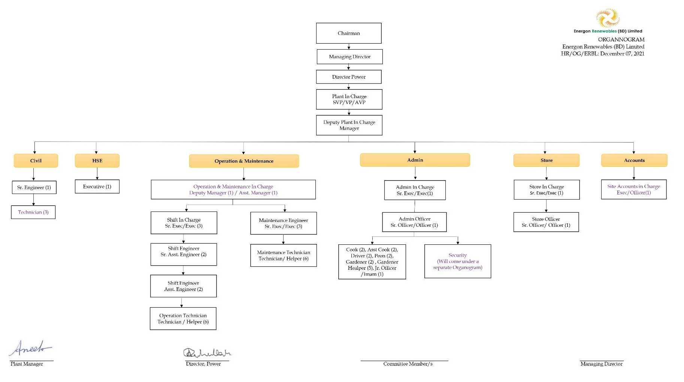

Roles and Responsibilities
Environmental, Health & Safety (EHS) department is responsible for monitoring the implementation of the various actions which are to be executed by the agencies specified in the ESMP. In general, EHS department has to perform the following activities:
- Preparation of required documents on environmental and social management;
- Ensuring availability of resources and appropriate institutional arrangements for implementation of ESMP;
- Implementation of the health and safety measures;
- Collection of the statistics of health of workers;
- Providing support during routine medical check-ups of workers;
- Awareness and implementing safety programs;
- Providing job specific induction training;
- Compliance of regulatory requirements;
- Carrying out environmental audits;
- Identify unsafe acts & conditions and suggest remedies;
- Develop safety culture and comply with company’s HSE policy & standards requirements;
- Encourage and enforce the use of PPE’s;
- Educate all employees for the use of PPE’s & safe practices;
- Direct, coordinate and orient the safety activities;
- Promulgate the spread of policy, objectives, rules and/or regulations;
- Perform a thorough investigation of all accidents and review the recommendations to avoid any repetition;
- Monitoring the progress of implementation of ESMP; and
Reviewing and updating the ESMP as and when required for its effective implementation.

Inspection, Monitoring & Audit
Inspection and monitoring of the environmental impacts of the project activities will increase the effectiveness of ESMP. Through the process of inspection and auditing, ERBL will ensure that the conditions stipulated under various permits are followed. The inspections and audits will be done by EHS department and by external agencies/experts. The entire process of inspections and audits should be documented. The inspection and audit findings are to be implemented by the site in-charge or plant manager.

Report and Documentation
ERBL will develop and implement a program of regular reporting through the stages of the project lifestyle. The personnel delegated EHS roles shall be required to fully comply with the monitoring program in terms of timely submissions of reports. Reporting can be done in form of environmental checklist, incident record register, training records and environmental and social performance records (weekly, monthly, quarterly, half yearly, yearly, etc.).

ESMP Review and Amendments
The ESMP acts as an environment and social management tool which needs to be periodically reviewed to address changes in the organization, process or regulatory requirements. Following a review, plant manager in coordination with EHS personal will be responsible for making the amendments in the ESMP. The amended ESMP will be communicated to all the staff on the project.

Training Program and Capacity Building
Training is needed for effective implementation of ESMP. The training program will ensure that all concerned members of the plant understand the following aspects:
- Purpose of management plan for the project activities;
- Requirements of the management plan and specific action plans;
- Understanding the sensitive environmental and social features within and surrounding the project site;
- Aware of the potential risks from the project activities.
Also, general environmental awareness will be increased among the staff to encourage the implementation of environmentally sound practices and compliance requirements of the project activities. This will help in minimizing the adverse environmental impacts, compliance with the applicable regulations and standards, and achieving performance beyond compliance.

Environmental and Social Management Plan
As the solar plant is already in operation, this section only outlines the potential adverse impacts, mitigation measures, monitoring and management responsibilities during the operation phases of the Project.
The purpose of ESMP is to:
- Provide an institutional mechanism with well-defined roles and responsibilities for ensuring that measures identified in ESIA designed to mitigate potentially adverse impacts, are implemented;
- List all suggested mitigation measures and control technologies, safeguards identified through the ESIA process;
- Provide Project monitoring program for effective implementation of the mitigation measures and ascertain efficacy of the environmental management and risk control systems in place; and
- Assist in ensuring compliance with all relevant legislations at local, state and national level for the Projects.
In order to minimize adverse impacts during the operation and decommissioning phase of project lifecycles, mitigation measures, monitoring plan and responsibilities for its implementation are given in Table 12.1 and Table 12.2.

Table 12-1: Environmental and Social Management Plan (ESMP) for Operation Phase
Attribute | Project Activity/ Affected Area | Potential  Impact | Impacted  Objects | Management Action and Compensation  Measures | Type of  Action | Monitoring  Action | Frequency | Responsible  Entity
Land Use | filling of site, handling of construction material | impact the actual land use. | Land, Water Bodies | - Special care was taken during sand filling at the project site. The whole project was divided into many sub-sectors for sand filling purposes to minimize disturbed areas for dredging water discharge, soil stabilization, and slope protection. | Mitigation | Inspection | During Construction period (completed) | Project In-Charge
 |  |  |  | - During sand dredging control. the runoff of water also created a sand sedimentation trap for smooth dredging works. | Mitigation | Inspection | During Construction period (completed) | Project In-Charge
Soil | Soil Compaction and erosion due to Vehicle Movement | Soil Erosion  Soil Contamination | Livestock,  pastures,  fertile soil,  animals and  plants may be  impacted. | - Vehicles will only utilize the existing access road to undertake maintenance activities at the solar power plant. | Mitigation | Inspection and briefing  of local  workforce | Quarterly | Project In-Charge
Soil | Improper  management of solid waste,  hazardous  waste and other hazardous materials. | Soil Erosion  Soil Contamination |  | - Implement a proper waste management plan. Make sure that no solid waste is being dumped on the land and distribute sufficient numbers of bins and containers with respective labeling.  - Ensure that such containers are emptied or collected by respective contractors in a timely manner in order to prevent overflowing.  - Further, instruct the local workforce to keep the produced amount of waste at a minimum level. Keep track of the produced volume of waste generated onsite and compare with the amount collected by the contractor to prevent illegal dumping.  - Hazardous materials shall be stored in appropriate areas and it needs to be ensured that they do not contact land in case of spillage. (Impermeable surface, accessible only by authorized personnel, etc.). | Mitigation | Inspection and briefing  of local  workforce | Monthly | Project In-Charge
Soil | soil contamination | Soil Erosion  Soil Contamination |  | - Ensure regular maintenance of all equipment and machinery used onsite. If there is a risk of hazardous material spillage during such maintenance, such maintenance shall take place on suitable locations to prevent spilling on the land. Further, dripping pans shall be installed on machinery which is likely to leak hazardous materials such as oil and fuel.  - Spill control kits will be used to contain and clean small spills and leaks during O&M activities. | Mitigation | Inspection | Monthly | Project In-Charge
Water and Wastewater Management | Solar PV Module Cleaning  Improper  Management of Water and  Wastewater | Water Wastage  Water Pollution | People,  biodiversity | - Mechanisms on water conversation and sustainable use of water in order to improve the ratio of water resource management and reduce water usage. Workers shall be instructed to prevent the loss of water. | Mitigation | Inspection and briefing  of local  workforce | Monthly | Project In-Charge
 |  |  |  | - Install fuel and lubricants storage containers and prevent leakages to avoid water pollution. | Mitigation | Inspection | Monthly | Project In-Charge
 |  |  |  | - Analysis of the use of groundwater supplied from environmental inspection and testing program on appropriate periods. | Mitigation | Inspection | Quarterly | Project In-Charge
Noise | facility’s inverters and transformers | noise level  around the project site. | All  employees and workers on site. | - Monitoring of ambient noise level in appropriate intervals in comparison to national and international standards | Mitigation | Inspection | Quarterly | Project In-Charge
Air | Use of refrigerants in Air-Conditioners | Contribute to Global Warming | Environment | - For air-conditioning, HCFC refrigerants such as R-22 will not be used as they have ozone depleting potential as well as global warming potential.  - Regular inspection and maintenance of air-conditioning and refrigeration appliances will be conducted to prevent and minimize refrigerant leakage.  - Re-filling records will be kept and maintained.  - For existing air-conditioning and refrigeration appliances that operate on HCFCs, the refrigerant will be recovered or recycled whenever an overhaul of equipment is to be carried out. Replacing or retrofitting such equipment to operate on non-HCFCs refrigerant will also be considered.  - Alternative refrigerants will be looked for future replacement or purchase. | Mitigation | Inspection | Quarterly | Project In-Charge
Occupational  Health and Safety | During  operation and  maintenance  activities due to improper  material,  maintenance of machines,  training etc | Workers’ health and safety risks  . | Employees  And Workforce on the site | - Develop and implement a Workers Health and Safety Plan for the operation phase which ensures the safety of any employee on the project site. Such plan should, among others, include the proper maintenance of machines and tools used the proper instruction and training of personnel to use such machines and the supply of adequate equipment for the workers. | Mitigation | Inspection | Half-yearly | Project In-Charge
 |  |  |  | - Make sure that health screening is conducted for employees both before their employment and throughout the contract period on an irregular basis. | Mitigation | Inspection | Half-yearly | Project In-Charge
E-Waste & Other hazardous Waste | damaged or broken electrical equipment during operation phase | Risks of health hazards and environmental pollution | Workforce and environment | Hazardous Waste Storage  - Waste will be stored in a manner that prevents the mixing or contact between incompatible wastes and allows for inspection between containers to monitor leaks or spills.  - Hazardous waste will be stored in closed containers away from direct sunlight, wind and rain.  - Secondary containment systems will be constructed with materials appropriate for the wastes being contained and adequate to prevent loss to the environment  - Secondary containment will be included wherever liquid wastes are stored in volumes greater than 220 liters. The available volume of secondary containment should be at least 110 percent of the largest storage container, or 25 percent of the total storage capacity (whichever is greater) in that specific location  - Information on chemical compatibility will be readily available to employees, including labeling each container to identify its contents  - Access to hazardous waste storage areas will be limited to employees who have received proper training  - Clearly identifying (label) and demarcating the area, including documentation of its location on a facility map or site plan  - Periodic inspections of waste storage areas will be conducted and the findings will be documented  - Spill response and emergency plans will be prepared and implemented to address their accidental release.  Hazardous Waste Transportation  - On-site and Off-site transportation of waste will be conducted so as to prevent or minimize spills, releases, and exposures to employees and the public.  - All waste containers designated for off-site shipment will be secured and labeled with the contents and associated hazards, be properly loaded on the transport vehicles before leaving the site, and be accompanied by a shipping paper (i.e., manifest) that describes the load and its associated hazards.  Hazardous Waste Treatment and Disposal  - The technical capability will be developed to manage the waste in a manner that reduces immediate and future impact to the environment  - All required permits, certifications, and approvals will be acquired from applicable government authorities  - It will be ensured that commercial or government waste contractors handling, treating, and disposing of hazardous waste are reputable and legitimate enterprises, licensed by the relevant regulatory agencies and following good international industry practice for the waste being handled.  - Compliance with applicable local and international regulations will be ensured. | Mitigation | Inspection | Monthly | Project In-Charge
Flora | Change of landscape due to the project | Existing flora in its natural  habitat. | Flora | Implement management measures to prevent damage to the flora of the site. This may include establishing a code of behavior and ensure the awareness of local workforce and other involved people. | Mitigation | Inspection and briefing  of local  workforce | Annually | Project In-Charge
 |  |  |  | Record species of plants, its categorization, documentation and a long-term monitoring plan will be coordinated with the competent authorities. | Mitigation | Inspection | Annually | Project In-Charge
 |  |  |  | Ensure that flammable and lubricating materials are used in a suitable way and avoid negative impacts on the flora. | Mitigation | Inspection | Annually | Project In-Charge
Fauna | Change of landscape due to the project | Existing fauna  in its natural  habitat. | Fauna | Implement management measures to prevent damage to the fauna of the site. Establish awareness of the local workforce concerning the exiting fauna and avoid hunting. | Mitigation | Inspection and briefing  of local  workforce | Annually | Project In-Charge
 |  |  |  | Ensure that flammable and lubricating materials are used in a suitable way and avoid negative impacts on the fauna. | Mitigation | Inspection | Annually | Project In-Charge
Community Health  and Safety | Access to various project components  (substation,  trenches, and  modules) | Public safety risks. | Local  community  and visitors | - The project site must be fenced in order to avoid unauthorized access.  - Especially the substation area must be fenced with concrete walls and be locked for unauthorized personnel at all times.  - An onsite safety guard should be present at all times in order to avoid unauthorized access to the project site. These guards must be adequately trained.  - Further, setup signs in an adequate distance to the project area warning about the public safety risk of present components (substation, modules). | Mitigation | Inspection and briefing  of local  workforce | Annually | Project In-Charge
Socio-economic | New Employment | Positive  benefits | Local  community | - Job vacancies for the operation of the plant should be to the highest extent possible assigned to local people. | Enhancement | Reporting on the outcomes | Annually | Project In-Charge
 |  |  |  | - Implement a Corporate Social Responsibility (CSR) program. Assess and address the needs of the local community and work together with community members during the operation phase. The Plan should address the aims and objectives of community members and shall give them the opportunity to participate by expressing their concerns and limitations. It is important to build up a strong socio-economic relationship with the local community before and during the start of construction as well as during the operation of the plant.  - The grievance redress mechanism of the project shall be made available, including contractual workforce engaged during operation phase in order to provide a platform to share any concerns or grievance. | Mitigation | Reporting on the outcomes | Annually | Project In-Charge
Socio-economic |  | The  implementation  of the project  could increase  the awareness  of alternative  electricity  generation and  increase its  market share. |  | Implement cooperation with local Universities and institutions. Students can gain hands on experience in energy production from the large-scale PV Power Plant. Thereby, the project can play a significant role in the training and employment process. | Enhancement | Reporting on the outcomes | Annually | Project In-Charge
Landscape and  Visual | Installation of Solar PV Panel | Visual impact  of the  photovoltaic  panels and the  project site  during the day. | All employees  of the facility,  community  members and visitors. | Incorporate the local community members and explain the purpose of the project.  The visual impact may be perceived as positive and future-orientated rather than negative. | Mitigation | Inspection | Annually | Project In-Charge
 |  |  |  | Avoid putting colorful graphics and advertising on the project site. | Mitigation | Planning and  Installment | Annually | Project In-Charge

Table 12-2: Environmental and Social Management Plan (ESMP) for Decommissioning Phase
Environmental Attribute | Project Activity/ Affected Area | Potential Impact | Management Action and Compensation Measures | Monitoring Action | Responsible Entity
Landscape and Visual | Dismantling of solar panels and mounting structures | The decommissioning activities are likely to create a visual intrusion and a disruption to aesthetics including materials lay down, excavation, backfilling, and spoil. | - Ensure proper housekeeping and instruct the workforce accordingly.  - It should be ensured that all machines, vehicles and tools used during decommissioning should be removed on the earliest time possible, waste is collected and evacuated in a timely manner and the project site is left in an orderly state after each working day. | Inspection and briefing of local workforce | ERBL/ appointed contractor
Soil | Soil erosion, compaction and contamination due to the increased vehicular and workforce movement | Soil erosion and pollution may be caused due to human activity within the framework of decommissioning works of the Solar PV power plant and utilization of heavy machinery and other technical equipment. | - The vehicular movement during decommissioning activities should be restricted to the designated route path.  - In addition, in order to protect the surface soil erosion, trees, shrubs and perennials shall be planted and cultivated to prevent soil erosion around the area.  - Hazardous materials shall be stored in appropriate areas and it needs to be ensured that they do not contact land in case of spillage. (Impermeable surface, accessible only by authorized personnel, etc.).  - Ensure regular maintenance of all equipment and machinery used onsite. If there is a risk of hazardous material spillage during such maintenance, such maintenance shall take place on suitable locations to prevent spilling on the land.  - Further, dripping pans shall be installed on machinery which is likely to leak hazardous materials such as oil and fuel. | Inspection and briefing of local workforce | ERBL/ appointed contractor
Soil | Wastes generated from dismantling plant components and demolition debris from plant foundations, storage yard and substation complex |  | - Implement a proper waste management plan.  - Make sure that no solid waste is being dumped on the land and distribute sufficient numbers of bins and containers with respective labeling.  - Ensure that such containers are emptied or collected by respective contractors in a timely manner in order to prevent overflowing.  - Further, instruct the local workforce to keep the produced amount of waste at a minimum level by for example reusing materials where possible.  - Keep track of the produced volume of waste generated onsite and compare with the amount collected by the contractor to prevent illegal dumping. | Inspection and briefing of local workforce | ERBL/ appointed contractor
Soil | Engagement of labor for decommissioning activities |  | In consideration of household waste, suitable toilets, garbage and waste containers shall be installed in the project area. Latrines and drainage points shall be installed downwind side  of the settlement. | Installation | ERBL/ appointed contractor
Water and Waste Water Management | drinking and domestic purposes | Improper Management of Water and Wastewater. | - The provisions of septic tank and soak pits will be provided onsite for treatment and disposal of sewage, thereby minimizing the impacts of wastewater discharge. Planning of toilets, soak pits and septic tanks, waste collection areas should be away from natural drainage channels. | Inspection and briefing of local workforce | ERBL/ appointed contractor
Water and Waste Water Management | drinking and domestic purposes | Improper Management of Water and Wastewater. | - Authorized hazardous waste disposal plant in order to avoid pollution of groundwater. Install fuel and lubricants storage containers and prevent leakages.  - Ensure proper cover and stacking of loose construction material to prevent surface runoff and contamination of receiving water body.  - Regular inspection for identification of water leakages and preventing wastage of water from water supply tankers. | Installation | ERBL/ appointed contractor
Water and Waste Water Management | drinking and domestic purposes | Improper Management of Water and Wastewater. | - Labors will be given training towards proactive use of designated areas/ bins for waste disposal and encouraged for use of toilets. Open defecation and random disposal of sewage shall be strictly restricted.  - Construction labor deputed onsite to be sensitized about water conservation and encouraged for optimal use of water.  - Use of licensed contractors for management and disposal of waste and sludge  - Recycling/ reusing to the extent possible. | Inspection | ERBL/ appointed contractor
Air | Emissions from site clearing, excavation work, cutting and leveling work | Air pollution from fugitive dusts | - Minimize stockpiling by coordination excavations, spreading, re-grading and compaction activities.  - Work shall be ceased or phased down if excess fugitive dust is observed. Source of dust shall be investigated and proper suppression measures ensured. | Inspection | ERBL/ appointed contractor
Air | Transportation Movement | Air pollution from fugitive dusts | - Speed of vehicles on site will be limited which will help in minimizing fugitive dust emissions due to vehicle movement  - Idling of vehicles and equipment will be prevented. | Inspection | ERBL/ appointed contractor
Air | Use of Diesel Generator | Air pollution from fugitive dusts | - Emissions from the emergency DG set and other stationary machines will be controlled by ensuring that the engines are always properly tuned and maintained. | Inspection | ERBL/ appointed contractor
Noise | Movement of vehicles carrying dismantled structure and equipment | Impact on the noise level around the project area | - Normal working hours of the contractor to be defined  - If work needs to be undertaken outside these hours, it should be limited to activities that do not generate noise.  - Only well-maintained equipment should be operated on-site  - If it is noticed that any particular equipment is generating too much noise then lubricating moving parts, tightening loose parts and replacing worn-out components should be carried out to bring down the noise and placing such machinery far away from the households as possible.  - Machinery and equipment that may be in intermittent use should be shut down or throttled down during non-work periods.  - Minimal use of vehicle horns and heavy engine breaking in the area needs to be encouraged. | Inspection | ERBL/ appointed contractor
Solid Waste | Dismantling PV modules, Racks and Supports | Improper solid waste management can cause environmental pollution | - All modules will be disconnected, removed from the racks, packaged and transported to a designated location for resale, recycling or disposal.  - The solar PV panels should be stored in an enclosed area, so that no contact or contamination can occur.  - If the modules are not to be reused in a different location, the glass and silicon will be reclaimed and the aluminum frames will be recycled. Locally registered electrical good disposal vendor will do the disposal as per the Environmental rules & regulations. The connecting underground cables and the junction boxes will be de-energized, disconnected and removed.  - The steel lattice racks supporting the modules will be unbolted and disassembled using standard hand tools, possibly assisted by a small portable crane. The vertical steel posts supporting the racks and all steel support posts (driven or screwed) will be completely removed by mechanical equipment and transported off-site for salvage or reuse.  - Any demolition debris that is not salvageable will be transported by truck to an approved disposal area. Other salvageable equipment and/or material will be removed from the site for resale, scrap value or disposal depending on market conditions. | Inspection | ERBL/ appointed contractor
Solid Waste | Dismantling Electrical Equipment, Buildings and Foundations |  | - Decommissioning will require dismantling and removal of the electrical equipment, including inverters, transformers, underground cables and overhead lines, the prefabricated inverter enclosures and substation electrical building. The equipment will be disconnected and transported off-site by truck.  - Prior to removal of the transformers, the oil will be pumped into a disposal container and sealed to prevent any spill during storage and/or transportation. Equipment and material may be salvaged for resale or scrap value depending on the market conditions. | Inspection | ERBL/ appointed contractor
Occupational Health and Safety | Engagement of workforce during decommissioning period | There could be additional risks arising for workers health and safety during decommissioning due to improper material, maintenance of machines, training and so on. | Develop and implement a Workers Health and Safety Plan which ensures the safety of any employee on the site. Such plan should, among others, include the proper maintenance of any machines and tools used, the proper instruction and training of personnel to use such machines and the supply of adequate equipment for the workers. | Inspection and Planning | ERBL/ appointed contractor
Occupational Health and Safety | Engagement of workforce during decommissioning period |  | Implementation of a Camp Management and Security Management Plan to ensure the workers access to safe and healthy work and living environment. | Inspection and Planning | ERBL/ appointed contractor
Occupational Health and Safety | Engagement of workforce during decommissioning period |  | Make sure that health screening is conducted for employees both before their employment and throughout the contract period on an irregular basis. Increase awareness on communicable disease prevention and collaborate with an on-site medical team. | Inspection and Planning | ERBL/ appointed contractor

Monitoring, Evaluation, and Reporting

Institutional Requirements
ERBL is in principle obligated to relevant national and international environmental and social compliances and standards. Inspection and monitoring of the environmental impacts of the Project activities will increase the effectiveness of ESMP. Through the process of inspection and auditing, ERBL will ensure that the conditions stipulated in various permits are complied. The inspection and audits will be done by an internal audit team comprising EHS committee and with the help of external third-party agencies. The duties of the audit team will include to:
  - Ensure environmental and social safeguard compliances;
  - Coordinate environmental monitoring process;
  - Act as liaison with the public, local organizations and government;
  - Ensure and supervise record keeping, data storage for follow-up actions;
  - Monitor hazardous materials storage and handling;
  - Promote environmental awareness and safety measures; and
  - Prepare environmental management and periodic monitoring reports as required by DOE.
The entire process of inspections and audits should be documented. The inspection and audit findings are to be implemented by the site In-charge in their respective areas.
To look after the EHS aspects, ERBL has deployed an EHS Officer/Compliance Officer having sound qualification and experience. The major responsibilities of the EHS Officer/Compliance Officer are as follows:
- Monitor the environmental, health, safety, fire protection and emergency response matters;
- Ensure the compliance of the Department of Environment;
- Ensure the compliance of other external stakeholders;
- Monitor the implementation of the ESMP;
- Develop standard operational procedure (SOP) for EHS aspects;
- Conduct safety inspections; provide safety training to promote a safe working environment for the employees.

Environmental Training Program
Training is needed for effective implementation of ESMP. EHS Officer will ensure that Environmental health and safety induction training and job specific trainings are identified and given to the concerned personnel during operations of the solar plant.
Also, general environmental awareness will be increased among the projects’ teams to encourage the implementation of environmentally sound practices and compliance requirements of the project activities. This will help in minimizing adverse environmental impacts, compliance with the applicable regulations and standards, and achieving performance beyond compliance. The same level of awareness and commitment will be imparted to the contractors and sub-contractors involved in the project.
According to the “Environmental and Social Audit”, ERBL has developed a training and mock drill calendar covering mock drill on fire safety and training sessions for general housekeeping, job safety analysis and job specific safety, PPE inspection, first aid, electric shock, hazardous material handling, etc.
ERBL should develop a training register in a tabular format (e.g. on MS Excel) depicting the names of all staffs in one column, names of trainings for each month on different columns in chronological manner. The register should be able to clearly depict which staff should go for which training on which month. It should also depict whether the concerned staffs participated and successfully completed the trainings. This means, the Training Register shall have to be updated on regular basis.
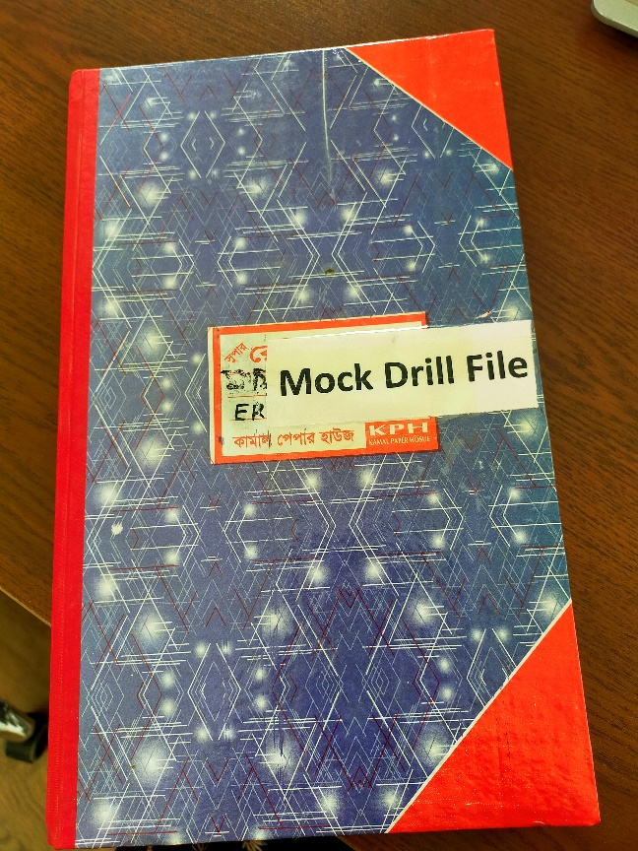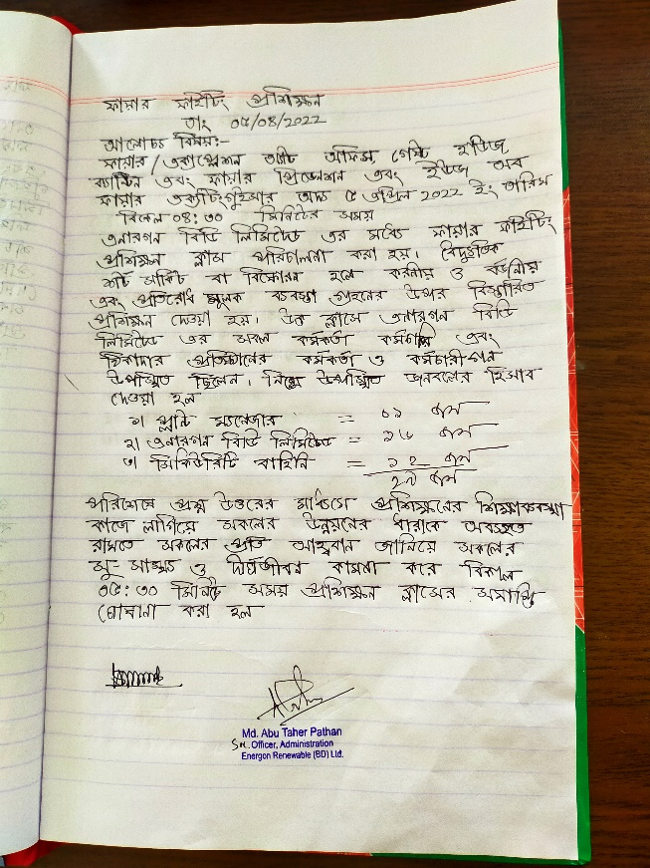

Environmental and Hazardous Waste Monitoring
During operation phase, waste generated from the project will include domestic waste at site office, scrap materials like scrap tools, damaged PPEs etc.; hazardous waste like waste oil, lubricants, used transformer oil; damaged batteries; electronic waste like damaged PV modules etc. Following measure will be adopted for disposal of solid waste;
- The hazardous wastes will be stored temporarily onsite at separate designated covered area provided with impervious flooring and secondary containment and will be disposed in accordance with best practices;
- The broken solar panels if any, may be sent back to the vendor as part of buyback arrangement; and
- Bio-degradable domestic solid waste will be disposed at compost pit within the project site. The recyclable waste will be disposed through local vendors.
The management of hazardous and non-hazardous waste should include the following monitoring activities:
- Regular visual inspection of all waste storage collection and storage areas has to be done for evidence of accidental releases and to verify that wastes are properly labeled and stored.
- Regular audits of waste segregation and collection practices has to be conducted.
- Tracking of waste generation records by proper documentation
- Characterizing waste for proper management, especially for hazardous wastes
- Keeping manifests or other records that document the amount of waste generated and its destination
- Hazardous wastes are to be disposed off through DOE approved certified vendors
Waste should be stored in a manner that prevents the commingling or contact between incompatible wastes and allows for inspection between containers to monitor leaks or spills. Examples include sufficient space between incompatibles or physical separation such as walls or containment curbs. Access to hazardous waste storage areas should be limited to employees who have received proper training. Periodic inspections of waste storage areas should be conducted and the findings are to be documented.
Preventive maintenance has to be carried out to identify and resolve problems. Other environmental good practices include maintaining hygienic conditions, maintenance of fire and safety equipment etc. and clearing of grass will be done periodically.
Damaged solar panels are categorized as hazardous wastage. So proper management mechanism has be adopted. Damaged or broken solar panels should be kept at a separate designated area and it is to be ensure that panels should be kept in cover so that there is no contamination in ground and water through leaching.
Third party waste contractor collects waste on regular basis. Scrap wastes such as scrap metals which are sold to the scrap vendors should be kept in a confined space avoid any incidents or accidents and to ensure workers’ health and safety. Waste disposal register has to be maintained regularly and auditing of the waste contractor shall have to be done accordingly. It is to be ensured that DoE approved waste contractors handling, treating, and disposing of hazardous waste, licensed by the relevant regulatory agencies and following good international industry practice for the waste being handled.

Environmental Monitoring and Management Budget
Environmental monitoring is conducted to compare the change between baseline condition and after project scenario, by testing some environmental parameters of air, water and noise and in case of necessity soil is tested. EHS committee is fully responsible for environmental monitoring as well as implementation of environmental management plan. The list of possible parameters to be tested, sample number and sampling frequency is given in Table 13.1 for the operation phase.

Table 13-1: Monitoring parameters and frequency of monitoring during operation phase
Key parameters to be monitored: (1) Ambient Air Quality
Location | Frequency | Parameter | Submission
At Project site, residential /institutional /commercial areas within 500m outside from plant boundary | Quarterly (routine) analysis | SPM, PM₁₀, PM_{2.5} | Quarterly submission to DOE.
Key parameters to be monitored: (2a) Surface Water
Location | Frequency | Parameter | Submission
Project site | Bi-annual basis in each year (pre-monsoon and post-monsoon)  Quarterly Basis for relevant stakeholders | pH, Temperature, DO, BOD, COD, TDS, TSS, Oil and grease | Bi-annual submission to DOE.  Quarterly submission to relevant stakeholders/ lenders
Key parameters to be monitored: (2b) Ground Water
Location | Frequency | Parameter | Submission
Project site | Bi-annual basis in every year (pre-monsoon and post-monsoon)  Quarterly Basis for relevant stakeholders | pH, Temperature, DO, BOD, COD, TDS, Oil and grease | Bi-annual submission to DOE.  Quarterly submission to relevant stakeholders/ lenders
Key parameters to be monitored: (3) Noise
Location | Frequency | Parameter | Submission
At four corners of Project boundary, residential/institutional /commercial areas within 100m and 300m outside from plant boundary | Quarterly (routine) analysis  Hourly basis for 24 hours during | Limits in dBA | Quarterly submission to DOE.
Key parameters to be monitored: (4) Electromagnetic Force
location | frequency | parameter | submission
Measurement of electromagnetic force by a certified agency for Transmission line, switch gears and transformers | Annual | electromagnetic force | Lender/Financier

As testing environmental parameters required sophisticated instruments, it is suggested that the committee should outsource consulting firm for testing and analyzing environmental parameters. A tentative environmental monitoring budget has been proposed in Table 13.2. Laboratory analysis fees considered as per monitoring fees format of DOE/private laboratories.
Table 13-2: An Annual Tentative Budget for Environmental Monitoring
Activity | Units | Annual Total Cost (Tk.)
Firefighting and suppression equipment, training and annual fire safety drill | lump sum | 150,000
Cost of occupational health and safety equipment | lump sum | 300,000
Quarterly test of ambient air quality (SPM, PM₁₀, PM_{2.5}) | 4 | 100,000
Quarterly test of surface water (pH, Temperature, DO, BOD, COD, TDS, Oil and grease) | 4 | 100,000
Quarterly test of ground water (pH, Temperature, DO, BOD, COD, TDS, Oil and grease) | 4 | 100,000
Quarterly noise monitoring | 4 | 80,000
Environmental Training | lump sum | 125,000
Quarterly Environmental & Social Audit by Third Party | 4 | 800,000
Sub Total in Tk. |  | 1,755,000
Contingency (10 %) |  | 175,500
Total in BDT |  | 1,930,500

Labor Assessment
The purpose of conducting the labor audit is to assess compliance with the national laws and IFC PS2 requirements, and then suggest corrective action plans for ensuring improved labor conditions at the plant.
Operation of a solar power plant is not labor intensive. ERBL ensures that Bangladesh Labor law is strictly followed. ERBL provides various compensation & benefits to their employees. Grievance redress mechanism is in place for the ERBL staff. No child labor or forced labor is accepted or encouraged in ERBL. ERBL focuses on their worker’s health and safety. Adequate training on various safety related issues, use of PPEs, emergency preparedness and job hazards are arranged frequently.
The HR policy of ERBL and labor assessment report are detailed in Annex-12 and Annex-13 respectively.

Environmental & Social (E&S) Audit
The primary objective of conducting environmental and social audit was to assess the compliance status of the Project and its various components with respect to the agreed ESAP, Operations Phase Environmental & Social Management & Monitoring Plan (ESMMP) of the ESIA, and applicable Performance Standards of IFC.
Since, this was the first environmental and social audit for ERBL, attempts were made to observe as many items as possible in an overall or gross perspective. Detailed audit report can be found in Annex-14.

Environmental and Social Action Plan (ESAP)
During the E&S audit, a set of recommendations was provided to ERBL based on the field observation and shared documents and an action plan was formulated. The detailed action plan including the recommendations, observation, responsible person and expected timeline is listed in Annex-15. ERBL management is committed to the action plan and within the timeline, they will try to implement the remaining recommendations.

Disaster Management and Emergency Response Plan
PV systems are subject to electrical faults like any other electrical installation, such as arc faults, short circuits, ground faults and reverse currents. These faults and other system failures, including cable insulation breakdowns, rupture of a module, and faulty connections, can result in hot spots that can ignite combustible material in their vicinity. Incorrectly installed or defective system components have been the cause for several PV fires as well.
The entire plant has been equipped with suitable fire protection and fighting systems for entire plant area as per the international safety standards and local fire authority requirements. Firefighting system (detection and protection) of transformers and other electrical equipment as required is installed in accordance with NFPA 70, NFPA 2001 and NFPA 72 guidelines. Wherever required latest Bangladesh fire safety codes / standards have been followed for building fire protection and prevention.
ERBL has prepared SOPs for preventive maintenance of Fire alarm system and Operation and Maintenance of portable fire extinguishers. From the findings of E&S audit, it has been observed that inspection of fire extinguisher is done once in every month on regular basis and records are kept by the EHS personnel. Mock drill on fire prevention and use of fire extinguisher is done once in every month. The inventory of firefighting equipment includes:
Items | Description | Quantity
1 | 12 KG ABC Dry Powder Portable Fire Extinguisher (Cartridge Operated Type) | 13 pcs
2 | 5 KG CO2 Portable Fire Extinguisher | 33 pcs
3 | 9L Foam Portable Fire Extinguisher (Cartridge Operated Type) | 13 pcs
4 | 135L AFFF Foam Mobile Fire Extinguisher (Cartridge Operated Type) | 6 pcs
5 | Fire Bucket | 13 pcs

ERBL also possesses fire license from Fire Service & Civil Defense, Bangladesh. The fire license was issued on 1st July 2021 and is valid till 30th June, 2022. ERBL also has applied for the renewal of the license (Please refer to Annex-1(G)).
Regarding the seismic hazard, all structures of ERBL is designed complying BNBC code, ASCE-07-10 code and AISI-96-LRFD, which ensure identifying accurate hazard level as well as ensure safe structure. Here no high-rise structure is present which also reduces seismic hazards significantly. All employees of ERBL plant is trained with emergency evacuation plan and they regularly arrange mock drill.
ERBL has prepared an Emergency Response Plan (ERP). The ERP is an outline of the procedures to be followed by all workers, employees and visitors at the ERBL premises in the event of an emergency. The plan describes possible emergencies, responsibilities of key personals and preparedness and responses for each emergency such as fire, spillage or leakage or hazardous materials, falling from height, floods, collapse of building, cyclone, earthquake, electrocution, lighting, bomb threats, etc. The ERP is attached in Annex-16.1 and Annex-16.2.

Impact Summary and Conclusion
This Environmental and Social Impact Assessment (ESIA) has been conducted to evaluate the impacts associated with the 100 MW solar power project. The impact assessment conducted in compliance with the administrative framework identified herein, including relevant national legislative requirements and international guidelines/ conventions.
This ESIA was focused on interactions between the project activities during the operation phase and various resources/ receptors that could result in significant impacts.
The project is a green energy project. The E&S impacts during operation phase are likely to be minor to negligible. The social impacts from the project are assessed to be in terms of loss of land and agricultural income and community health and safety but beneficial in terms of local employment and overall local area development.
The environmental and Social Management Plan (ESMP) describes mitigation measures for impacts specific to project activities and also discuss implementation mechanism. To conclude, the implementation of ESMP will help ERBL in complying with its internal E&S requirements as well as national regulatory framework in addition to World Bank’s Operation Procedure OP 4.03.

Nahin, K.T.K., Basak, R. & Alam, R. (2020). Groundwater Vulnerability Assessment with DRASTIC Index Method in the Salinity-Affected Southwest Coastal Region of Bangladesh: A Case Study in Bagerhat Sadar, Fakirhat and Rampal. Earth Syst Environ 4, 183–195.

